C A R I B B E A N
M E T E O R O L O G I C A L
O R G A N I Z A T I O N

CARIBBEAN METEOROLOGICAL COUNCIL Doc. 9
FORTY-SEVENTH SESSION
Kingstown, ST. VINCENT & THE GRENADINES, 29-30 NOVEMBER 2007

OTHER PROJECT UPDATES AND PROPOSALS
(Submitted by the Coordinating Director)

Introduction

1. This is primarily an information document on some of the various projects that involve CMO Member countries. In some cases, these are on-going projects and the information is intended to keep the Council up-to-date on the progress of implementation. In the case of proposals for new projects, the guidance of Council will be sought.

(a) CAYMAN ISLANDS RADAR PROJECT PROPOSAL

2. CMC47 Doc.8 gives details of the implementation by the Caribbean Meteorological Organization of a 13.2 million Euro Project, funded by the European Union, to establish a new, modern and expanded radar network in collaboration with other countries in the Caribbean, as part of the regional early-warning system. The new radar network will stretch from French Guiana, along the South American coast to Trinidad, then north along the Eastern Caribbean Islands, then westward across the Greater Antilles to Jamaica and to Belize in Central America. The 46th session of the Council was informed that the CMO Headquarters had made a proposal to the Government of the Cayman Islands to plug the one glaring gap in the radar coverage; that is, the gap around the Cayman Islands.

3. As a large number of tropical storms and hurricanes go close to or directly through that gap, the Government of the Cayman Islands recognized the urgent need to fill that gap in the radar network. Over the last year, the Government has looked at possible ways to fund this project. The CMO will work closely with the Meteorological Service and other authorities in the Cayman Islands to produce a more detailed project document for this purpose.

4. An important element in this proposal is the direct benefit from all technical and administrative components of the EU-funded CMO Radar Project. That is, it would utilize all the studies already undertaken by the CMO, including the radar technical specifications, radar tower infrastructural designs and project cost analyses, meteorological training programme, and would benefit from CMO’s administrative experience in implementing and commissioning a complex weather radar system. The National Weather Service of the Cayman Islands would operate the weather radar as the centrepiece of the Cayman Islands early warning system and as part of the full CMO network and would benefit from the CMO’s regional radar maintenance system. If this proposal is realized, the new extended regional network would be as depicted in Figure 1.

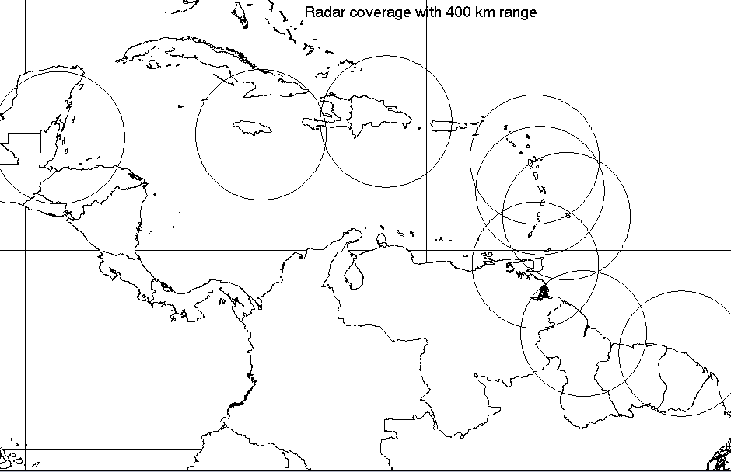
Belize
Jamaica
Dominican Rep.
Guyana
Fr, Guiana
Guadeloupe
Trinidad
Barbados
Martinique
Cayman Isl.

Figure 1: Proposed Radar for the Cayman Islands to provide complete Caribbean radar coverage

(b) WMO/FINLAND SIDS-CARIBBEAN PILOT PROJECT

Introduction

5. The Council will recall previous reports on the SIDS-Caribbean Pilot Project, funded by the Government of Finland and implemented by the World Meteorological Organization (WMO), in collaboration with the Caribbean Meteorological Organization (CMO) and under the direction of a Supervisory Board headed by the Association of Caribbean States (ACS).

6. The WMO/Finland SIDS-Caribbean Project was implemented between May 2001 and September 2004 through a Project Office located at CMO’s Caribbean Institute for Meteorology and Hydrology (CIMH). The Project included the areas of telecommunications, equipment allocations, the provision of calibration and maintenance facilities for meteorological equipment, the development of data management and data rescue systems, meteorological training and awareness building.

7. The Project upgraded the operational meteorological workstations at the regional Weather Forecast Centres of several National Meteorological Services (NMS and funded part of the major upgrade of the WMO Regional Meteorological Telecommunication Network (RMTN) that occurred in April 2004. After the completion of the Project, the Steering Committee accepted a CMO proposal for a follow-up Pilot Project to build on these two aspects of the main Project’s achievements, aimed at the production of a large number of specialized forecasts and products for a wide variety of users and customers in a semi-automated manner.

8. The Pilot Project, which involved the Meteorological Services of Jamaica and Trinidad and Tobago, was implemented for the WMO by the Finland Meteorological Institute (FMI). Training and product development took place in Finland and the installation of the hardware, configuration of the software and training were accomplished in the two CMO Member States by the end of December 2006. The Pilot Project implementation activities and their status are as follows:

 | Activity
((i) | The design, development and testing of the system for the Caribbean National Meteorological Services (NMS) by FMI based on its own system.
((ii) | A three-week training and development period for two operational meteorologists from each participating country (Jamaica and Trinidad & Tobago) at the FMI facilities in Helsinki, Finland.
((iii) | Provision of hardware, the installation of systems, adaptation of NMS workstations for new systems, and 2-week hands-on training in each of the participating countries.
((iv) | - Development of special semi-automated forecasts on the local workstations  - Verification of the results, and  - Dissemination to special users

9. The two Meteorological Services have had one year of operational use of the system. The next logical step to be undertaken in 2008 would be to analyse the outcome of the Pilot to determine if the methodology and the products generated are suitable for extension to the other Forecast offices in CMO Member States in the first instance.

(c) FEASIBILITY STUDY FOR AN EARLY WARNING PROJECT FOR CARICOM STATES - Government of Italy/CARICOM Agreement

10. The 45th and 46th sessions of the Council were presented with a proposal for a Feasibility Study for the Establishment of a Modern Hydro-meteorological Monitoring System in the Caribbean. This project proposal is based on an agreement between the Government of Italy and CARICOM, in which the Government of Italy will fund the Project Feasibility Study, with the CIMH as the Implementing Agency. The cost of the Feasibility Study is approximately €100,000 for the execution prior to the development of a full Project (Project Preparation Facility).

11. During the first half of 2007, The CIMH and the CMO Headquarters recognized several synergies between the aims of this Feasibility Study and the Carib-HYCOS Project about to be implemented in the Caribbean by the World Meteorological Organization (WMO) [see Section (d) below]. These synergies were explored at a meeting between representatives of the Carib-HYCOS Project, the CMO Headquarters and the CIMH. Further details of the status of the Feasibility Study will be presented to the Council by the CIMH.

(d) WMO CARIB-HYCOS PROJECT UPDATE

Background

12. In 1993 WMO launched the World Hydrological Cycle Observation System (WHYCOS). Its aim is the development of water resources information systems to assist Member countries to improve their water management, mitigate the impact of water-related disasters such as floods and droughts and contribute to regional and global studies of the impact of climate change on water resources. WHYCOS is being developed through a series of regional HYCOS components. Some 16 HYCOS projects are at varying stages of development and implementation in various regions of the world; Carib-HYCOS is one of these projects. The Carib-HYCOS has been proposed as two components, one addressing the needs of the Caribbean Island countries (CIC) and the other, the needs of the mainland countries of the Caribbean Basin. Draft project framework documents for both components, prepared by WMO, had been circulated to the countries concerned and were first made available to the Council at its 40th session (Barbados, 2000).

13. As a regional institution, the CMO has been supporting Carib-HYCOS, particularly to ensure that the CIMH plays an integral part in this important activity. Unfortunately, preparation for the implementation of the island component of Carib-HYCOS, involving the English, French and Spanish-speaking countries of the Caribbean, has not progressed well over the last few years. At the WMO level, the Coordinating Director of CMO has several times expressed dissatisfaction with the slow progress and, as a result, the CMO Headquarters removed it from the Agenda of the 46th Session of the Council (2006). This year, 2007, relevant agreements for the implementation have been signed and progress now seems possible. More detailed information on Carib-HYCOS and the latest developments towards its implementation are contained in ANNEX I to this document.

14. When the Carib-HYCOS Project was discussed at previous sessions of the Council, it was pointed out that several CMO Member States that could benefit from the Project had actually never indicated their interest to the WMO and therefore had no input into the Project formulation. The CMO Member States that expressed interest are Barbados, Jamaica and Trinidad and Tobago. The CMO will explore with the WMO, the possibility of the participation of the CMO Member States that are not WMO members; namely, Grenada, St. Kitts & Nevis and St. Vincent and the Grenadines. If their participation is possible, it might have to be done through a special arrangement under the CMO, which has a special working arrangement with the WMO.

15. Of particular relevance to the Carib-HYCOS project is a related project entitled “Co-operation in Hydro -meteorological Monitoring, Natural Disaster Prevention and Early Warning”, referred to in Section (c) above. The objectives of this “feasibility project” support the objectives and activities of the Carib-HYCOS project and collaboration between the two initiatives will be developed, if possible.

ACTION PROPOSED TO COUNCIL

16. The Council is invited to:

Note the updated information and provide any further guidance on (i) The Cayman Islands Radar Project Proposal; (ii) WMO/Finland SIDS-Caribbean Pilot Project; (iii) Feasibility Study for an Early Warning Project for CARICOM States - Government of Italy/CARICOM Agreement; and (iv) WMO Carib-HYCOS Project.

_____END_____

CMO Headquarters
November 2007

CMC47, Doc 9, ANNEX I has been produced separately

