C A R I B B E A N
M E T E O R O L O G I C A L
O R G A N I Z A T I O N

CARIBBEAN METEOROLOGICAL COUNCIL Doc. 8
FORTY-SEVENTH SESSION
Kingstown, ST. VINCENT & THE GRENADINES, 29-30 NOVEMBER 2007

CMO RADAR PROJECT IMPLEMENTATION - UPDATE
(Submitted by the Coordinating Director)

A. Introduction and Background

1. In October 2003, the European Commission approved a 13.2 million Euro Regional Project to construct and install four new digital weather radars in the Caribbean to replace an old and obsolete radar network installed by the Caribbean Meteorological Organization (CMO) in the late sixties and early seventies. The CMO Member States operated the old radars since the early seventies, with some units lasting for over 30 years, more than twice the expected lifetime of the radars, before the entire network was surpassed by new technology.

2. Under this new CMO Radar project, four new Doppler radars will be installed in Barbados, Belize, Guyana and Trinidad & Tobago. The Project will link the new radars with others already in place in the region to form a modern network of nine radars as part of the Caribbean Early Warning System for severe weather conditions. After several years of preparatory work, the Project’s full implementation began in 2005.

3. The Caribbean Forum of ACP States (CARIFORUM) in Guyana has overall responsibility for the Project, officially entitled the “Regional Weather Radar Warning System Project, using resources of the 9th European Development Fund (EDF). The implementation of the Project is under the overall supervision of a high-level Administrative Steering Committee, with membership from the European Commission as the Funding Agency, CARIFORUM as the Contracting Authority, and the CMO as the Project’s Implementing Agency/Supervisor. The overall management of the Project is being carried out in a centralized manner through the Headquarters of the CMO in Trinidad & Tobago. The Project Management Unit (PMU) is provided by a consortium of the MET OFFICE of the United Kingdom and Royal Haskoning (Netherlands-UK) and is made up of a Project Manager and a team of engineering and radar experts. The PMU began operations in July 2005 and is located in the CMO Headquarters.

4. The Council will recall the very hectic activities over the last few years, including those in 2006 that brought the Project close to collapse. This document will provide the Council with information on all implementation activities since its last session and discuss the programme to take place within the next year, including hurdles still to be overcome in what should be the final year of implementation.

B. Summary of Technical Features of the Project

5. The Radar Project will feature:
- Four new Doppler digital weather radars in Barbados, Belize, Guyana and Trinidad & Tobago;

- The creation of a regional radar network comprising these four radars, plus existing radars in Jamaica, the Dominican Republic, Guadeloupe, Martinique, and French Guiana.

6. The configuration of the network is shown in Figure 1 below. The composite is being created by the French Meteorological Service - Météo-France. The gap shown over Puerto Rico is covered by a radar on that island but not as part of this network, while the real gap in the vicinity of the Cayman Islands will be discussed under Agenda item 9.
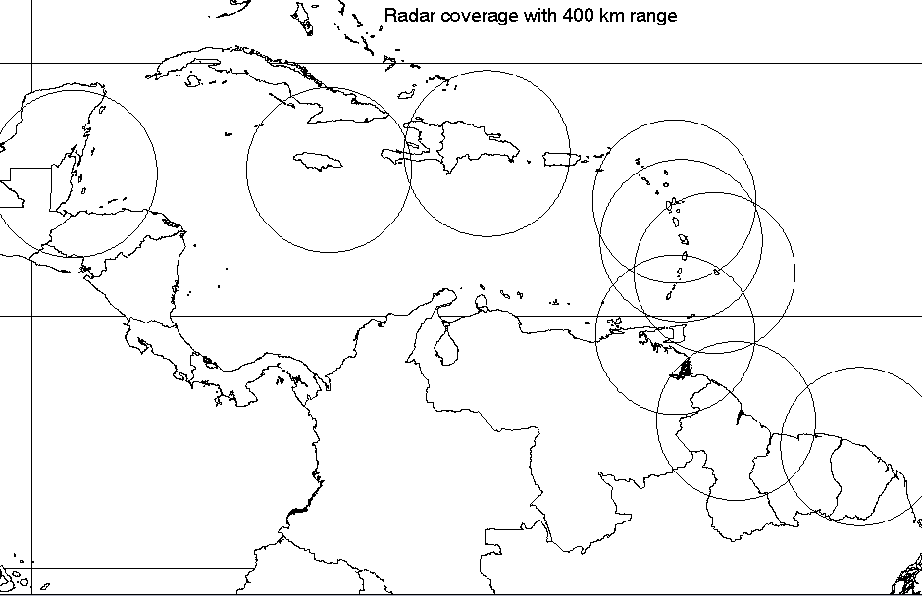
Belize
Jamaica
Dominican Rep.
Guyana
Fr, Guiana
Guadeloupe
Trinidad
Barbados
Martinique

Figure 1 shows the theoretical radar coverage at 400km range

C. Implementation

C1 Radar System
7. Four powerful, high-precision METEOR 600 S-band Doppler radars are being supplied by the Selex-Gematronik Company of Germany. Originally, the METEOR 500S radar was ordered, but that system has been relabeled as the 600S as part of the manufacturer’s normal upgrade. These will be installed in Belize, Barbados, Guyana and Trinidad & Tobago. The METEOR 600S is particularly suited to tropical regions where there is extremely heavy rainfall and severe thunderstorm activity.

8. The Factory Acceptance Test (FAT) for the first radar took place as scheduled in September 2007 and preparation for the shipment to the Caribbean is well underway. However, the delivery of the four radars is being timed to match the completion of the local construction of the structures upon which the radars will be installed.

C2. Radar Locations
9. The four new weather radars will be located on the following sites owned by the national governments and operated by the Meteorological Services of the four host countries:
- Barbados – Castle Grant in the parish of St. Joseph;
- Belize – the Meteorological Office at Philip Goldson International Airport;
- Guyana – near Cheddi Jagan International Airport (just to the south of the airport perimeter);
- Trinidad and Tobago – Brasso Venado on the Central Mountain Range in Trinidad.

C3. The Radar Buildings – Status, Problems and Solutions
10. The Council will recall the failure of the tender for the construction of four reinforced concrete towers at the sites shown in paragraph 9. This was due to the escalating construction costs in the region over the last few years. To avoid the collapse of the entire Project, considering that no new funds were available, the following solution was negotiated and agreed to, as dictated by the strict constraints of the European Commission’s rules and regulations:
- The construction of reinforced concrete towers in Guyana and Trinidad,
- The construction in Barbados of a steel tower and ancillary buildings to accommodate the new radar and associated equipment;
- The renovation of relevant parts of the existing Met. Office building in Belize that housed its old weather radar, in order to accommodate the new radar.

11. The design of the 15-20 metre concrete towers for Guyana and Trinidad, produced by Vikab Engineering Consultants Limited (VECL) of Trinidad and Tobago, is shown in Figure 2(a). The Barbados radar would have a similar appearance to that in Figure 2(b), while Figure 2(c) shows the old Belize radar on the building to be renovated.

Figure 2(a): Design of the Concrete Radar Buildings, showing Radar Antenna and Dome (© CMO)

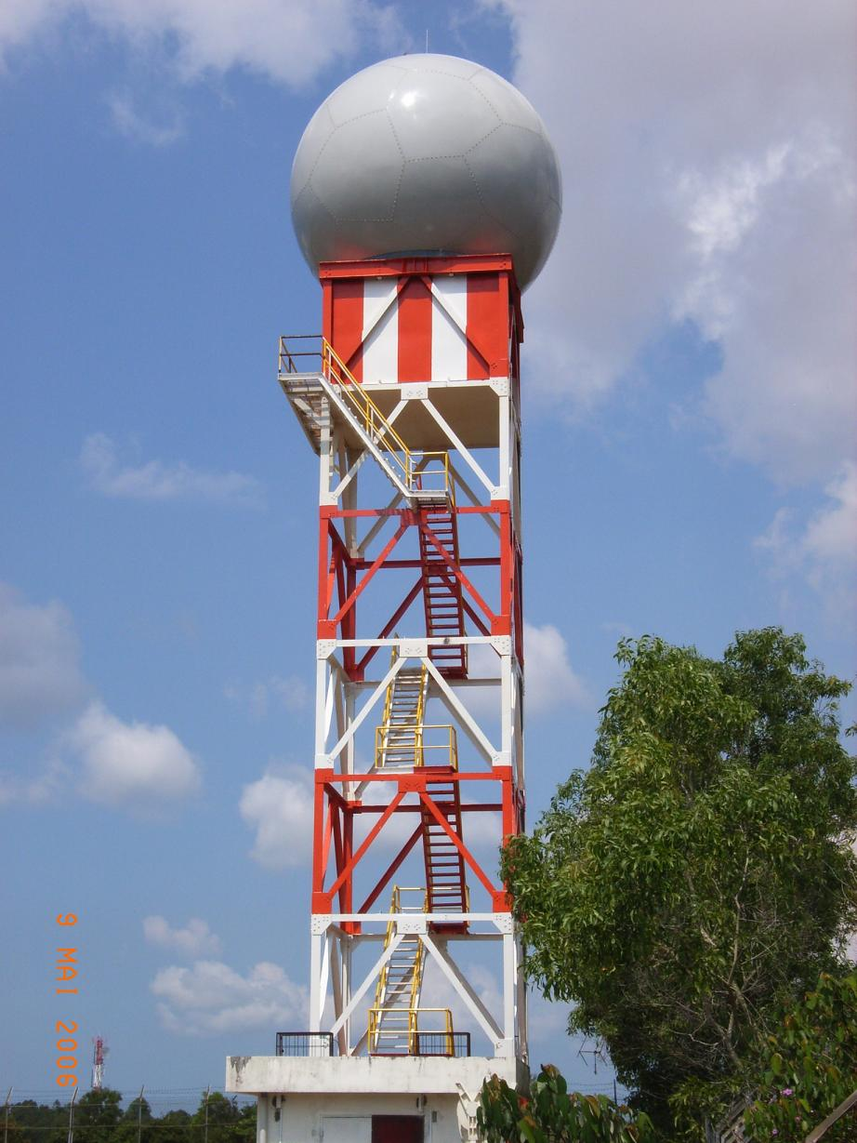
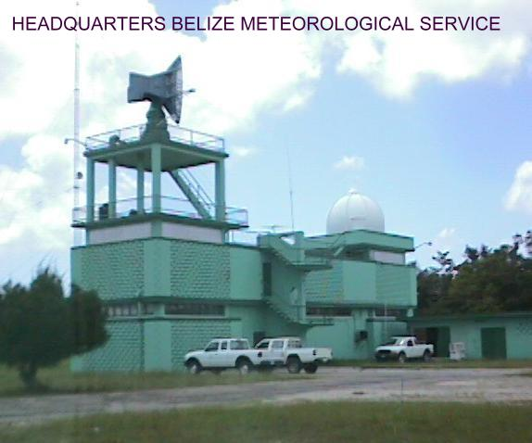
Figure 2(c): Old Belize radar on building to be renovated
Figure 2(b): Radar on a Steele Tower
with equipment room

12. The construction of the tower in Trinidad has progressed very satisfactorily and the building should be ready for the installation of the radar in early January 2008. Trinidad & Tobago has therefore been slated to receive the first of the new radars.

13. The procurement of the steel tower for the Barbados radar site is being undertaken through an addendum to the radar supplier’s contract, while the construction of the foundation of the tower and an ancillary building is being undertaken by a local construction company. Construction of that tower and building and the installation of the radar could be completed around March 2008, so that Barbados is expected to receive the second radar.

14. In Belize, delays were experienced in the provision of calculations which would inform the Project whether the existing building would be able to house the new radar with some modifications and strengthening. Further delays were experienced in receiving architectural drawings. Tenders for the renovation of the building therefore closed at the end of October and the renovation is slated to commence by the end of November 2007. Belize should therefore receive the third radar sometime around May 2008.

15. The Guyana tower commenced about the same time as Trinidad and was progressing at about the same pace. By the middle of May, the foundation had already emerged above the ground and work started on the ground floor when the construction was halted by the Government of Guyana. This occurred because the Guyana Civil Aviation Authority “suddenly” objected to the location of the tower due to the possible interference of the tower with its VHF Omni-directional Radio (VOR) navigation system, although the Civil Aviation Authority was itself among the many agencies in Guyana that had given prior clearance for the construction on that site. The Government of Guyana was, thankfully, very quick to agree to bear the cost of the relocation to a new site in the vicinity that met the clearances and other requirements of ALL stakeholders. The recommencement of the tower at the new site got underway in early November. This unfortunate incident has moved the installation of the Guyana radar to a date about August 2008.

D. Training Activities

16. The two types of training provided under the Project are for (i) radar technicians and (ii) meteorological staff. Training for the radar technicians from each radar host, plus the CIMH, is being provided by the radar manufacturer under its contract, while the training for meteorological staff will be undertaken under the direction of the CMO.

17. The first phase of the technician training was undertaken at Selex-Gematronik’s factory in Düsseldorf, Germany in two groups. The first group of seven attended their session from 10-21 September followed immediately by three days of factory acceptance tests (FAT) from 24-26 September. The second group of six technicians attended training from 8-19 October. The second phase for these technicians will comprise a period of practical On-the-Job Training (OJT) at each radar site, so that the local technicians would participate in the installation of their radar with the supplier’s technicians. Training will continue through the Site Acceptance Test (SAT) period and after installation.

18. The primary and higher level training of the Met. Services’ staff will be undertaken by an international Training Expert. Staff of the CIMH and selected staff from each radar site will undertake other components of training. In November 2007, a professional consultant was contracted by the Project to coordinate this large task. The CMO has been experiencing great difficulty in identifying a sufficient number of international experts with the type of operational and training experience needed in the region; specifically, considerable Doppler applications in the tropics. This important activity is running behind schedule as a result. The World Meteorological Organization (WMO) is assisting in trying to identify suitable candidates.

E. Remaining Challenges and Risks to the Project

19. The maximum level of funding for the Project is € 13.2 million. Under the 9th EDF rules, there are no other funds available to the Project. After the reorganization of budget allocations resulting from the radar tower solutions mentioned in paragraph 10, the CMO believes that it can complete the Project within the allocated resources, but the possibility still exists for cost overruns, particularly in Guyana as a result of the relocation to the new site and associated time-related costs,

20. The delays in Belize and the restart of the tower in Guyana have created conflicts with other contracts that are already running within the Project. The contract for creation of the regional composite by Météo-France could be in danger if the radars are not all installed before its contract ends. The PMU’s contract ends in September 2008. If the Guyana radar has not been installed and tested by that time, the PMU’s radar experts will be unable to certify the radar’s performance as required during the Site Acceptance Tests (SAT).

21. Paragraph 18 noted difficulties with scheduling the training of meteorological staff. Notwithstanding, all training activities have to be completed by August 2008 - the time limit set by the Operational Work Programme of the Project. The second phase of meteorological training should take place after the installation of the radars. Therefore, delays in the construction of the radar towers, particularly Belize and Guyana, could put the training component at risk of failure.

22. Delays in the operational status of the radars could impact on the timing of one activity seldom mentioned by the CMO. It is the intention of the CMO to contact independent expertise to test and verify the conformity of the radar emissions to international health and safety standards. This process will also be undertaken within the time limit of the Operational Work Programme of the Project.

23. Extension of contracts for the PMU, Météo-France, the training coordinator and the international training expert to facilitate time overruns will be difficult to achieve because of the limited resources and restrictions placed by the European Commission’s rules. Even where such extensions may be possible, the time needed to have these processed and approved by the EC is normally quite lengthy.

24. Government authorities in the four radar host countries have done a great deal to ensure that the Project implementation is undertaken as smoothly as possible. However, there are still some hurdles at the local level to be cleared and some national activities to be undertaken, as determined in the MOUs signed by the Governments.

25. In this regard, a continued sense of urgency needs to be maintained by all parties involved in the Project, namely the CMO, the PMU, the host governments and respective NMSs, CARIFORUM and the EC, to ensure that all implementation activities are carried out within the limited time available. As occurred over the last few years, the Radar Project will continue in 2008 to be the primary focus of the CMO Headquarters. It is still expected that 2007 will be the last without any of the new radars and that all the radars will be installed, tested, commissioned and handed over to the respective Governments well before the end of 2008 – and indeed, before the 48th session of the Caribbean Meteorological Council in 2008.

Action Proposed to Council:

26. The Council is invited to:

- Note the activities connected with the implementation of the Radar Project;
- Note the particular challenges and risks still facing the implementation of the Project,
- Urge the radar host countries to continue all local activities that would facilitate and expedite implementation within the relevant deadlines
- Provide any guidance it may desire for the future implementation.

___________

CMO Headquarters
November 2007

