

C A R I B B E A N

M E T E O R O L O G I C A L

O R G A N I Z A T I O N

**CARIBBEAN METEOROLOGICAL COUNCIL** **Doc. 10**

SIXTY-FIRST SESSION

18-19 NOVEMBER 2021, VIRTUAL PLATFORM

##### CMO WEATHER RADAR NETWORK

(Submitted by the Coordinating Director)

## Introduction

1. The CMO Weather Radar Network currently comprises six S-band Doppler radars, namely, the radars in Barbados, Belize, Grand Cayman, Guyana, and Trinidad, and a new radar in Jamaica that has been installed but not operationalize at the time of writing of this report. This network, along with other pre-existing radars in other Caribbean islands, provides the Caribbean with a modern sophisticated tool that complements other surface, upper-air and satellite-based weather observing platforms as part of the regional early weather warning system.
2. The radars in the CMO Member States are critical infrastructure for weather surveillance, forecasts and warnings in the Caribbean. The reliance on the system has been growing within and outside of the region and, under the auspices of the *World Meteorological Organization* (WMO), plans have been in place to integrate, in stages, the data from these radars with all other radars in the entire Caribbean basin as part of a larger weather surveillance system. For a CMO-wide or the larger Caribbean-wide radar network to function properly, all radar-operating States need to work steadily to ensure reliability of their individual radar operations. This document will examine the operational status of the CMO Radar Network Operations, as well as the operations of the regional radar mosaics/composites.

## (a) Status of CMO Radar Network

### Operational Status

1. For most of 2021, the radars in Barbados, Belize, Cayman, and Guyana were operating steadily. The easternmost of the radars, in Barbados, had returned to operations in late 2020, after a prolonged period of outage. After functioning without issues for several years, the radar in Trinidad developed problems in February 2020 and several replacement parts were ordered later that year, including one part that has a 9-month delivery schedule. Arrangements are being made for a maintenance visit to Trinidad by the radar manufacturer. The radar in Belize returned to full functionality after replacement of four parts, of which two were procured from the repository at CIMH and two directly from the manufacturer. On 24 May 2021, amidst several days of significant amounts of rainfall, an electrical event knocked out Guyana’s National Weather Watch Center power, internet, and telephone lines and the weather radar stopped working the next day. Fortuitously, Guyana had already scheduled a maintenance visit for June. With the technical assistance of the manufacturer, the radar was back in operation three weeks later. Cayman Islands radar had an outage on 21 October 2021 and was still offline to date (29 October 2021). Repairs to the antenna are expected to be scheduled in 2022. When requested the CMO Headquarters has been facilitating the purchase of parts using funds available to Members from the CMO Radar and Rawinsonde accounts. Sample images from the radars are shown in **Figure 1**, including volcanic ash from the eruption of La Soufriere on the island of St Vincent on 11 April and Hurricane Elsa on 2 July 2021, with its eye over the volcanic eruption zone.

In the case of Jamaica, the Meteorological Service installed a new dual-polarized, S-band, Doppler radar, which is now in its testing phase. The new radar was installed at the same site as the previous Doppler radar and is expected to be in full operation in 2022. The radar project was funded by the World Bank project for Improving Climate Data and Information Management, under the Pilot Program for Climate Resilience (PPCR). The old radar has been made available for research to The University of the West Indies (Mona) Department of Physics in Jamaica.

### X-Band Radar Project in Saint Lucia

1. Council will recall the presentation at CMC59 (Anguilla, 2019) by *Mr Andre Joyeux*, the Director of the Saint Lucia Meteorological Service, A Geo-Information Centre (GIC) is being implemented in Saint Lucia by agreement between the Government of Saint Lucia and the Government of Italy. The GIC installations are being implemented by the Caribbean Community Centre for Climate Change (5Cs). The project includes the installation of an X-band radar, which has a radius of 120 km and is to be cited within line of sight of the Hewanorra Airport in Vieux Fort, Saint Lucia.

The Government of Saint Lucia has provided a suitable site to locate the radar. The civil works carried out to date, include; (i) construction of an access road, (ii) building of a one-room structure and platform to house the radar and accompanying equipment. The radar equipment is in storage at the Ministry of Infrastructure, Ports, Energy and Labour storeroom. The installation of the radar is scheduled to be completed by 17th November 2021. The training on the use of the radar was conducted virtually and further training will occur after the installation is completed.

Council will also recall that the Saint Lucia Meteorological Service has appealed for assistance from CMO with the maintenance of the radar and its application for their monitoring and forecast services. The CMO Headquarters has therefore included staff from Saint Lucia Meteorological Service in the Operational Radar Working Group approved by Council.

a

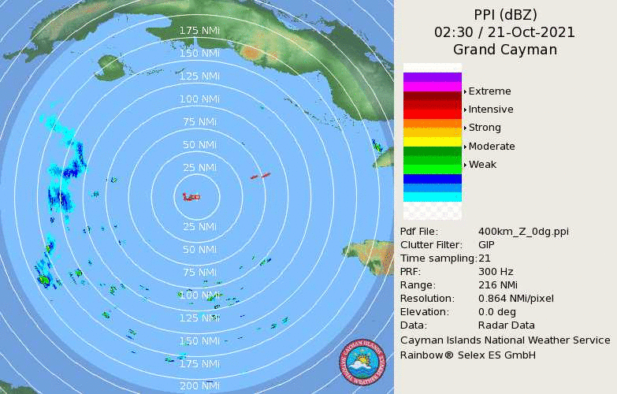

**Figure 1(a)**: Belize - 400 km

**Figure 1(a, c)**: Cayman Islands at 400 km (**↑**) and 250 km (**↓**), 21

October 2021.

c

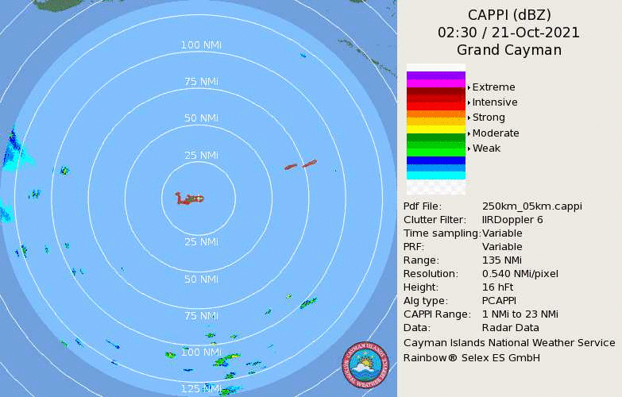

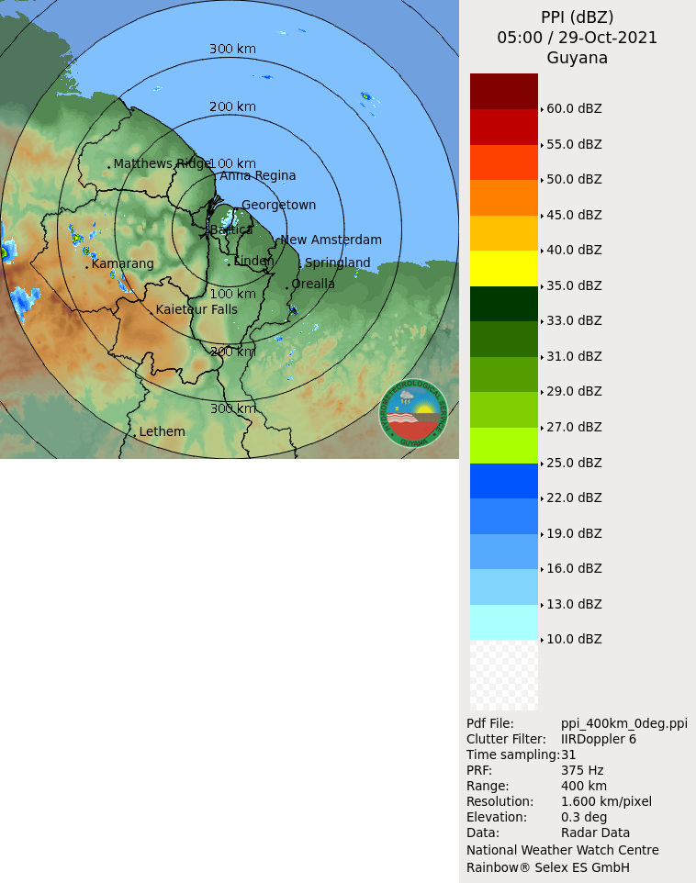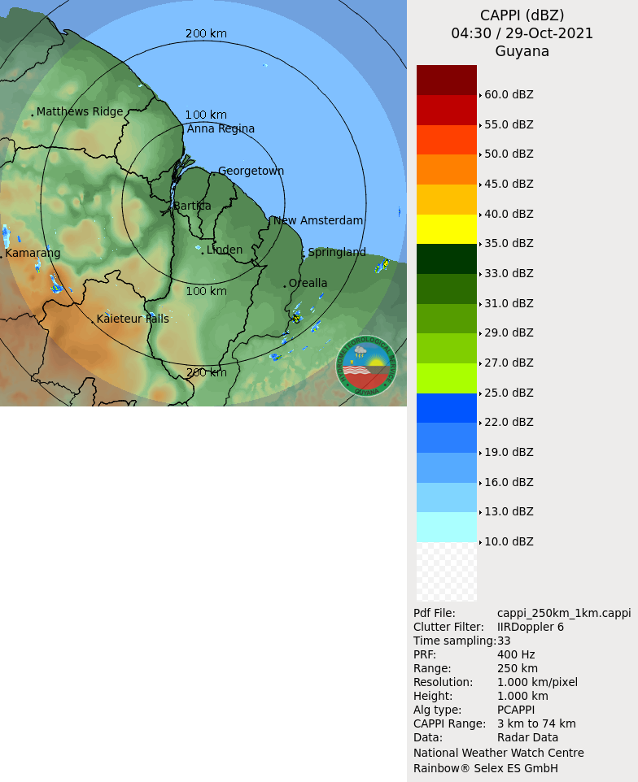

b

**Figure 1(b, d):** Guyana at 400 km (**↑**) and 250 km (**↓**) – 29 October 2021



d

**Figure 1()**: Cayman Islands at 400 km (**↑**) and 250 km (**↓**), 6

October 2020. Note the eye and rainbands of Tropical Storm Delta

e

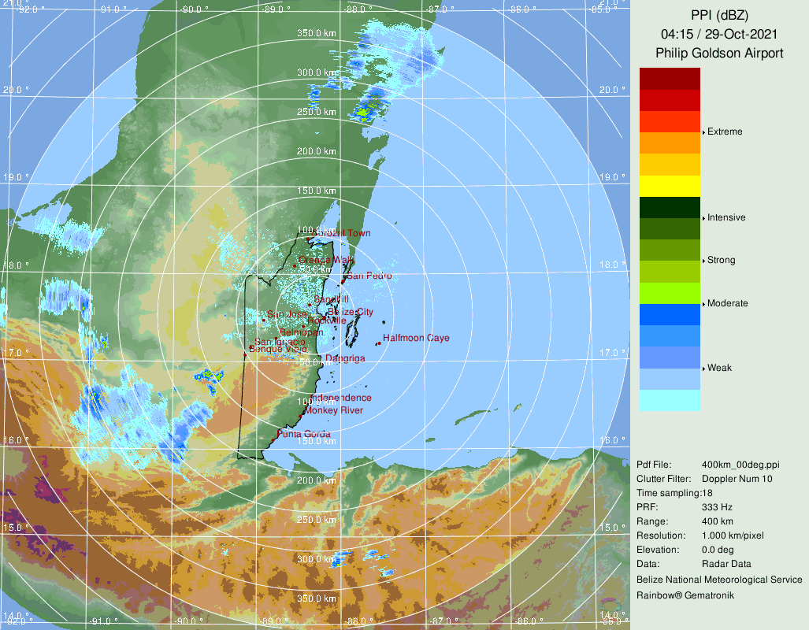

**Figure 1(e, g)**: Belize at 400 km (**↑**) and 250 km (**↓**), 29

October 2021.

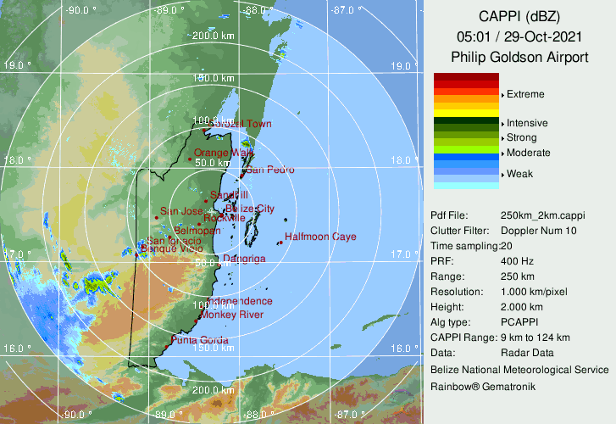

g

f

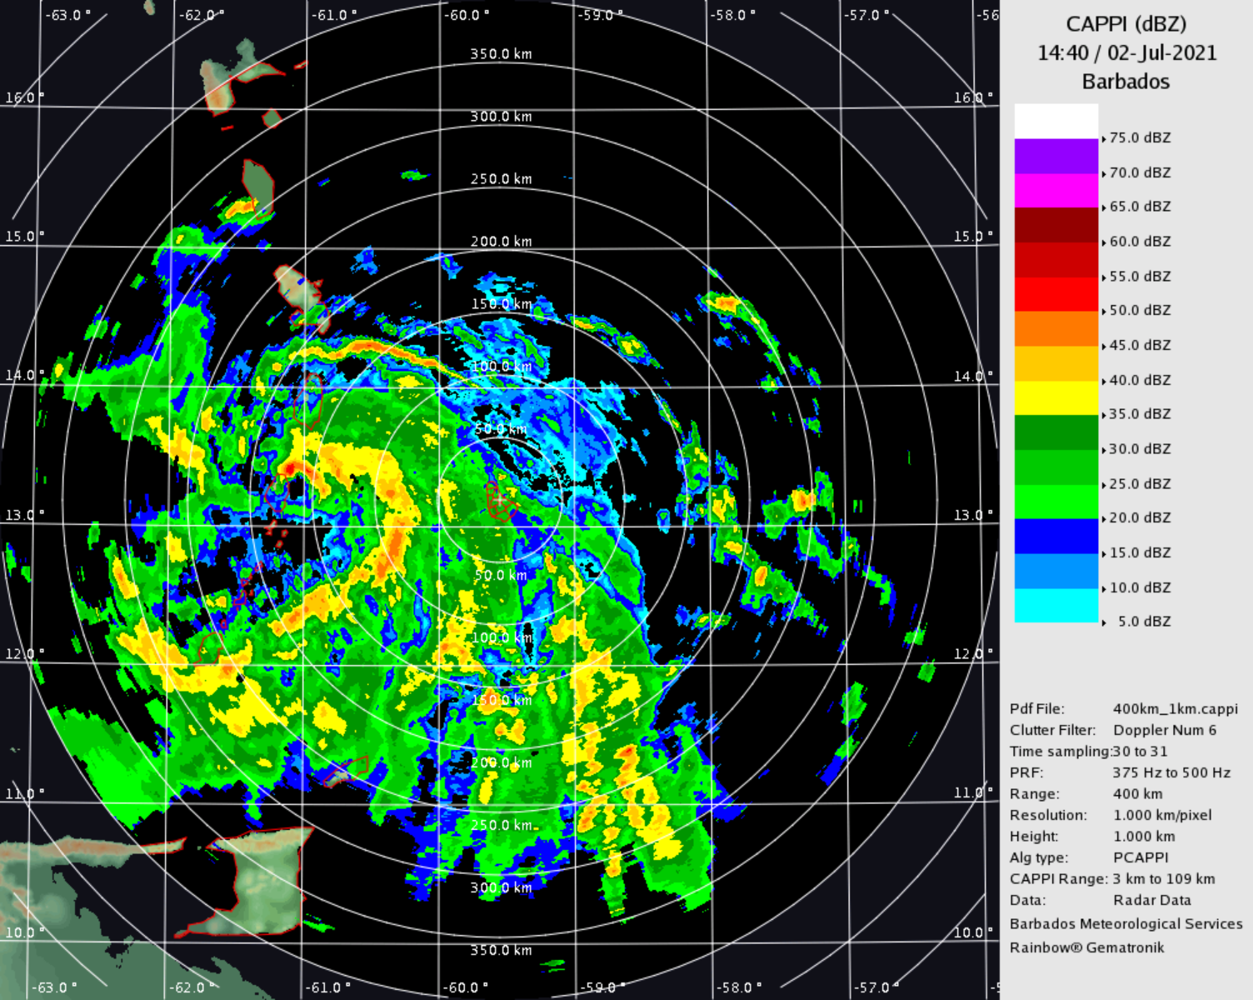

**Figure 1(f, h):** Barbados at 400 km (**↑**) on 2 July 2021 and 250 km (**↓**) – 11 April 2021. Note above the eyewall of Hurricane Elsa over St Vincent. Note below volcanic ash from the eruption of La Soufriere on St. Vincent and the ash being dispersed eastward towards Barbados.

h

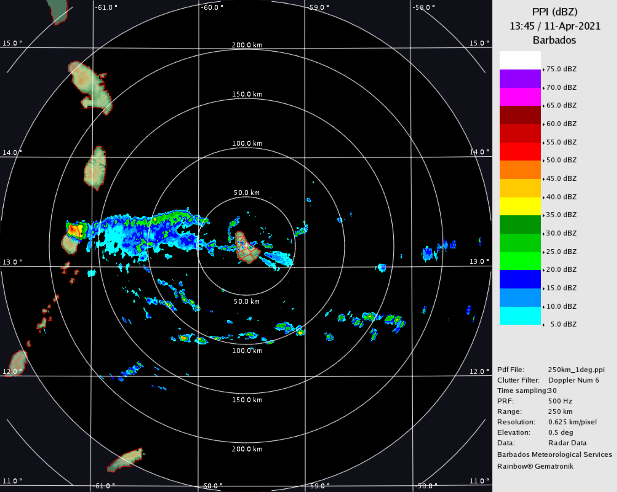

### Website Access and Usability

1. All radar host Meteorological Services operate websites that provide access to their radar imagery, as follows:

Belize: http://www.hydromet.gov.bz/

Cayman Islands: http://www.weather.gov.ky/

Barbados: http://www.barbadosweather.org/

Trinidad: http://www.metoffice.gov.tt/

Guyana: http://www.hydromet.gov.gy/

In addition, the CMO Headquarters website provides a link to all these sites through http://cmo.org.tt/links.html.

## (b) Operations of the Regional Radar Composite and other Regional and International Obligations

1. For several years, the CMO Headquarters has made considerable efforts, in collaboration with the radar sites and WMO’s *Global Telecommunications System (GTS) Internet File Service* (GIFS) server in Washington DC, to ensure that data from all the radar sites have been in the correct format and transmitted in a timely manner for ingestion into regional radar composites. The first regional radar composite was generated at the French Meteorological Service (Météo-France) centre in Martinique, which was developed through an agreement between Météo-France and the CMO. That mosaic is no longer available on the Météo-France website but the data are still being provided on the GIFS server in real-time.

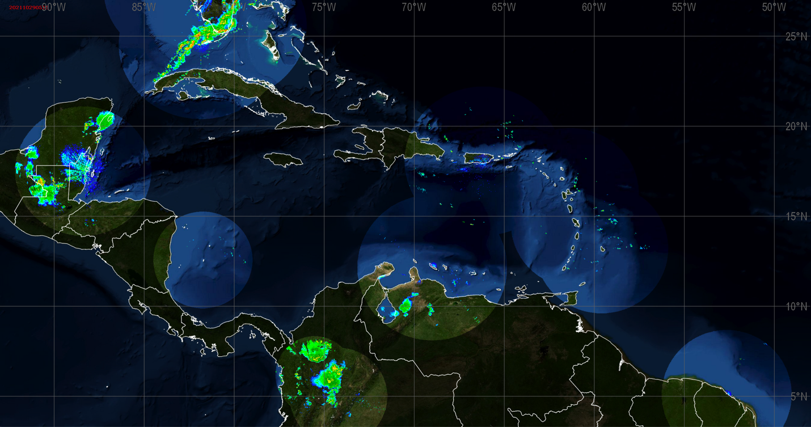

**Figure 2:** Regional Radar Composite created by Barbados (29 October 2021)

1. A second regional composite was developed separately by the Barbados Meteorological Service. An example of the composite (with some missing data) is shown in **Figure 2,** but sub-sectors are also available. From a practical point-of-view, the Barbados-generated composite has become the more widely used composite regionally, including by the US National Hurricane Center in Miami and other Caribbean States (**Figure 3**). Radar composites are a regional priority under the ***WMO Integrated Global Observing System*** (WIGOS) (see CMC58 Doc 5). The CMO Headquarters has been asked several times by the WMO Region IV Management about the sustainability of the Barbados-generated composite, since WIGOS became operational in 2020. As discussed during the last few Council sessions, the Barbados composite was not yet the subject of a formal arrangement or long-term commitment by Barbados, which is necessary for it to be part of WIGOS. The CMO Headquarters believes that this excellent effort by the Barbados Meteorological Service should have firm national commitment and become an official service provided by Barbados.

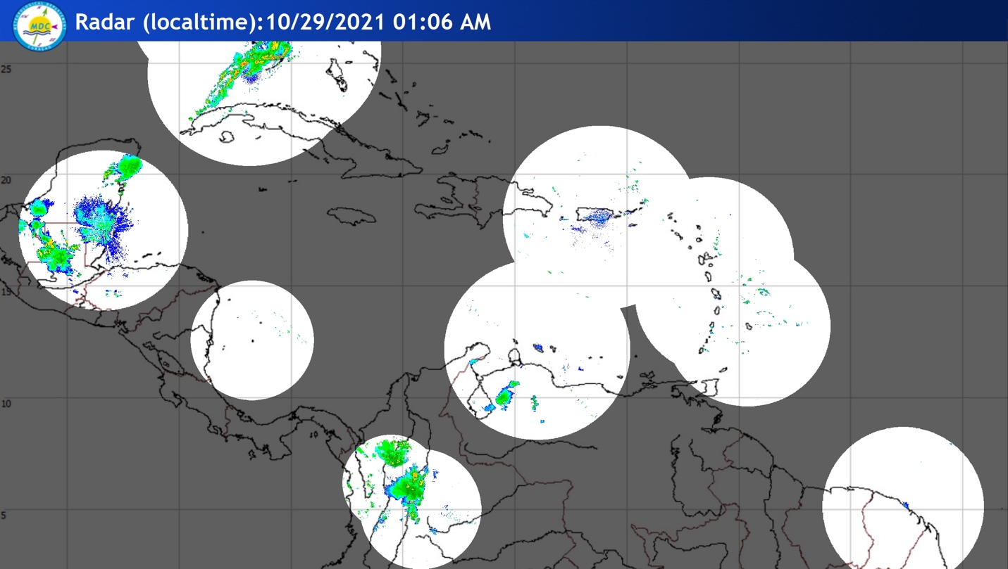

**Figure 3:** Curacao display of theRadar Composite created by Barbados (29 October 2021)

1. In this regard, Council should note the importance placed by the US National Hurricane Center in Miami on the imagery, both individually and as a composite, from the weather radars in CMO Member States. The National Hurricane Center indicated that radar data from the Caribbean and neighbouring areas were extremely important in determining the evolution of the several tropical storms and hurricanes that moved across this region and also allowed them to provide additional position updates as the cyclones approached land. The National Hurricane Center encourages the Meteorological Services to continue to make radar imagery from the region available operationally via operational telecommunication systems or via the Internet.
2. The Region should be aware that, through participation in the NOAA *Multi-Radar Multi-Sensor* (MRMS), the full volume radar data from the Cayman Islands and Belize have been assimilated into the numerical weather models of the *NOAA/National Centers for Environmental Prediction* (NCEP). This program benefits the region by improving the initial conditions in the NCEP models, such as the Global Forecast Systems (GFS) model, which are utilized by many Meteorological Services. MRMS develops specific products for transportation, hydrometeorology, and severe weather. The original data received from individual radars are not shared outside of NOAA/NCEP. The CMO HQ has been working with the MRMS project leaders to identify other potential collaborators as well as a mechanism by which CMO Member Services could receive training on the use of MRMS products in operations.
3. As part of the CREWS Caribbean Project implementation, the CMO Headquarters is coordinating the development of a Gridded Precipitation dataset comprised of radar, rain gauges, and satellite-estimated precipitation. The project is being implemented by the World Bank, through a contract with the Centro Internazionale in Monitoraggio Ambientale (CIMA) Foundation. The resulting dataset is expected to be a valuable regional resource for early warning systems, climate monitoring, risk analysis for flooding, and water resource management.
4. Council is also reminded that the CMO Radar Network has considerable potential for climate risk analysis and other scientific applications. Approaches for better utilizing of Caribbean radars and archived data, including setting up easy access to the full data archives; more usage would increase benefit to the region. For example, an archive of high-resolution radar rainfall estimates is valuable for understanding rainfall variability on the scale of small watersheds and provides improved flash flood guidance and knowledge of climatological extremes. With climate change, the Caribbean is expected to experience high variability in precipitation and radar information will offer guidance on the “new normal” for setting infrastructure standards and other necessary adaptation.
5. It is also important to note that additional weather radars are expected be installed by other regional States over the next few years that will increase coverage over some parts of the region and provide coverage in areas not currently covered by radars. One such example is the radar network in the Bahamas that was implemented in 2019 (**Figure 4**), which, when completed will cover the entire Archipelago, as well as portions of the Turks and Caicos Islands.

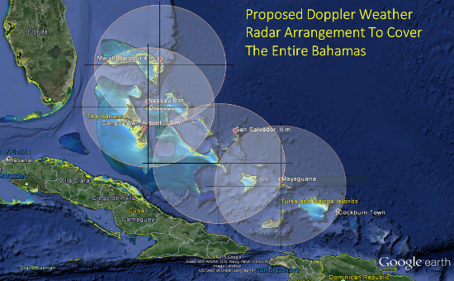

**Figure 4:** The Bahamas proposed dual polarized C-band Doppler Weather Radar Network

1. Discussions have begun in the Turks and Caicos Islands on the procurement of a radar joint facility of the Department of Disaster Management and Emergencies and the Turks and Caicos Airport Authority; to be compatible with being part of the Bahamas mosaic. The CMO Headquarters has been asked to provide advice on the project.

## (c) Operational Radar Working Group

1. Council would recall that at the 59th Council Session it approved the Terms of Reference for a ***CMO Operational Radar Group***. The first workshop that CMO Headquarters organized for 11-12 May 2020 was cancelled due to the pandemic. It will be rescheduled for 2022.

## (d) Upgrading CMO Radars to Dual Polarization

1. At the time when the Caribbean weather radar network was planned the technique of dual-polarization was in an emerging state. Today, the majority of radars being installed are equipped with dual-polarization capability, i.e., having both horizontally and vertically polarized beams. Dual-polarization is now the operational standard in the US National Weather Service, after a series of upgrades. Indeed, the Cayman Islands radar, installed in 2013, has dual-polarization and the new radar installed in Jamaica is a dual-polarized radar. The advantages of dual-polarization, compared with current weather radars, are:

* the effective removal of non-meteorological echoes, typically called clutter;
* significantly better quantitative rainfall estimates;
* the differentiation between very heavy rain and hail, which will improve flash flood watches and warning; and
* the potential to increase lead time for flash flood hazard warnings, because of greater confidence in dual-polarimetric radar data

1. Council will recall that the CMO Headquarters received its support to pursue funding for a capital project, with internationally-funded and tendered process, to obtain the necessary equipment to upgrade our radars to dual polarization. To that end, the Headquarters Unit began discussions with the Caribbean Development Bank about pursuing international climate grant financing. As a precursor to that activity, the CMO Headquarters has been coordinating with the World Bank CREWS Caribbean Project on a review of the CMO Radar Network. The CMO Science and Technology Officer (STO) was scheduled to work with the World Bank consultant on the study. The consultant’s visit to Trinidad and Tobago had been scheduled to coincide with the first workshop of the Operational Radar Working Group. Both activities were postponed due to the pandemic. The findings of the review will inform a proposal being drafted to seek funds to upgrade the CMO radars to dual polarization.
2. The Government of Barbados has approved the upgrading of the Barbados radar to dual polarization, which is scheduled for 2022. The Barbados Meteorological Service will be making spare parts from the current radar available to other Member States at a reduced price.

## (e) Repair Response and Radar Spare Parts

1. The CMO radars are now past ten years since installation and are increasingly malfunctioning, creating gaps in the regional warning system. There is a need for more consistent maintenance and repairs of the radars, as the originally-agreed local support has been variable. Local meteorological services cannot always affect rapid repairs due to budget constraints, the sometimes-high cost of parts, and the unpredictability of failures. The CMO Radar and Rawinsonde funds provides some support and the Operational Radar Working Group will aid in meeting some of the maintenance needs. These efforts do not always solve the need for having a more rapid response to unforeseen problems and the need for a larger spare parts repository. Setting up a fund and system for managing rapid repairs could eliminate many months of down time. Some funding could be negotiated in exchange for data access; akin to the approach of National Meteorological Services in other regions.

**Action Proposed to Council:**

15. The Council is invited to:

1. **Note** the status of the weather radars in the CMO Member States; including a new radar installed in 2021 and another scheduled to be installed in 2022.
2. **Reiterate** its call for the Meteorological Service operating radars to fully publicize their websites; for all Services to provide a link on their websites to relevant radars and composite loops, and to work towards the greater use of live radar data by regional television stations;
3. **Urge** Barbados to make a formal long-term commitment to the regional radar composite that it developed and to ensure its availability for contribution to the regional components of the *WMO Integrated Global Observing System* (WIGOS);
4. **Encourage** the Meteorological Service operating radars to participate in the NCEP Multi-Radar Multi-Sensor (MRMS) activities for the benefit of the region and the wider meteorological community;
5. **Note** the development of a prototype multi-sensor gridded precipitation product with radar data as the primary data source.
6. **Encourage** the archiving and access to the full set of radar data for flash flood guidance, climate services, and other scientific applications;
7. **Discuss** and **provide guidance** on the matters related to upgrading the weather radars;

___________

CMO Headquarters

October 2021