

C A R I B B E A N

M E T E O R O L O G I C A L

O R G A N I Z A T I O N

**CARIBBEAN METEOROLOGICAL COUNCIL** **Doc.3(a)**

FIFTY-NINTH SESSION

The Cove, ANGUILLA, 14-15 NOVEMBER 2019

**THE COORDINATING DIRECTOR’S REPORT - 2019**

**ON CMO HEADQUARTERS UNIT ACTIVITIES**

# (Submitted by the Coordinating Director)

1. This document highlights activities of the CMO Headquarters since the 58th session of the Council, held in Basseterre, St Kitts and Nevis on 15-16 November 2018. Factors affecting operational aspects at the Headquarters and other matters of interest are also mentioned for information and guidance where appropriate. Details of some activities and developments, where necessary, will be dealt with under separate agenda items.
2. Since the last session of the Caribbean Meteorological Council in November 2018, the major weather impacts in our region for 2019 has been the deadly and catastrophic Hurricane **Dorian**, which ravaged the Bahamas in September 2019 as shown in **Figure 1**. Elsewhere in the region, Member States that were severely impacted in 2017 continued in primarily in a recovery mode in 2019, with rebuilding efforts aided by fewer land falls and weaker tropical cyclones in 2019.

In the Caribbean/Atlantic basins, the seasonal average is 12 named storms, including six hurricanes, of which three would be major hurricanes. The first half of the hurricane season was relatively quiet with only three named storms up until the third week in August.

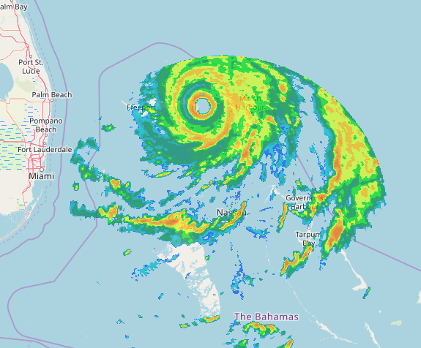

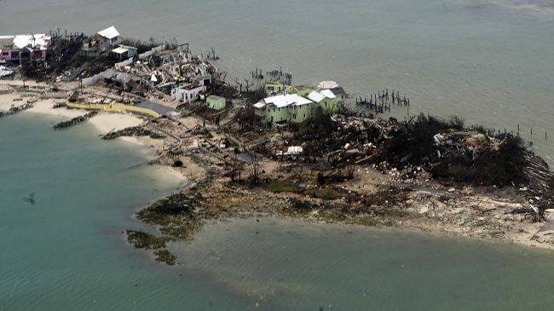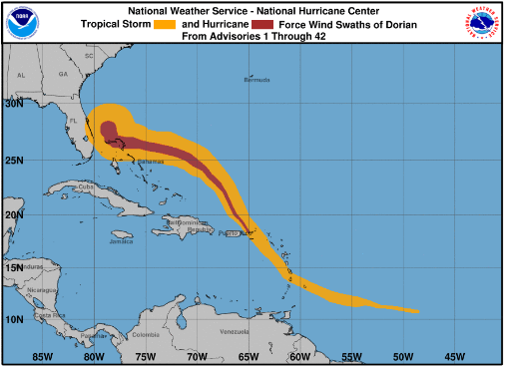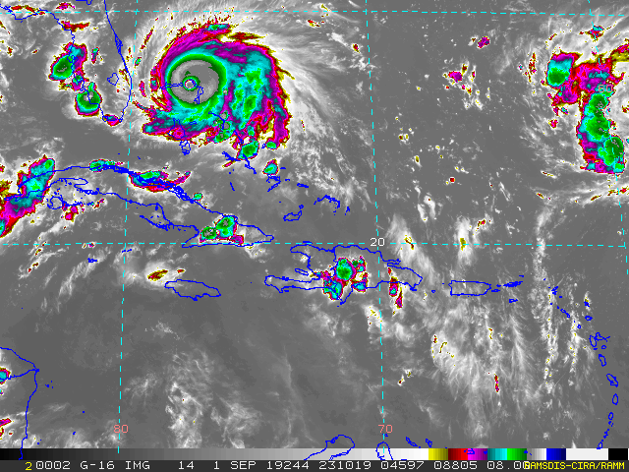

Figure 1. Wind history, enhanced satellite IR image, and base radar reflectivity of major Hurricane Dorian. The latter is courtesy of the Bahamas Meteorological Department. Photo credit (US Coast Guard).

1. The second half of the hurricane season could be described as starting with Dorian on 23rd August, when then Tropical Storm **Dorian** brought winds and rain to the islands of the Eastern Caribbean. As a Category 1 hurricane, Dorian was the first hurricane to pass by the Virgin Islands and Puerto Rico since 2017. Dorian gathered strength as it moved towards the Bahamas. After intensifying to a Category 5 Hurricane just east of the Bahamas, the powerful, record-breaking hurricane devastated Grand Bahama, with 185 mph winds, gusting to 220 mph; the strongest Atlantic hurricane at landfall. It then stalled over the Abaco Islands and lashed the islands with violent winds and high storm surge for more than one day. As of 1 October 2019, the numbers of fatalities from Dorian stood at 60, with hundreds missing. Three weeks after Dorian, the Windward Islands were affected by Tropical Storm **Karen**, which rapidly intensified from a tropical wave to a tropical storm in less than 24 hours. The center of Karen passed to the north of Grenada, bringing heavy rain and gusty winds to several Windward Islands and coastal South America. It weakened to a tropical depression while moving northward over the eastern Caribbean Sea. It re-intensified before making landfall in eastern Puerto Rico producing heavy rain and gusty winds over the Virgin Islands, Puerto Rico, and the Dominican Republic. During the September peak of the hurricane season, several weather systems were present in the Atlantic Ocean at the same time as Karen, including Hurricane Lorenzo. While a major hurricane over the north-east Atlantic that was heading towards Europe, Hurricane Lorenzo, nevertheless, produced the swells that reached theeast coast of North America and as far south as Trinidad and Tobago. The rip currents and rough seas along the Carolina coast were implicated in the tragic, drowning death of ***Dr William "Bill" Lapenta***, Director of the NOAA/ National Weather Service (NWS). National Centers for Environmental Prediction. Dr Lapenta oversaw nine prediction centers of the NWS, including the US National Hurricane Center (NHC) and his passing is a great loss for the global weather prediction community. It is also a personal loss for the Coordinating Director who had worked with Dr Lapenta at the Weather Prediction Center. A graphical preliminary summary of the 2019 Atlantic Tropical cyclone activity is shown in **ANNEX I**. The CMO Headquarters monitored the warnings issued by the main forecast offices in the region, along with the local alerts by the individual Meteorological Services as usual. The CMO Headquarters also conveyed to potentially affected states, the rainfall outlooks provided by the International Training Desk at the US Weather Prediction Center. The rainfall outlooks are supplementary information that is also shared with the NHC. The CMO Headquarters also shared other experimental, non-operational, high-resolution model guidance from the United Kingdom Met Office ensemble and High-Resolution Rapid Refresh (HRRR) model guidance over the Caribbean, from NOAA Earth System Research Laboratory.
2. After the 58th CMC Session, the CMO Headquarters focused on the transition of the office of Coordinating Director from ***Mr Tyrone Sutherland*** to *Dr Arlene Laing*. Mr Sutherland retired on 30 November 2019 and Dr Laing assumed office on 1 December 2018. A retirement luncheon was held for Mr Sutherland at the Hyatt Regency in Port of Spain on 30 November 2018. Several officials were present, including three retired Directors of the Trinidad and Tobago Meteorological Service, Mr Willis Mills, Mr Emmanuel Moolchan, and Mr Marlon Noel; Mr Shawn Boyce, representing Dr David Farrell, Principal of Caribbean Institute for Meteorology and Hydrology (CIMH); and retired CMO Administrative Officer, Ms Lynn Nimblett. Several tributes were made to Mr Sutherland and he was presented with a special gift from the staff of the Headquarters.
3. As one of the pillars of its mandate, the Caribbean Meteorological Organization must actively participate in World Meteorological Organization (WMO) activities so one of the first tasks of the new Coordinating Director was attending the 9th International Workshop on Tropical Cyclones held in Hawaii. The IWTC, held every four years, is a forum for knowledge exchange between tropical cyclone researchers and forecasters. The CMO delegation, which included Ms Margaret Mayers-Als of CIMH and Mr Dale Destin of the Antigua and Barbuda Meteorological Service, actively participated in the workshop and the CMO concerns and written contributions were reflected in the final set of recommendations submitted to the WMO Tropical Cyclone Program.
4. Bearing in mind the importance and multi-faceted nature of the functions of our National Meteorological and Hydrometeorological Services, the increasing demands for their services, and the wide range of their customer base, it is essential that their operations be underpinned and guided by comprehensive legislation. This legislation should clearly define their roles and responsibilities; the extent of their authority; their organizational structure and funding mechanisms; and provide a solid basis for defending them; and by extension their Governments, from litigation. Therefore, the CMO Headquarters has been collaborated with the Organization of Eastern Caribbean States (OECS), with the support of the CIMH, on a proposal for the drafting of harmonized model legislation for National Meteorological Services. The development of model legislation will be supported by the WMO *Climate Risk and Early Warning Systems (CREWS) Caribbean* project for the period 2020-2021.
5. The CMO Headquarters engaged with the *Regional Maritime Adviser of the International Maritime Organization* (IMO) as part of an outreach to the regional maritime community. CMO Headquarters conducted interviews with marine customers and forecasters, to understand their service needs and to guide WMO in developing new Marine Meteorology Service Delivery training to benefit regional forecasters. The interviews were delivered to the WMO in July 2019.
6. At CMC58, Council "*Resolved that the Member States Representatives of the Organization of Eastern Caribbean States (OECS) present at the Caribbean Meteorological Organization 58th Caribbean Meteorological Council call upon the Eastern Caribbean Civil Aviation Authority (ECCAA) to give priority to providing oversight and expanding regulatory support (even through outsourcing) to Quality Management Systems in the Meteorological Services of the various States in the OECS region*". The CMO Headquarters was tasked with conveying the resolution to the ECCAA, which was completed in May 2019, but to date, no response has been received from ECCAA. The lack of safety oversight has potential economic implications for airport operations of OECS States that are Members of the International Civil Aviation Organization (ICAO. Council may wish to determine what other avenues of intervention are available.
7. The CMO Headquarters was also occupied with the preparation for, participation in and follow-up to the 18th World Meteorological Congress, held in Geneva, Switzerland, 3-14 June 2019. The Congress is the supreme body of the WMO. Delegates of its Member States and Territories assemble every four years to set out the policies and programmes that impact on matters relating to weather, climate and water in every country of the world, whether large or small, developed or developing. Over the years, primarily because of cost, it has not been easy for some CMO Member States to actively participate routinely in WMO activities at the Congress level. It has, therefore, always been imperative for the Caribbean Meteorological Organization, as one of the pillars of its mandate, to actively participate in WMO activities at the highest level; to ensure that the interests of small developing states are accounted for and to guide and advise the CMO Member States in their own related activities. The Coordinating Director, who was provisionally elected to the WMO Executive Council in 2018, was accompanied to Congress by an experienced team of senior Advisors and Experts from the Headquarters and CIMH.
8. While details of the 18th WMO Congress will be discussed under Agenda Item 5, it is worth noting a few of the major items. A new strategic plan and a major governance reform of the WMO were approved by Congress. During a two-year transition period, the current variety of eight technical commissions will be replaced by two more coordinated commissions. Members are urged to contribute to a *Global Multi-hazard Alert System (GMAS)* that will compile information from existing or planned national and regional systems and boost impact-based forecasting services. Members are reminded of the compulsory implementation of the *WMO Integrated Global Observing System* (WIGOS), scheduled to be operational by 2020. Decisions were also made by Congress concerning the governance of the *Global Framework for Climate Services,* which have special implications for institutions of the CMO. Congress approved a *Country Support Initiative*, whereby WMO will support NMHSs in accessing development and climate financing. Additionally, special emphasis has been placed on support for regional operations and capacity development as well as greater and controlled engagement with the *private sector and academia*
9. It is also useful to highlight the many activities of the CMO Headquarters and CIMH that continued to be aimed at regional implementation of global programmes and initiatives, particularly those set in motion by the WMO as they relate to the Caribbean region in general and CMO Member States in particular. Among these continues to be support for WMO regional activities related to the *WMO Integrated Global Observing System* (WIGOS), which continued in its Pre-Operational Phase (2016-2019) and has been scheduled to go into full operations in 2020. The Science and Technology Officer at the CMO Headquarters continues to lead the Regional Task Team for the regional implementation of WIGOS. The Coordinating Director represented WMO RA IV in the 8th Meeting of the *Inter-Commission Group on WIGOS* (ICG-WIGOS) in January 2019. The CMO Headquarters, CIMH, and some of the National Meteorological Services in the region have been working with the WMO Secretariat to develop other project activities to advance the implementation of WIGOS in the region, including the organization of the Global Climate Observing System workshop in Belize in July 2019. Further WIGOS activities will be discussed under the relevant agenda item.
10. Recognizing the potential negative effects of new International Mobile Telecommunications technology on weather observations and forecasts, Congress passed a resolution expressing its “serious concern at the continuing threat to several radio-frequency bands allocated to the meteorological aids, meteorological-satellite, Earth exploration satellite and radiolocation (weather and wind profiler radars) services posed by the development of other radio communication services.” Following the urging of Congress, the CMO Headquarters made a formal appeal to the *Caribbean Telecommunications Union* (CTU) to protect these radio frequencies that are critical to the accuracy of weather forecasts and the safeguarding of lives, livelihoods. The CTU gave favourable consideration to CMO's appeal and recommended that its Members support regional proposals, for the next World Radio Communications Conference, that promote safety and safety related services, inclusive of meteorological and related environmental observations. The World Radio Communications conference is scheduled for 28 October to 22 November in Egypt.

1. The CMO Headquarters continued its collaboration with the Caribbean Community Secretariat on aspects of the *Caribbean Community Strategic Plan 2020* and the establishment of a Results-based Management System (RBMS) by all community institutions. A virtual meeting on this matter was organized in February 2019, in which the CMO Headquarters and all institutions of CARICOM participated, along with the Secretariat. In that meeting, the *Caribbean Disaster and Emergency Management Agency* (CDEMA), presented on its experience with using the RBMS. The Coordinating Director also attended a sensitization meeting on the RBMS system, held in April in Port of Spain for Community Institutions based in Trinidad and Tobago. The CMO Headquarters has reported to the CARICOM Secretariat on its progress in implementation of the RBMS. In keeping with this approach, which is also used by the WMO, the CMO Headquarters drafted the CMO Strategic Plan for 2020-2023 using the RBMS. The new CMO Strategic Plan, which will be presented to Council for its approval, after which it will be linked to the Community Plan.
2. One of the main challenges identified as affecting the implementation of the Community Strategic Plan is the capacity of Member States to implement regional initiatives at the national level. To aid in strengthening the capacity at the national level, the CMO Headquarters is collaborating with the WMO CREWS Caribbean Project to help CMO Member States to develop Strategic Plans for their National Meteorological Services. Details will be provided under Agenda Item 11.
3. Council will recall its discussions over the last few years concerning the establishment of a *Caribbean Community Administrative Tribunal* (CCAT). The primary purpose of CCAT is to develop a dispute settlement process for Community institutions. In February 2019, the Heads of Government of the Caribbean Community adopted the CCAT Statute and the CCAT is scheduled to be launched on 30 January 2020. Council should note that the Coordinating Director is a Member of the CCAT Steering Committee, which is responsible for organizing the launch of the CCAT. That Committee, led by the Caribbean Court of Justice, held regular virtual meetings to organize the launch and its associated activities. The governing bodies of the Community Institutions have been requested to sign the Declaration indicating their approval to submit to the jurisdiction of the CCAT by the launch date. A training session for regional institutions will be held in conjunction with the launch. On the financial arrangements for the operations of CCAT, Council agreed that the overall CMO contribution for both the CMO Headquarters and the CIMH be included in the budget of the CMO Headquarters and not in the budgets of both Organs. At CMC58, Council authorized the Coordinating Director to sign the legal documents submitting the Organization to the jurisdiction of the CCAT. Given the differences in the size and governance of staff at the CIMH, compared with the CMO Headquarters, the Principal of the CIMH has indicated that he would like the Council to revisit that decision.
4. During CMC58, Council began formal discussions about the status of the *Caribbean Meteorological Foundation* (CMF), following informal discussions during the previous few sessions of the Council. The Organs of the Caribbean Meteorological Organization are the *Caribbean Meteorological Council* (CMC), the *Headquarters Unit*, the *Caribbean Institute for Meteorology and Hydrology* (CIMH) and the *Caribbean Meteorological Foundation* (CMF), which has never really been functional. Its *Purpose and Functions* are defined as:

1. The purpose of the Foundation is to raise funds for the promotion through the Institute of the study and research of meteorology and allied sciences.

2. The Foundation shall perform such other functions and have such powers as the Council may entrust to it.”

The Council discussed the purpose and functions of the CMF and noted that further review on this matter was needed before Council could provide a policy on the way forward. To that end, the Coordinating Director sought guidance from the Office of the General Counsel of CARICOM, on the interpretation of the second purpose and function of the CMF (**ANNEX II**). The CARICOM General Counsel has advised that "Article 21 (2) allows for other functions to be ascribed to the Foundation.  Such functions would be related to or follow along similar or related lines as the main specified function or functions." The Office of the General Counsel cited examples of such other functions, from among those that were mentioned in CMC58 Doc 3(a), ANNEX II: *Talking Points: Re-Implementation of the Caribbean Meteorological Foundation (CMF)*".

1. The Council may wish to hold further discussion on the re-implementation of the CMF, in light of the legal advice that has been received. It is not clear why the CMF did not develop as a functioning organ of the CMO; although it has been speculated that raising of funds for research was not a priority of regional governments in the early years of the CMO and that persons responsible for raising funds were unsuited to the task. In recent decades, the importance of funding research has been recognized but primarily implemented through projects and partnerships, i.e., without the CMF. Since the CIMH has tapped into other funding sources for its research, the first purpose and function of the CMF seems to be superfluous. Nevertheless, discussion at CMC58 indicated interest in having a functioning CMF for other related purposes as articulated in ANNEX II. However, Council would need to give careful consideration to the return on investment of the effort that would be required and whether the needs articulated could be met by other means.
2. It should be noted that the Coordinating Director was invited to give the 2019 Tarbell Lecture in the Department of Meteorology and Atmospheric Sciences, Pennsylvania State University. The lecture, entitled, *Caribbean Weather and Climate: Opportunities and Challenges in Research, Applications, and Operational Forecasting*, was a vehicle for recruitment to the Caribbean and for developing collaboration. The visit has already borne fruit, with students expressing interest in internships at the CIMH and professors wanting to explore collaborative programs with CIMH and the CMO Headquarters Unit.
3. Council is asked to note that, by the end of September 2019, the level of financial contributions received from Member States had improved over last year, standing at 74% compared with only 60% at the same period in 2018. A few Member States were able to make specific contributions to arrears. More importantly, the delay and in some cases the outright failure, by a few of the larger Member States to make their contributions had a negative impact on the operations of the CMO Headquarters in 2019. In addition, there were seven Member States that failed to meet their current obligations up to that time, although one Member did clear all outstanding arrears for prior years. Details will be discussed under Agenda item 6(c). It is important to note that, with a lower than normal level of Member contributions, some approved activities had to be postponed until the situation permitted, such as the inaugural meeting for the establishment of the *CMO Operational Radar Working Group* and the hiring of an *International Affairs Officer*.
4. **ANNEX III** to this Document indicates meetings and other events attended (or scheduled attendance) by officers of the CMO Headquarters in 2019. This schedule of activities undertaken by the CMO Headquarters to-date was relatively heavy this year, comprising of primarily of a mix of CMO and WMO-related regional implementation activities Several regional meetings were related to disaster risk and Multi-Hazard Early Warning Systems in the Caribbean. The Coordinating Director, took advantage of meetings organized by others to introduce herself to the region, to develop familiarity with regional institutions, and to carry out some CMO activities, including courtesy visits to National Meteorological Services of CMO Member State,
5. The CMO Headquarters continues to promote the participation in as many scientific, technical and training events as possible by the National Meteorological and Hydrometeorological Services and the CIMH, particularly those sponsored by the WMO and its partners that have a special relevance to the region. The list below shows the events that the Coordinating Director was able to facilitate in 2019:
6. **WMO** *2019 Management Group Meeting of the Commission for Aeronautical Meteorology* (CAeM), Melbourne, Australia, 12-15 February *[Ms Kathy-Ann Caesar, CIMH]*
7. **WMO** Technical Conference on Future Priorities and Arrangement and the Extraordinary session of the Commission for Hydrology, Geneva, Switzerland, 11-14 February 2019 [*Dr David Farrell, CIMH*]
8. **WMO** RA IV Hurricane Committee [*Mr Hubert Whyte, Grenada*]
9. ***WMO/Eumetcal*** *2019 Advanced Online Course for Trainers of RA VI: Blended Learning,* 29 April - 31 May 2019 [*Mr John Peters, Mr Grahame Niles, CIMH*]
10. **WMO** Commission for Climatology (CCl)/Commission for Basic Systems (CBS) Inter-Programme Expert Team on Regional Climate Activities (IPET-RCA), Geneva, Switzerland, 29 April - 1 May [Mr *Adrian Trotman, CIMH]*
11. **WMO** Second A Multi-Hazard Early Warning Conference (MHEWC-II) Geneva, Switzerland, 13-14 May 2019 [*Mr Billy Jeffers, St Vincent and the Grenadines*]
12. **WMO**Regional Workshop – Caribbean GCOS/WIGOS in collaboration with UNFCCC. Belize, 10-12 July [*Multiple participants]*
13. **WMO** Training Development Workshop and 2019 CALMet/Eumetcal Conference. 16-20 September. Germany [*Mr John Peters, Mr Grahame Niles, CIMH*]
14. **NOAA**, WMO VCP, RSMC Hurricane Attachment, Miami, FL, USA, 26-30 August 2019 [*Shamal Clarke, Cayman Islands*]
15. **NOAA**, WMO Regional Climate Center (RCC)–Washington First International Training Workshop, College Park, MD, USA, 30 September – 4 October [*Multiple participants*]
16. **NOAA**, WMO VCP, RSMC Hurricane Attachment, Miami, FL, USA, 30 September to 4 October [*Mr Gilbert Miller Tayler, Cayman Islands*]**WMO**, 2019 Common Alerting Protocol (CAP) Implementation Workshop, Mexico City, 17-18 October [*Mr Shawn Boyce, CIMH*]
17. Council is asked to congratulate ***Mr Evan Thompson***, Director of the Meteorological Service of Jamaica, in his new role as ***Vice President of WMO RA IV***. Mr Thompson replaced *Dr Albert Martis*, who was elected as Second Vice President of WMO during the 18th WMO Congress.
18. Council lauded the outgoing Coordinating Director, ***Mr Tyrone Sutherland***, on his retirement, which became effective on 30 November 2018, after an international career spanning 50 years.

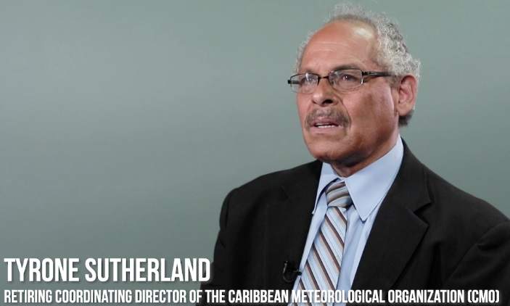He has been well recognized for his strong support for developing countries and Small Island Developing States in the Caribbean and around the world and for the transfer of appropriate technologies to the Caribbean. The CMO Headquarters orchestrated the production of a video feature celebrating his 50 years in meteorology that was aired on CaribVision, which broadcasts across the region and in some areas of North America. The television feature, which included an interview with Mr Peter Richards of the Caribbean Media Corporation and tributes from Mr Sutherland’s friends and colleagues from around the world, was presented on DVDs to Mr Sutherland and to those who contributed tributes.

1. 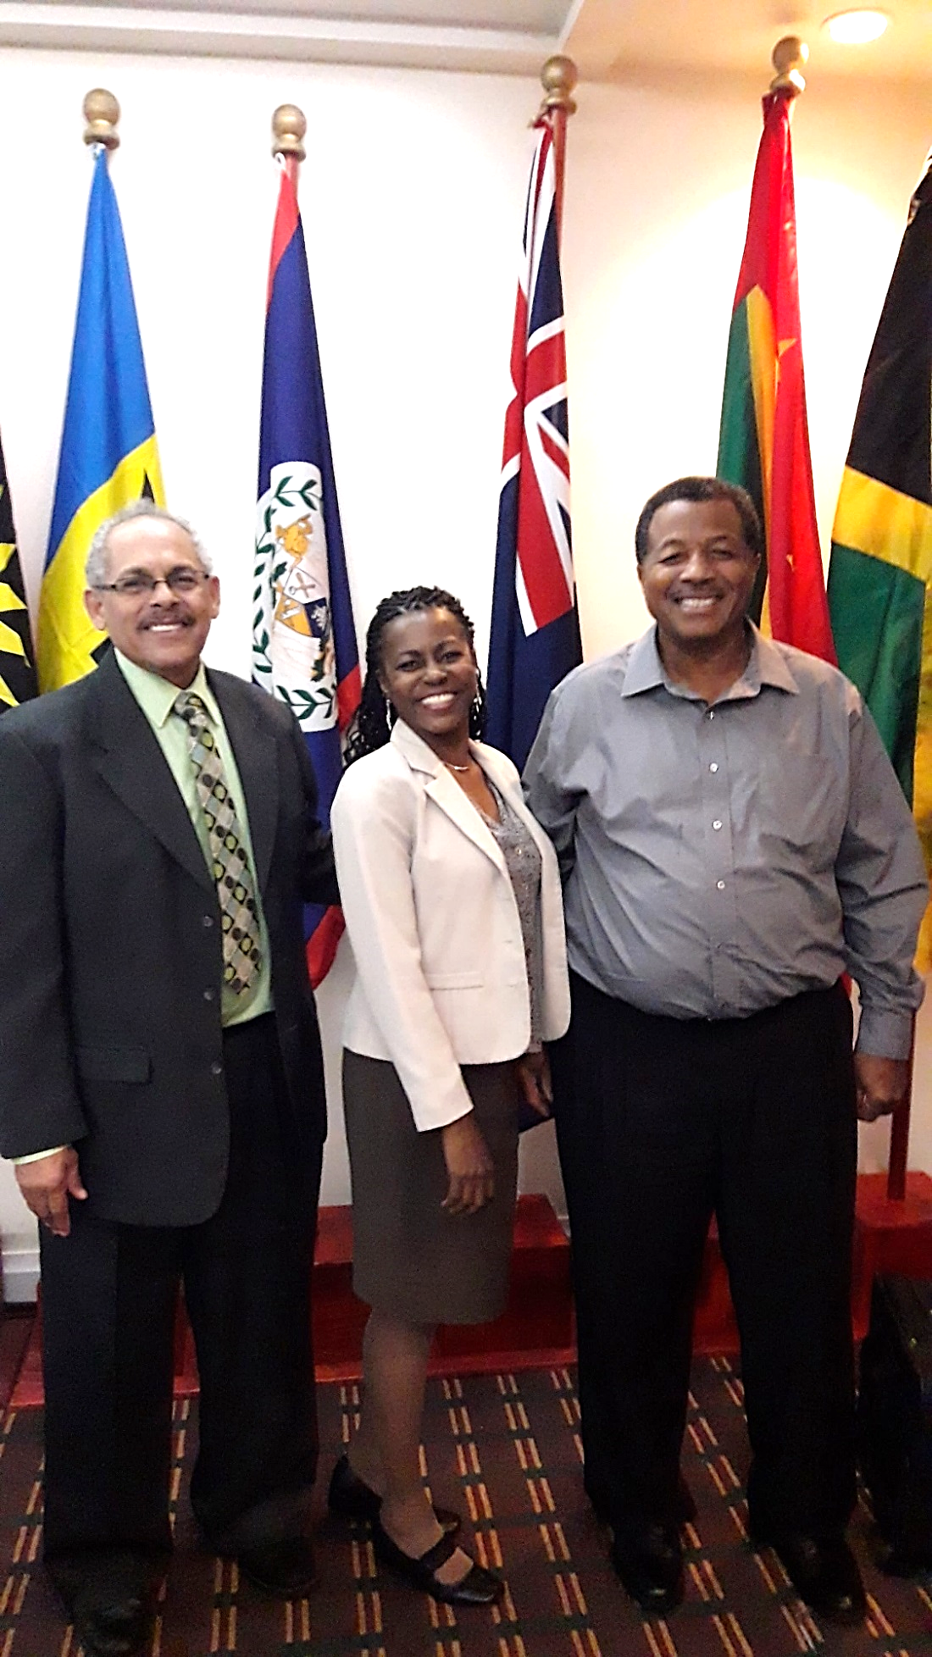Council may wish to take note of other regional players who demitted office in 2019. ***Mr Keithley Meade*** retired as the Director of the Antigua and Barbuda Meteorological Service in November 2019 after a period of pre-retirement leave starting in May 2019. Mr Meade, joined the service as an observer in 1980, rose through the ranks to become a Climatologist in 1997 and the Director in 2008, serving until his retirement in 2019.

Along with way, he gained a BSc in Meteorology and Computer Science from the University of the West Indies in 1999, an MS in Computer Software and Information Systems from Regis University, and various other certifications including a Higher Technicians Certificate in Hydrology from CIMH and Management certification.

Mr Meade was active in the international meteorological community, serving as the Deputy Co-Chairman of the WMO Regional Hurricane Committee and on the Regional Sub-project Management Team for the Severe Weather Forecast Demonstration Project - Eastern Caribbean. He was an Advisor to the Coordinating Director at a session of the WMO Executive Council in Geneva, Switzerland. In these roles, he gained the respect and admiration of professional colleagues the world over for his contribution and friendly personality.

***Mrs Corsel Robertson*** retired as Director of Airports, Government of St Vincent and the Grenadines. Mrs Robertson has served in that position since 2006, with responsibility for the Management and Operation of four Government owned airports. She has been an active participant in CMC Sessions from her acceptance of the position and recently served as the Chair of the Human Resources Committee of the Council, including chairing the search for the Coordinating Director's position. Mrs Robertson was honoured with an O.B.E in December 2018 for services to civil aviation.

1. The CMO Headquarters congratulates two new heads of National Meteorological Services who assumed office in 2019: ***Mr Dale Destin***, Director (Ag) of the Antigua and Barbuda Meteorological Service, and ***Mr Andre Joyeux***, Director of the Saint Lucia Meteorological Services. It also congratulates ***Ms Andrea Best***, the new Director of Airports (Ag), Government of St Vincent and the Grenadines.

**Action Proposed to Council:**

20. **The Council is invited to**:

1. **Note** the activities and issues concerning the CMO Headquarters in 2019 as well as those issues concerning the wider Caribbean Community;
2. **Discuss** the impact of the 2019 hurricane season on the region and, in particular, the impact on CMO Member States;
3. **Rescind** the authorization given at CMC58 to the Coordinating Director to sign the Declaration of Recognition of the Jurisdiction of the Caribbean Community Administrative Tribunal (CCAT) on behalf of the Organization
4. **Approve** the signing of the Declaration of Recognition of the Jurisdiction of the Caribbean Community Administrative Tribunal (CCAT) by the Coordinating Director on behalf of the CMO Headquarters, and by the Principal of the CIMH on behalf of CIMH**.**
5. **Discuss** and **provide guidance** on matters pertaining to the Caribbean Meteorological Foundation.

_________

CMO Headquarters

November 2019

# Preliminary Atlantic Tropical Cyclone Tracks

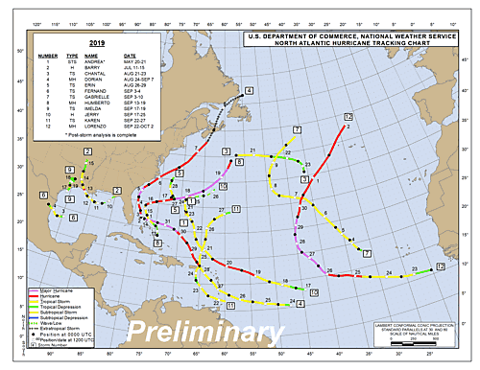

**Figure 3**: 2019 Tropical Storms and Hurricane tracks (preliminary) in the Atlantic-Caribbean basin to 2 October (courtesy NOAA/NHC)

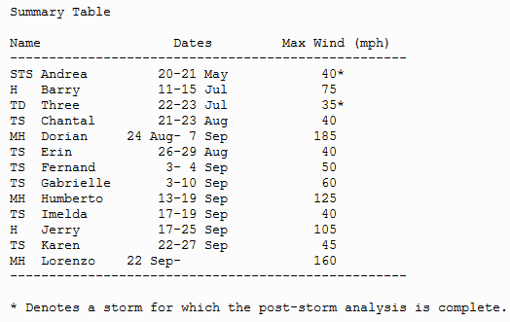

# Discussion Points: The Caribbean Meteorological Foundation (CMF)

The Caribbean Meteorological Organization was established by Acts of Parliament in *sixteen Member States of the Commonwealth Caribbean*. **ARTICLE 6** of the relevant Acts of Parliament shows the Organs of the CMO, namely :

(a) the Caribbean Meteorological Council

(b) the Caribbean Meteorological Institute

(c) the Caribbean Meteorological Foundation

(d) the Headquarters Unit.

However, the Caribbean Meteorological Foundation (CMF) remains outstanding for its lack of implementation as a functioning organ of the CMO. In light of limited government resources for weather, water, and climate services, CMO Member States have asked about the role of the CMF in helping them to achieve their missions.

Articles 19 to 21 elaborate as follows:

**ARTICLE 19**: The Foundation

The Foundation shall be established with the membership, powers and functions hereinafter set out.

**ARTICLE 20**: Membership and Management

1. Membership of the Foundation shall be limited to persons nominated by the Council.

2. The management of the Foundation shall be vested in a Board of Management which shall consist of persons appointed by the Council due regard being had to the principle of equitable geographical distribution.

**ARTICLE 21**: Purpose and Functions

1. The purpose of the Foundation is to raise funds for the promotion through the Institute of the study and research of meteorology and allied sciences.

2. The Foundation shall perform such other functions and have such powers as the Council may entrust to it.”

Legal advice was sought from the CARICOM's Office of General Counsel on Article 21 (2), in order for the CMF to benefit all of CMO. Annex II from CMC58 Doc 3(a) was provided as background material to the Office of the General Counsel, who advised that:

*Article 21 (2) allows for other functions to be ascribed to the Foundation.  Such functions would be related to or follow along similar or related lines as the main specified function or functions.*

*Examples of such other functions of the CMF (some of which are mentioned in the Talking Points: Re-Implementation of the Caribbean Meteorological Foundation (CMF)) would be to:*

*i.      identify potential partnerships, clients and sponsors;*

*ii.     facilitate discussions and negotiate and recommend MOUs and other agreements governing the provision of funds for approval by the Council (Article 9 (2));*

*iii.    facilitate public-private partnerships (e.g., the UCAR Foundation provides supplemental support or provides pilot funds for projects at NCAR);*

*iv.    Recommend the provision, through appropriate organisations or otherwise, grants, scholarships, bursaries or loans to persons for study or research of meteorology and allied sciences.*

# 2019 CMO HQ Missions

##### (Not related to the CMC meetings)

January 6-11 99th **American Meteorological Society (AMS)** Annual Meeting**,** Phoenix, AZ, USA [*CD*]

January 11 **WMO/NOAA-NWS International Session,** Phoenix, AZ, USA [*CD*]

January 24-26 ***WMO Inter-Commission Coordination Group on WIGOS*** *(ICG-WIGOS), 8th Session, WMO Secretariat, Geneva [CD]*

January 30 **CMO**, Courtesy Visits to the Saint Lucia Meteorological Service and the Organization of Eastern Caribbean States (OECS), Saint Lucia [*CD*]

January 31 **CDEMA**, Regional Early Warning Systems Consortium Meeting, Saint Lucia [*CD*]

1 February **CDEMA** , Multi-Hazard Early Warning Systems in the Caribbean: Multi-Hazard Early Warning Systems: Achievements and Strategic Path Forward, Saint Lucia [*CD*]

February 16 **CMO** - *EUREC4A Field Study: Launch and Coordination Planning*, CIMH, Barbados [*CD*]

March 14-15 **CCRIF,** *2019 Technical Models Workshop*, Caribbean Development Bank, Barbados [CD]

March 18-22 **WMO**, RA IV Hurricane Committee Meeting, Curacao [*CD & STO*]

April ***CARICOM***, Sensitization Meeting on Results-Based Management System (RBMS), Port of Spain, Trinidad and Tobago

April 29 **Caribbean Telecommunication Union** (CTU) 30th Anniversary, Trinidad and Tobago [*CD*]

May 20 ***CARICOM*** *- Ninth Meeting of the Secretary-General, Caribbean Community and Heads of Community Institutions, Georgetown, Guyana [CD]*

May 21-22 **CMO**, Courtesy Visits to the *Guyana Hydrometeorological Service*, the *Ministry of Agriculture*, and the *CARICOM Secretariat*

May 20 Meeting on Hosting CMC59, Anguilla [STO]

May 21-22 **CIMH** *- 6th Meeting of the Consortium of Regional Sectoral EWISACTs Coordination Partners in conjunction with*

May 23-24 **CIMH** - 2019 Wet/Hurricane Season *Caribbean Climate Outlook Forum* (CariCOF), Sint Maarten *[STO]*

May 27-30 **CDEMA** - in collaboration with the World Bank and the European Union, *Understanding Risk Caribbean Conference*, Barbados [*CD*]

June 3-14 **18th WMO Congress** (Cg-18), Geneva [*CD, P/CIMH, STO, S Boyce, CIMH*]

*followed by*

June 17-19 *71st Session* of the **WMO Executive Council,** Geneva, [*CD*]

July 3 **CMO** - 40th Meeting of the ***Conference of the CARICOM Heads of Government***, Saint Lucia [*CD*]

July 23-24 **CMO** - *10th Meeting of the CARICOM Community and United Nations System,* Guyana [*STO*]

September 3-5 **UNESCO** *Meeting on Local and Indigenous Knowledge for Understanding Climate Impacts and Vulnerabilities*, Georgetown,Guyana [*CD*]

September 25-27 **CDEMA**, 4th Regional Early Warning Systems Consortium Meeting, Barbados [*CD*]

Sept. 28 - October 4 **WMO** Meeting of *Coordination Group on Satellite Data Requirements for Regional Association III and IV (RA-III-IV-****SDR****)*

*in conjunction with the*

Joint AMS/EUMETSAT/NOAA Satellite Conference [*STO*]

October 1-3 **The Pennsylvania State University**, *2019 Tarbell Lecturer, Department of Meteorology and Atmospheric Sciences*, [*CD*]

October 17-18 **OECS**, Forecast-based Action Workshop, Saint Lucia [*STO*]

October 31 **Association of Caribbean States (ACS)**, 25th Anniversary and Excellence Lecture , Port of Spain, Trinidad and Tobago [*CD*]

November 6-8 Varysian-CMO *Caribbean Symposium 2019: Operational Hydrometeorology Leadership Summit*, Christchurch, Barbados [*CD*]

- - - - - - - - - - - - - - - - - - - - - - - - - - - - - - - - - - - - - - - - - - - - - - - - - - - - - - - - - - - - -- - - - - - - - - - - - -

November 25-27 **CIMH***- 7th Meeting of the Consortium of Regional Sectoral EWISACTs Coordination Partners*, Port of Spain, Trinidad and Tobago [*CD & STO]*

*in conjunction with*

November 27-29 **CIMH** - 2019 Dry Season Caribbean Climate Outlook Forum (CariCOF), Port of Spain, Trinidad and Tobago *[STO]*