

C A R I B B E A N

M E T E O R O L O G I C A L

O R G A N I Z A T I O N

**CARIBBEAN METEOROLOGICAL COUNCIL** **Doc. 11**

FIFTY-NINTH SESSION

The Cove, ANGUILLA, 14-15 NOVEMBER 2019

##### PROJECT UPDATES AND PROPOSALS

(Submitted by the Coordinating Director)

# Introduction

1. Weather, climate and water are at the heart of the environmental issues affecting the planet. National Meteorological and Hydrometeorological Services (NMHSs) in the Caribbean and the world over must provide accurate information, analyses and timely forecasts of hazardous weather-related conditions that affect the sustainable development of their nations in the short term. At the same time, the NMHSs must provide the appropriate data and scientific-basis for studies on the long-term potential impacts of both natural and human-induced climate change on the environment. The contribution of meteorology and related sciences to these global studies is driven by the constant adaptation to and use of technological changes and opportunities.
2. In this regard, many of the projects being undertaken or planned have observational and scientific data information components involving the use of new or modern technologies. This is primarily an information document intended to keep the Council up-to-date on the status and/or progress of implementation on any projects of this nature, which involve CMO Member States and partner organizations, such as the *World Meteorological Organization* (WMO) and Universities. The document provides information on the following:

# (a) WMO Severe Weather Forecasting Programme (SWFP)

1. Council has recognized the need to improve the weather warning system, particularly for episodes of severe weather that may not be the result of a tropical cyclone and could occur at any time of year. Council will recall that, in November 2015, it endorsed a proposal by CMO and partners to implement a WMO ***Severe Weather Forecasting Demonstration Project*** (SWFDP) in parts of the Caribbean, with an aim, among others, to foster greater collaboration among National Meteorological Services and Disaster Management Agencies. Since that time, significant strides have been made towards the implementation of the SWFDP in the Eastern Caribbean. The WMO Secretariat, the CMO Headquarters supported by the CIMH, and the Meteorological Service of France, through its centre in Martinique, have been preparing for the official start of the Project.
2. In this regard, the Regional WMO Management structure established a *Regional Subproject Management Team* (RSMT) for the development and implementation of the SWFDP. The Coordinating Director co-chairs the RSMT with an expert from France. Other CMO representatives on the RMST include Ms Kathy-Ann Caesar of the CIMH and Mr Keithley Meade of Antigua and Barbuda, until his retirement in 2019. Mr Dale Destin, Director (Ag) of the Antigua and Barbuda Meteorological Service, has indicated his willingness to serve and it is hoped that he will become involved in the near future. It will be recalled that the WMO Severe Weather Demonstration Project was being developed along the following lines:

(i) The SWFDP would cover all the islands from Trinidad in the south to Puerto Rico in the North, with special arrangements for Haiti;

(ii) The Météo-France Centre in Martinique will serve as the *Regional Forecast Support Facility* (RFSF) for the Project;

(iii) The Caribbean Institute for Meteorology and Hydrology (CIMH) will provide technical support for the SWFDP.

1. SWFDP implementation in the Eastern Caribbean has been made possible by seed funding from Canada through the WMO CREWS (Climate Risk and Early Warning Systems) Project. The SWFDP was being developed in four phases: 1) Overall Planning; 2) Implementation plan development and execution; 3) Demonstration and 4) Operational (no longer a project). Phase 3 and 4 include capacity building through training of meteorologists, public weather service focal points and the media.
2. A satellite meteorology workshop, held in July 2019 at CIMH, also supported training for the SWFDP, helping forecasters from participating Member States to develop and improve their skill in the use of satellite products for severe weather forecasting. Additional training will be conducted in December 2019, as a part of a Caribbean Weather Forecasting Initiative to support the EUREC4A field study. More details are provided under Item (c) below.
3. A pre-operational Demonstration (testing) Phase was initiated in 2019, with the development of a Web-based platform for data/products sharing (e.g., figure below). National Meteorological Services of Member States were provided with a license and access to the platform.

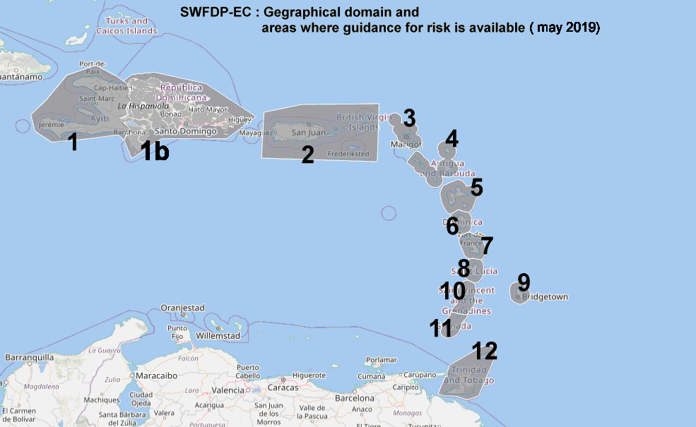

1. In March 2019, the *Regional Subproject Management Team* had a side-meeting in conjunction with the Regional Hurricane Committee Meeting to examine progress made at the at the *Regional Forecast Support Facility* (Météo-France Martinique), including the development of the Web-based platform for data/products sharing, to produce severe weather guidance, and to ensure real-time coordination.
2. The RSMT held a virtual meeting in May to review its *Regional Sub-Project Implementation Plan* (RSIP) and discuss matters arising from the meeting in Curacao. One critical issue was the responsibility of the *Regional Forecast Support Facility* when a tropical cyclone is in the domain. The Regional Specialized Meteorological Center (RSMC)–Miami is responsible for tropical cyclone forecast and warning services. While the RFSF Martinique has clear responsibility outside of the hurricane season, the distinction of what is non-tropical cyclonic severe weather is not always clear when a tropical cyclone is in the domain. Therefore, it is necessary to develop procedures for distinguishing areas of responsibility for each regional centre in cases where that distinction is ambiguous. Council will recognize that maximizing the benefits of the SWFP, requires a better understanding of the needs of each country for forecasting and warning of severe weather and to determine the gaps in capability and the necessary resources, services and training needed to improve that capability.
3. In order to address both of these issues raised, the Coordinating Director developed an internship project to determine the severe weather warning needs and capabilities of participating States and also identified a sample of ambiguous cases of tropical cyclones and recommend procedures for assigning responsibility between the two regional centres. CMO Headquarters hosted an intern, funded by the Caribbean Catastrophic Insurance Risk Facility (CCRIF), who researched the two topics, under the supervision of the Coordinating Director. WMO provided funding for the intern to visit the RFSF in Martinique to learn more about their facilities. A written report and Powerpoint presentations of the findings and recommendations were submitted to the WMO. The report and presentations will be reviewed at the next meeting of the Regional Sub-Project Management Team of the SWFP and shared with the Regional Hurricane Committee.
4. Council will recall that the WMO Expert Group on the SWFDP identified the *Caribbean Meteorological Organization* (CMO), through its Headquarters and Organs, as the regional entity to support the SWFDP in the operational phase.

## (b) Building Resilience to High-Impact Hydro-meteorological Events through Strengthening MHEWS in Small Island Developing States (SIDS) in the Caribbean

1. Council will recall presentations from CMC58 about the Climate Risk and Early Warning System (CREWS) Caribbean Project, co-funded by the CREWS Initiative, and Environment and Climate Change Canada (ECCC). The aim of the CREWS-Caribbean project is to strengthen and streamline regional and national systems and capacity related to weather forecasting, hydrological services, multi-hazard impact based warnings and service delivery for enhanced decision-making in CARICOM countries.

1. The implementing partners are the World Meteorological Organization (WMO), the Global Facility for Disaster Reduction and Recovery (GFDRR), the United Nations Office for Disaster Risk Reduction (UNDRR), and the World Bank Group (WBG). The primary partners are the CIMH and the Caribbean Disaster and Emergency Management Agency (CDEMA), The Project has three components: Component 1) Development of regional strategy for EWS; Component 2) Institutional Strengthening and streamlining of early warning and hydromet services; and Component 3) Support for Piloting High Priority National Activities.
2. The CMO Headquarters and the WMO are developing a Letter of Agreement (LoA) for the partial delivery of the CREWS-Caribbean Project Component 2 - *Institutional Strengthening and streamlining of early warning and hydromet services.* This sub-project will help create an enabling environment for National Meteorological and Hydrological Services (NMHS) of CMO Member States through the development of their National Strategic Plans (NSPs) and Model Legislation that can be used by all NMHSs and their Governments to formally establish the legal mandate for their services. The proposal for the consultancy to draft the meteorological bill was developed in collaboration with the Organization of Eastern Caribbean States (OECS), with support from the CIMH. The project is scheduled to start in early 2020.

## (c) Caribbean Weather Forecasting Initiative

1. Through a partnership between the Caribbean Meteorological Organization (CMO) and the University of Leeds, a *Caribbean Weather Forecasting Initiative,* will support *EUREC4A-ATOMIC*, an international field study that is led by France and Germany; with the Caribbean Institute for Meteorology and Hydrology (CIMH) as one of the lead institutions. The field campaign will be held 20 January to 20 February 2020 and will be based out of Barbados. The initiative is supported by a grant from the Natural Environment Research Council (NERC), United Kingdom, and the WMO Climate Risk and Early Warning Systems (CREWS) Caribbean Project.
2. Council will note the benefits to the National Meteorological Services in the Caribbean**,** whichwill gain enhanced capability in understanding local weather, such as localized storms, through training workshops and weather forecast “test-beds". A knowledge exchange workshop before the EUREC4A field campaign will bring together researchers and forecasters to introduce the particular science and weather to be studied in EUREC4A. During the forecast testbed, the participants will work in dispersed teams, collaborating via online communication systems to deliver weather forecasts for mission planning. The testbed participants will evaluate the forecasts using near real-time information gathered during the project. A follow-up workshop will consolidate information learned during the testbed.
3. Council is advised that the project is partially funded through an agreement between WMO and CMO Headquarters Unit, as it supports the Severe Weather Forecast Programme by developing collaboration practice among regional forecasters and helping forecasters to understand the strengths and limitations of high-resolution weather models.

## (d) Caribbean Symposium 2019: Operational Hydro-meteorology Leadership Summit

1. Council is asked to note that, in response to challenges articulated by Directors of NMHSs, the CMO Headquarters Unit co-organized a symposium focused on operational hydro-meteorology in the Caribbean. The symposium was motivated by requests from Met. Directors for guidance in dealing with various issues, including growing demands for new weather and climate services and the data requirements that underpin those services. With co-sponsorship from Varysian Ltd, a UK Hydromet. networking company, the CMO Headquarters created a forum for Met Directors to learn and to share best practices in:
2. data collection, management, sharing, and integration for decision-making;
3. how NMHSs can invest, improve, and work collaboratively, with public sector, private sector, and academic partners, on hydro-meteorological infrastructure and services.
4. The symposium was also an opportunity to understand data policies and practice from the Caribbean perspective, in advance of the WMO Data Conference in 2020. Council will recall the WMO Geneva Declaration 2019 (Resolution 80 (Cg-18)): Building Community for Weather, Water and Climate Actions, reported under Item 5. Recommendations from the symposium will contribute to the WMO Open Consultative Platform by identifying and promoting good practice in public-private cooperation models in the Caribbean context. Starting with the opening presentation by *Dr David Farrel*l, Principal of CIMH, the gathering featured examples of public-public, public-private, and public-academia partnerships from Caribbean hydro-meteorology entities, including The University of the West Indies Climate Studies Group at Mona and water resource agencies. Delegates from the private sector noted that they rely on data network of the NMHSs, as the trusted source and that long-term success depended on building relationships not just conducting transactions. It was also noted that NMHSs need to champion their contribution to operational efficiency value, not only in the areas of disaster risk reduction and climate change information. Lessons on private sector engagement were also shared by the Private Sector Alliance for Disaster Resilient Societies (ARISE) program..
5. Council is asked to note that the Met Directors found the symposium very valuable and wish to have follow-up symposia in subsequent years.

## (e) Lightning Detection System

1. Council will recall that, in the past, the CMO Headquarters indicated its interest in establishing a ground-based *Lightning Detection System* in the region in partnership with the Meteorological Service of France [Météo-France]. The CMO Headquarters has studied this system in detail and was of the opinion that such a system was very necessary in the Caribbean. Over the years, the CMO Headquarters reported to the Council, the results of a demonstration period of a long-range lightning detection system that showed its tremendous value to the prediction of severe weather in the region. This section of the document is to provide the Council with an update since its discussions at the 58th session in 2018.
2. In the presentations to Council, it was shown how ground-based systems use triangulation from sensors at multiple locations to determine the location of the lightning flash. Therefore, for this higher resolution to be achieved, it would be necessary to install some lightning sensors along the island chain to allow for adequate triangulation using the commonly known phenomenon “lightning spherics”.
3. Over the years, the CMO Headquarters has received several proposals from a number of lightning-detection suppliers. The CMO Headquarters proposed that the Council consider a capital project approach, in which international funding could be sought, in the same way as was done for the CMO Radar Project, through an internationally-tendered process, in which the equipment purchased and installed under such a project would be owned and operated by the CMO for the benefit of all CMO Member States and the region in general.
4. The 57th session of the Council (2017) discussed the matter and endorsed the concept of a *CMO Lightning Detection Network* (CLDN). However, it was felt that more information was required as to the cost of, and a sustainability model for the system. It was also suggested that before a final decision could be made on CLDN, the *Geostationary Lightning Mapper* (GLM), which had just become available on the new GOES satellites, should be evaluated during 2018 and 2019 prior to deciding on the CLDN. The real-time GOES-East GLM data became available from July 2017, while GOES-West GLM data became available, in test mode, in May 2018. Studies conducted over North America that compared the GLM with the Vaisala's National Lightning Detection Network and Earth Networks Total Lightning Network, provided guidance for how to proceed. For operational forecasting, it is best to have lightning observations from both the GLM and a ground-based network of sensors. The GLM provides high quality observations over data sparse regions (e.g., the ocean) and while ground-based networks are excellent at locating cloud-to-ground flash strikes. Some Member States have began exploring setting up sensors, which can become part of a regional network. Council is asked to approve the initiation of a project to develop a CMO Lightning Detection Network.

**ACTION PROPOSED TO COUNCIL**

1. The Council is invited to:

**Note** the progress made towards the WMO *Severe Weather Forecasting Demonstration Project* (SWFDP) in the Eastern Caribbean and to **strongly support** the regional participation in its implementation.

**Note** developments regarding the CREWS-Caribbean project to strengthen the National Meteorological and Hydrometeorological Services of CMO Member States through the development of model legislation and National Strategic Plans and to **strongly support** these critical activities.

**Note** the initiation of a collaborative forecasting project to advance forecaster skill and allow regional forecasters to have a knowledge exchange with researchers and contribute to an international field study.

**Note** the recent operational hydro-meteorology symposium for Directors of National Meteorological Services and other key stakeholders, which identified best practices in data management, sharing and integration for decision-making as well as development of public, private, and academic partnerships to enhance weather and climate services in the Caribbean.

**Note** the recent developments in connection with an operational ground-based lightning detection system.

___________

CMO Headquarters

October 2019