

C A R I B B E A N

M E T E O R O L O G I C A L

O R G A N I Z A T I O N

**ANNUAL MEETING OF DIRECTORS OF METEOROLOGICAL SERVICES Doc. 6**

St. John's, ANTIGUA AND BARBUDA, 15 NOVEMBER 2017

**OUTCOME/HIGHLIGHTS OF THE SIXTY-NINTH MEETING OF WMO EXCUTIVE COUNCIL**

(Submitted by the Coordinating Director)

**Summary**

1. The sixty-ninth session of the WMO Executive Council (EC) was held in Geneva from 10 to 17 May 2017 at the WMO headquarters building, 7 bis, avenue de la Paix.

2. The documentation for the Meeting continued in the format of decisions and/or resolutions requiring EC action. Resolutions contained formal decisions on budgetary, regulatory and other matters requiring implementation by Members and delegated to EC by Congress; establishment of subsidiary bodies and their terms of reference. Other decisions were recorded in the form of structured and numbered decisions. Decisions will be used to place on record instructions/directives to the Secretary-General, the President, and constituent bodies in accordance with Cg resolutions/decisions; EC subsidiary bodies and other bodies reporting to EC; EC opinion/observations on a specific topic, procedural decisions and other decisions pertaining to the internal matters of EC.

**A. WIS Implementation - BUFR Migration**

3. The Meeting of the Directors will recall that the migration from Traditional Alphanumeric Code (TAC) of SYNOP, TEMP and CLIMAT to Table Driven Code Forms (TDCF) was to be completed by November 2010. The World Weather Watch quantitative monitoring gathers information on observations received from stations in the Regional Basic Synoptic Networks (RBSNs) during the first fifteen days of January, April, July and October. A component of that monitoring is the Special Main telecommunication network Monitoring (SMM) that records the RBSN stations reported in each file or message passing through the participating centres on the Global Telecommunication System.

4. The Executive Council was informed of the results of the SMM monitoring which was carried out during the period 1-15 January 2017. Figures 1 and 2 compare the percentage of expected reports received from RBSN stations in TAC and TDCF. Colour coding of left-pointing arrows show the percentage of required reports that were received in TAC, and right-pointing arrows show the percentage of required reports that were received in TDCF.



Figure 1. Percentage of the required number of surface reports received from RBSN stations during the period 1-15 January 2017

Key to the Figures



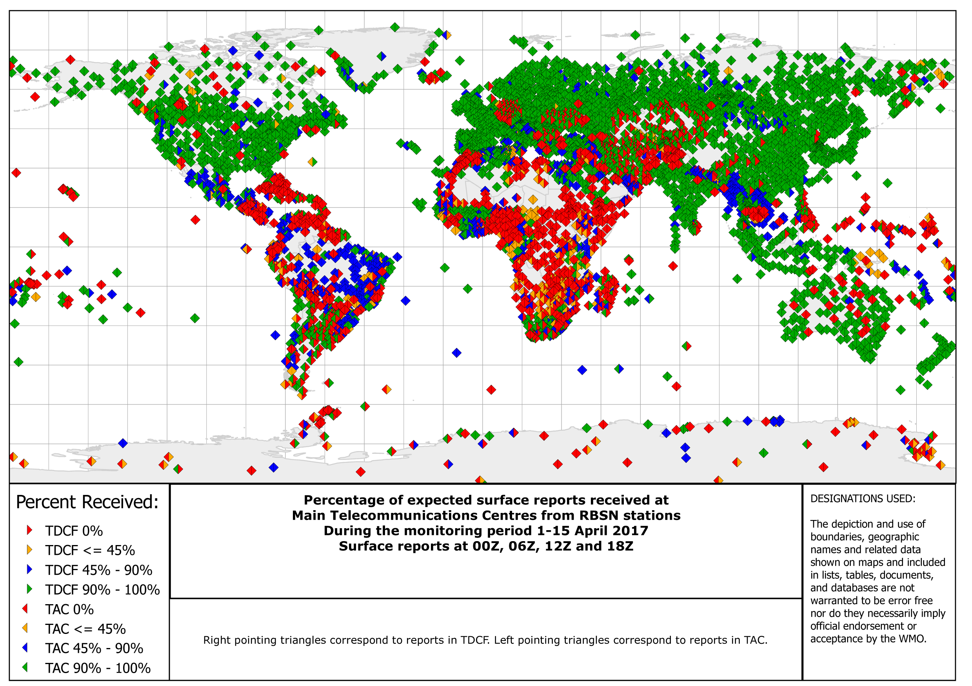

Figure 2: Percentage of the required number of surface reports received from RBSN stations during the period 1-15 April 2017

5. The Executive Council decided that;

1. Provisions in technical regulations, other than the *Manual on Codes,* that specify obligations to exchange information shall be amended to state explicitly what information has to be exchanged, and which information representations in the *Manual on Codes* may be used to represent that information;
2. The status of the *Manual on Codes*, Volume I.1 shall remain unchanged until such time as the traditional alphanumeric codes are no longer supported for operational exchange by the World Weather Watch, but that if any provision for information exchange that is expressed as an obligation in that volume should change, that provision should be transferred to the technical regulations from which the obligation is derived

**B. Meteorological Services for Aviation**

6. The Executive Council noted that air transport plays a major role in driving sustainable social and economic development and that, today, it carries more than 3 billion passengers – a figure which is expected to double by the end of the next decade. Council recalled that the Global Air Navigation Plan (GANP) of the International Civil Aviation Organization (ICAO) provides a rolling, 15-year strategic methodology for air transport upgrade progress, including a description of expected enhancements in the aeronautical meteorology domain which, together with other domains, are considered necessary or desirable to achieve tangible air navigation capacity and efficiency performance improvements, while sustaining aviation’s number one priority: safety.

7. Some key findings were observed from a recent global survey on aeronautical meteorological service provision conducted by the Commission for Aeronautical Meteorology (CAeM). The survey highlighted, inter alia, that while NMHSs of WMO Members were still heavily involved in aeronautical meteorological service provision – at local, national, regional and/or global levels – a number of other parties were now typically involved, including air navigation service providers and commercial meteorological service providers. It was also observed that while there had been great progress in the implementation, by Members, of key initiatives including quality management systems for aeronautical meteorological service provision and competency assessment of aeronautical meteorological personnel, gaps still remained in some regions.

8. Recognizing the prevailing drivers for change: the foreseen growth of air traffic, the need to maintain aviation safety whilst also increasing air navigation capacity and efficiency, reduction of the impacts of aviation on the environment, and noting the trend of increasing regionalization and globalization in response to user’s needs for globally harmonized and seamless services, the Executive Council recognized the need for the meteorological community to respond to the associated paradigm shift in modes of service delivery. These would include the development of new business models, utilization of the latest information technologies and scientific research, harnessing new and innovative methods of service delivery and being able to leverage a higher level of regional and international cooperation to bridge existing gaps. In this connection, the Executive Council acknowledged that WMO and ICAO should further strengthen their cooperation and collaboration in aeronautical meteorology matters – as emphasized at the recent bilateral meeting between the Secretary-General of WMO and the Secretary General of ICAO – to thereby enable Members/States to better fulfill their mandates.

9. It was recognized that aeronautical users, including but not limited to the airlines represented by the International Air Transport Association (IATA), require more transparency and a simplification of aeronautical meteorological charges, and that this could be achieved through improved engagement between, not least, the aeronautical meteorological service provider and user communities, facilitated through WMO, ICAO and IATA. It was also recognized that, on occasion, the costs recovered from aviation do not always make their way back to the service provider(s), often due to the arrangements within a Member State, with consequent ramifications on the ability of the service provider(s) to deliver and further develop their services.

10. In respect of aviation safety, the Executive Council was informed that hazardous meteorological conditions continue to be a significant factor in aviation incidents and accidents at airports and in the air. When considering flight safety as well as the efficiency, economy and environmental protection factors, aeronautical meteorology understandably continues to be a priority area of interest to, not least, the airlines and air traffic management (ATM).

11. It was noted that the rapid advancement in the methods of disseminating meteorological information to the flight deck, including increased use of computer tablets, which was also now influencing how users were undertaking flight crew training in meteorology. It was further noted, for example, that the pilots are now harnessing the power of new technologies and that, as a consequence, the traditional means of obtaining pre-flight briefing materials and in-flight updates were likely to become outdated sooner rather than later. Meteorological information was at the heart of ATM and emerging operational concepts in support of trajectory-based operations would be heavily reliant on the availability of relevant ATM information (including meteorological information) at the right time, in the right place and in the right format. Meteorological information with increased granularity covering the wide range of weather scales down to the nowcasting scale (< 20 min) was envisaged for the future.

12. In the context of service delivery models, the Executive Council considered a variety of current models – at a global, regional, sub-regional/multi-national and national level – that may serve as guidance and inspiration for the future. The Executive Council recognized that all models, regardless of their geographic coverage, shared a common characteristic: their intent to provide an efficient and effective, globally harmonized and seamless meteorological service for international air navigation typically building on collaborative partnerships and a spirit of cooperation unconstrained by national borders.

13. In considering multi-national coordination and collaboration in aeronautical meteorological service provision, the Executive Council appreciated that challenges often have to be overcome, including national legislative barriers. However, it was noted that overcoming the challenges often leverages new opportunities, through the building of mutual trust, honesty and engagement amongst the parties involved.

14. The Executive council urged Members to conduct a thorough SWOT (strengths, weaknesses, opportunities, threat) analysis of their NMHSs, and to consider developing their own plans taking into account national stakeholder requirements for aeronautical meteorological service provision, global and regional plans and trends.

**C. Public Weather Services**

15. The Executive Council approved a recommendation of the Commission for Basic Systems (CBS) to amend the Technical Regulations to include Implementation of Public Weather Service (PWS) Competency Framework and Development of PWS Provisions for the WMO *Technical Regulations*, Volume I (WMO-No. 49).

16. It was recognized that major changes have taken place in the way National Meteorological and Hydrological Services (NMHSs) operate, including the rapid development of technologies that affect each and every link in the chain that carries weather information to the user; there is an increasing need to strengthen the interaction with various user groups for improved service delivery; the increasing demand for more tailored services and products; and the growing emergence of service providers other than NMHSs.

17. Effective service delivery was considered to be emerging as a key component in the recognition of credibility of NMHSs as advocated in the WMO Strategy for Service Delivery, that requirements in terms of systems and infrastructure to support service delivery would need to be identified; and that the Competency Framework for PWS Forecasters and Advisors was approved by Cg-17 and a new section covering general requirements for provision of public weather services should be included in the Guide to PWS Practices.

18. CBS decided that the Guide to Public Weather Services Practices should be completely revised to include broadened responsibility of Members for the routine delivery of services to public and other users, which was to be reviewed and approved by CBS, and be published prior to the next session of the Commission.

19 As stated above, the Executive Council agreed with this recommendation and decided to approve the amendment which is in Annex I.

____________

**Draft PWS Provision for inclusion in WMO *Technical regulations,***

**Volume I (WMO-No. 49)**

**IV Meteorological, Hydrological and Climatological Services**

**5. PUBLIC WEATHER SERVICES**

**5.1 General**

5.1.1 Members should provide public weather services to cover:

(a) Forecasts and related services in the areas of weather, climate and water to aid citizens in their day-to-day activities;

(b) Warnings of high impact weather and extremes of climate, and information to other government authorities as appropriate in pursuance of their mission to protect the lives, livelihoods and property of the citizens.

5.1.2 The purpose of public weather services provided by Members should be to support decision-making related to:

(a) Protection of life, livelihood and property;

(b) Welfare and well-being of the population;

(c) Social and economic development in response to the wide spectrum of requirements of the public and weather-sensitive user groups.

**5.2 Public Weather Services Delivery**

5.2.1 User Focus

Members should identify users and understand their needs for weather, climate, water and environmental-related information in their decision-making practices. Close coordination should be maintained with users and effective feedback mechanisms should be established.

5.2.2 Quality

Members should establish a properly organized quality management system comprising procedures, processes and resources necessary to provide for sustainable quality levels of public weathers services to be supplied to users.

Note: Quality management system in conformity with ISO 9000 standards are considered as a good practice.

5.2.3 Dissemination and communication of products

Members should ensure preparation and timely dissemination to relevant users, of public weather information including warning information concerning occurrence and evolution of severe weather phenomena. Such information should be fit for purpose for integration into decision-making processes and procedures related to protection of life and property and general welfare of the public.

5.2.4 Preparation of warnings

Warning information intended for decision-making related to protection of life, livelihood and property should be provided by bodies designated and mandated by government.

Members should provide warning information through the implementation of an early warning system.

Warning information should incorporate, to the extent possible, information about impacts of weather hazards on individuals and communities.

5.2.5 Socioeconomic benefits of meteorological and hydrological services

Members should perform socioeconomic benefit assessments to both measure and demonstrate the value of their services to the public and other users.

5.2.6 Public education and outreach

Members should engage in education, awareness and preparedness activities aimed at helping citizens make the best use of forecasts and warnings information, understand the potential threats of high impact weather and extremes of climate, and be aware of the appropriate mitigating actions.

**5.3 Organization**

Members should ensure that their NMHSs are properly equipped to provide essential public weather services and especially warnings of severe weather.

**5.4 Competency**

Members should ensure that the competency requirement of personnel engaged in the provision of public weather services is in accordance with the requirements indicated in Part V of the WMO *Technical Regulations*, Volume I (WMO-No. 49)(to be developed*).*

__________