

C A R I B B E A N

M E T E O R O L O G I C A L

O R G A N I Z A T I O N

**CARIBBEAN METEOROLOGICAL COUNCIL** **Doc. 12**

FIFTY-SEVENTH SESSION

St. John's, ANTIGUA and BARBUDA, 16-17 NOVEMBER 2017

##### PROJECT UPDATES AND PROPOSALS

(Submitted by the Coordinating Director)

**Introduction**

1. Weather, climate and water are at the heart of the environmental issues affecting the planet. National Meteorological and Hydrometeorological Services (NMHSs) in the Caribbean and the world over must provide accurate information, analyses and timely forecasts of hazardous weather-related conditions that affect the sustainable development of their nations in the short term. At the same time, the NMHSs must provide the appropriate data and scientific-basis for studies on the long-term potential impacts of both natural and human-induced climate change on the environment. The contribution of meteorology and related sciences to these global studies is driven by the constant adaptation to and use of technological changes and opportunities.

2. In this regard, many of the projects being undertaken or planned have observational and scientific data information components involving the use of new or modern technologies. This is primarily an information document intended to keep the Council up-to-date on the progress of implementation on any on-going projects of this nature,which involve CMO Member States and partner organizations, such as the *World Meteorological Organization* (WMO). The document also brings to the Council for its deliberation and guidance, ideas for a future regional project that could require a major funding initiative. The document provides information on the following:

(a) Finland Initiative –COPS - Complementary Project to the SIDS - Caribbean Project and SHOCS I and II

3. Council will recall that, between 2001 and 2004, the Government of Finland funded the SIDS-Caribbean Project titled “*Preparedness to Climate Variability and Global Change in Small Islands States, Caribbean Region*”. This was followed by a project entitled ***“Strengthening Hydrometeorological Operations and Services in the Central America and the Caribbean (SHOCS)”***.

4. Phase I of SHOCS, called SHOCS I, was implemented between 2010 and 2012 with a budget of 0.5 million Euros. A Phase II, called SHOCS-II, was implemented between 2013 and 2015 with a budget of one Million Euros. The Project was implemented by the Finnish Meteorological Institute (FMI) in partnership with the *Association of Caribbean States* (ACS), WMO and CMO. The CMO Member States that participated in SHOCS-II are Antigua and Barbuda, Belize, Dominica, Grenada, Guyana, Jamaica, St. Kitts and Nevis, Saint Lucia and St. Vincent and the Grenadines.The other States that participated are Cuba, the Dominican Republic, Haiti and Suriname. The beneficiaries of the Project have been the National Meteorological and Hydrological Services (NMHS) and Disaster Management Agencies of the above States, along with the CIMH as a regional institution.

5. At the conclusion of SHOCS-II, there were residual funds available from the components of SIDS and SHOCS, so that the Project Board identified priorities for capacity building during a continuingphase called the ***Complementary Project to the SIDS - Caribbean Project and SHOCS I and II* (COPS)**.

6. In this regard, the COPS Project, with 130,000 Euros available, commenced late in 2016 and was expected to end late in 2017. The CMO Headquarters arranged for some COPS funds to be used to support training for some radar technicians in Belize. The work plan includes updating of software in the in-country missions which assures that the region has the newest software available in utilization.On FMI’s behalf, some of the activities have been intentionally scheduled to latter half of 2017 due to the software development work (especially with SmartAlert software) done at FMI. The work plan of COPS includes three activities:

* + **Activity 1.1** : The rehabilitation of selected observation stations for improved data quality and data availability; (AWS spare parts acquisition)
  + **Activity 1.2** : The implementation of new tools at the weather forecast services to improve the capacity to analyse severe weather conditions; (SmartMet)
  + **Activity 2.1** : Development and implementation of solutions for common presentation and communication of early warnings; (SmartAlert)

7. **Activity 1.1** will aim at improvement in data availability, quality and sustainability by acquiring observation station spare parts for the selected observation station. The selection of stations to be restored and the components to be acquired will be based on an inquiry which was submitted to the beneficiary NMHSs in SHOCS II project. The restoration work will focus on those SIDS station networks that are least supported by other ongoing projects.

8. **Activity 1.2** aims that the work of forecaster becomes more productive especially under severe weather conditions, when products need to be updated more frequently. In previous projects, FMI-built forecaster workstations and weather forecast production systems had been installed in some ten countries in the region. The SmartMet system was installed to provide new technical tools and methods to enhance the capacity of NMHSs to contribute to the Caribbean Early Warning System and to enhance service production. Two types of SmartMet installations are already made in the region: ‘Main sites’ and a ‘Remote sites’. The Main Site software has full capability for data editing and post processing to prepare localized service products. A ‘Main site’ system includes a high capacity server to perform data collection to the system database. Data collection is tailored locally so that all available data communication lines and hydro-meteorological data sources are benefited. Maintaining a Main site operative on a 24/7 basis requires availability of qualified technical staff. This activity will work on assuring the sustainability of the systems installed in the region by training of the staff.

9. **Activity 2.1** aims to enhanced distribution of severe weather warning information by using, among others,**CAP –format** (*Common Alerting Protocol*) in warning messaging and delivery to stakeholders and general public. This is done by using the FMI-built warning information delivery software called ***SmartAlert*** which has already been installed in Antigua and Barbuda, Cuba and Jamaica. This activity will work on assuring the sustainability of the systems installed in the region by training of the staff.

**Activities during the autumn 2017**

10. The plan for the autumn of 2017 is to conduct in-country training missions to SmartMet “main site” countries (Antigua and Barbuda, Cuba and Jamaica) by FMI experts, each mission lasting one week. Each mission will be conducted by one FMI forecaster trainer and one FMI IT trainer and the training will be given to SmartMet and SmartAlert systems jointly during the same mission.

11. Equipment spare part acquisition for the activity 1.1 will also be completed during the autumn 2017. The needs assessment, made in SHOCS II project, will be updated and the acquisition will be performed reflecting those needs. It will be proposed to the Project Board that this acquisition will be limited only to the countries not receiving SmartMet and SmartAlert training mission. The reason is that the amount of funding for observation station spare parts is fairly small (20,000 €) and this should cover also the equipment delivery costs. If all countries would be included in this activity the funding is not sufficient to cover reasonable acquisitions since the delivery costs would most likely take major part from the funds.

(b) Lightning Detection System

12. Council will recall that, in the past, the CMO Headquarters indicated its intention to establish a ground-based *Lightning Detection System* in the region in partnership with the Meteorological Service of France [Météo-France]. The CMO Headquarters has studied this system in great detail and was of the opinion that such a system was very necessary in the Caribbean. In 2012, the CMO Headquarters reported to the 52nd session of the Council, the results of a demonstration period of a long-range lightning detection system that showed its tremendous value to the prediction of severe weather in the region. Lightning is global phenomenon, but is particularly frequent in the tropical areas of the world, as depicted in Figure 1.

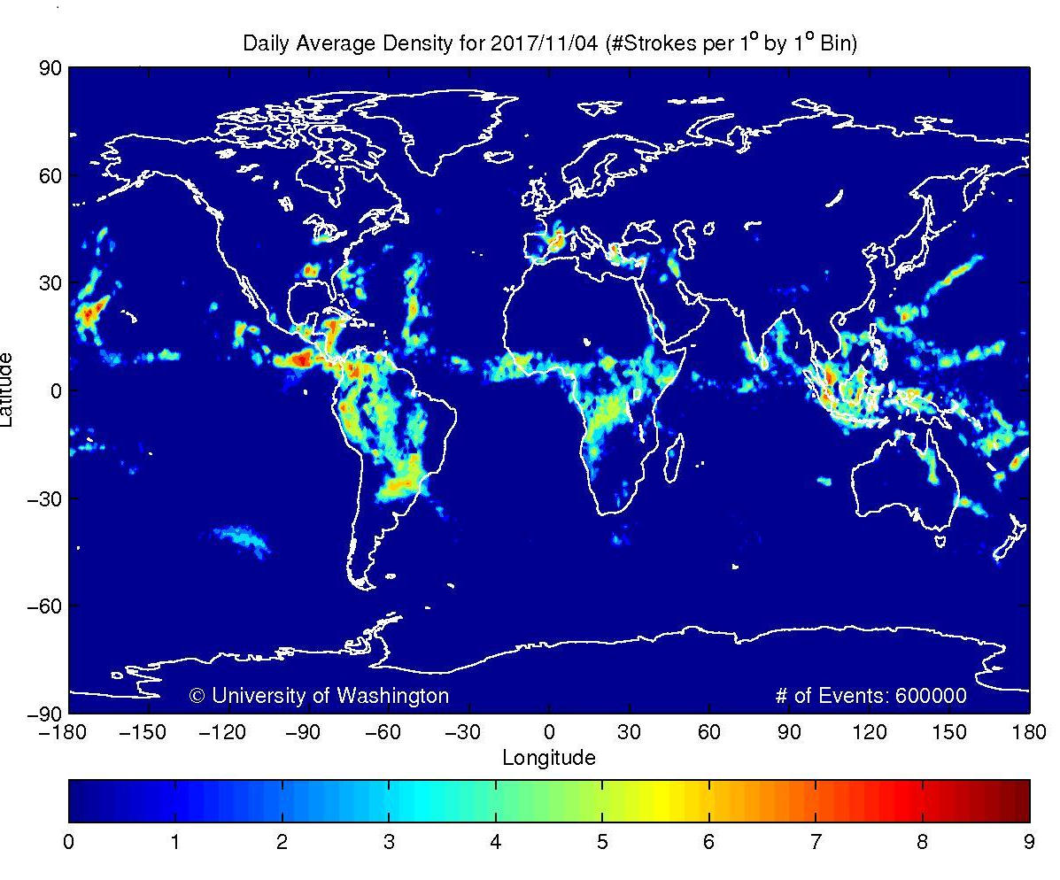

Figure 1: Daily Average of Global lightning strikes (Courtesy University of Washington)

|  |  |
| --- | --- |
| GLD360 2012 | http://webflash.ess.washington.edu/WWLLN_movies/Movie_of_Lightning_in_Americas_BIG.gif |

Figure 2:Long-range Lightning Detection (GLD360 Global Lightning Data) Figure 3: Long-range Lightning Detection

(Courtesy University of Hawaii, in collaboration with Vaisala Inc) (Courtesy University of Washington)

13. These can be monitored in detail in the different parts of the World. Two examples of such a system covering the Americas are shown in Figures 2 and 3, in which lightning data is superimposed on satellite data.

14. The long-range system shows that lightning data can be acquired over the oceanic areas associated with weather systems that are well outside of radar range. At this distance, the resolution of the data at these distances is not critical. However, at distances closer to land, higher accuracy and thus a high-resolution detection are necessary. **Ground-based systems** use triangulation from sensors at multiple locations to determine location of the lightning flash. Therefore, for this higher resolution to be achieved, it will be necessary to install some lightning sensors along the island chain to allow for adequate triangulation using the commonly known phenomenon “lightning spherics”.

15. The 52nd session of the Council discussed three basic options for consideration for an island-chain set of sensors; (i) the number and location of processing units for the data; (ii) the mode of transmission among the countries involved and (iii) the method of paying for the system. Over the years, the CMO Headquarters has received several proposals from a number of lightning-detection suppliers. The CMO Headquarters has not found the lease or rental approach to the acquisition of a lightning-detection system for the region to be viable since any failure to pay by the Member States would lead to the system being “turned off” or removed. The CMO Headquarters would like the Council to consider a capital project approach, in which international funding could be sought, in the same way as was done for the **CMO Radar Project,** through an internationally-tendered process, in which the equipment purchased and installed under such a project would be owned and operated by the CMO for the benefit of all CMO Member States and the region in general. There would be the added possibility that lightning data could also be provided for a fee to interested parties that require such information for their commercial operations.

**ACTION PROPOSED TO COUNCIL**

16. **The Council is invited to**:

1. **Note** the updated information and provide any guidance necessary on the Finland-funded Project Complementary Project to the SIDS-Caribbean Project and SHOCS I and II (COPS);
2. **Discuss** the benefits to the Caribbean region of installing an operational ground-based lightning detection system;
3. **Approve** the proposal that international assistance should be sought to finance such a project;
4. **Approve** the principle that such a lightning-detection system should be managed by the CMO Headquarters for the benefit of the meteorological community in all Member States;
5. **Authorize** the CMO Headquarters to engage the assistance of partners such as the World Meteorological Organization (WMO) or other Meteorological Services of developed countries with experience in lightning detection systems, in developing project proposals for consideration of Council.

___________

CMO Headquarters

November 2017