

C A R I B B E A N

M E T E O R O L O G I C A L

O R G A N I Z A T I O N

**CARIBBEAN METEOROLOGICAL COUNCIL** **Doc. 7(d)**

FIFTY-SIXTH SESSION

St. George's, GRENADA, 10-11 NOVEMBER 2016

**FINANCIAL REPORTS**

**POLICY ON RADAR AND RAWINSONDE FUNDS**

(Submitted by the Coordinating Director)

**Introduction**

1. This document is presented to the 56th session of the Caribbean Meteorological Council to generate discussions on arrangements for the utility of certain funds held by the Headquarters of the Caribbean Meteorological Organization (CMO). These funds are in connection with the ***Caribbean Rawinsonde Network*** (CRN) and the ***CMO Weather Radar Network***.

2. The Caribbean Rawinsonde Network (CRN) in CMO Member States forms part of a large regional network, which in turn forms part of a larger global network. These rawinsonde stations...or upper-air stations...monitor the characteristics of the upper atmosphere and thus, collectively, allow for small-scale and large-scale analyses of the upper atmosphere.

3. **Figure 1** shows the typical Rawinsonde facilities for Meteorological Services that carry out these upper-air observations, as well as the full network covering the southern part of the WMO Region IV (North America, Central America and the Caribbean). The CMO Member States that operate upper-air stations within this network are Belize, the Cayman Islands, Jamaica, Barbados and Trinidad and Tobago.

4. The CMO Weather Radar Network was established in the late sixties-early seventies, with six radars in Belize, Jamaica, Antigua and Barbuda, Barbados, Trinidad & Tobago and Guyana. The radar in Barbados was located at the CIMH. Today, the new and modern Radar Network is made up of radars in Belize, the Cayman Islands, Jamaica, Barbados, Trinidad & Tobago and Guyana. The CMO radars, along with radars of neighbouring regional States, today form part of a wide Caribbean radar composite. **Figure 2** shows some of the radar facilities and the regional composite.

|  |  |
| --- | --- |
| F:\boi_raob 2.gif | F:\5May2010_AT351_rawinsonde_launch_007.jpg |

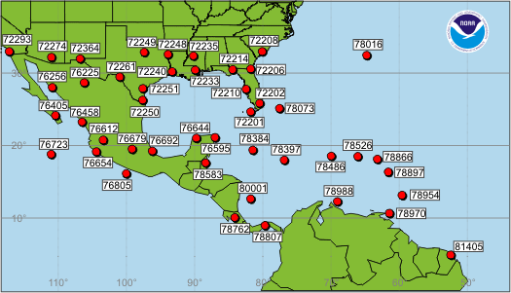

**Figure 1**: Typical rawinsonde facilities and balloon launch, as well as Upper-Air Network in the southern part of the WMO Region IV (North America, Central America & the Caribbean)

|  |  |
| --- | --- |
| F:\Trinidad concrete structure & radar.JPG |  |

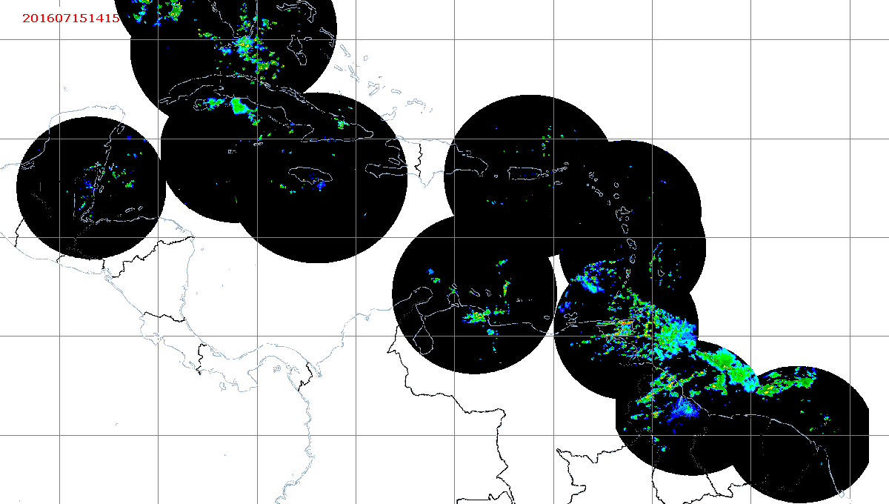

**Figure 2**: Radar facilities (Trinidad and Guyana) and the Caribbean Weather Radar Composite Coverage

5. The Caribbean Meteorological Council has always recognized that although these meteorological facilities, rawinsonde and radar, are operated by the above specific CMO Member States, the benefits accrue to all Member States since the essential data provided by these systems are used, ***directly and indirectly***, by all regional Meteorological and Hydrometeorological Services, regardless of size, in their daily provision of weather services and warnings. The rawinsonde and radar data, along with surface weather observations, satellite data and other platforms, are collectively used to analyse the weather conditions over the region and beyond, as seen in **Figure 3** and **Figure 4**. Both rawinsonde and radar data, as well as the data from the other platforms, are constantly ingested into the global and regional numerical weather prediction models, which provide guidance for short- and long-range weather forecasts and warnings that are essential to *all nations*. As a specific example, the outputs of these models, and thus both rawinsonde and radar data, are critical to the operations and safety of the aviation sector, which plays a major role in all national economies.

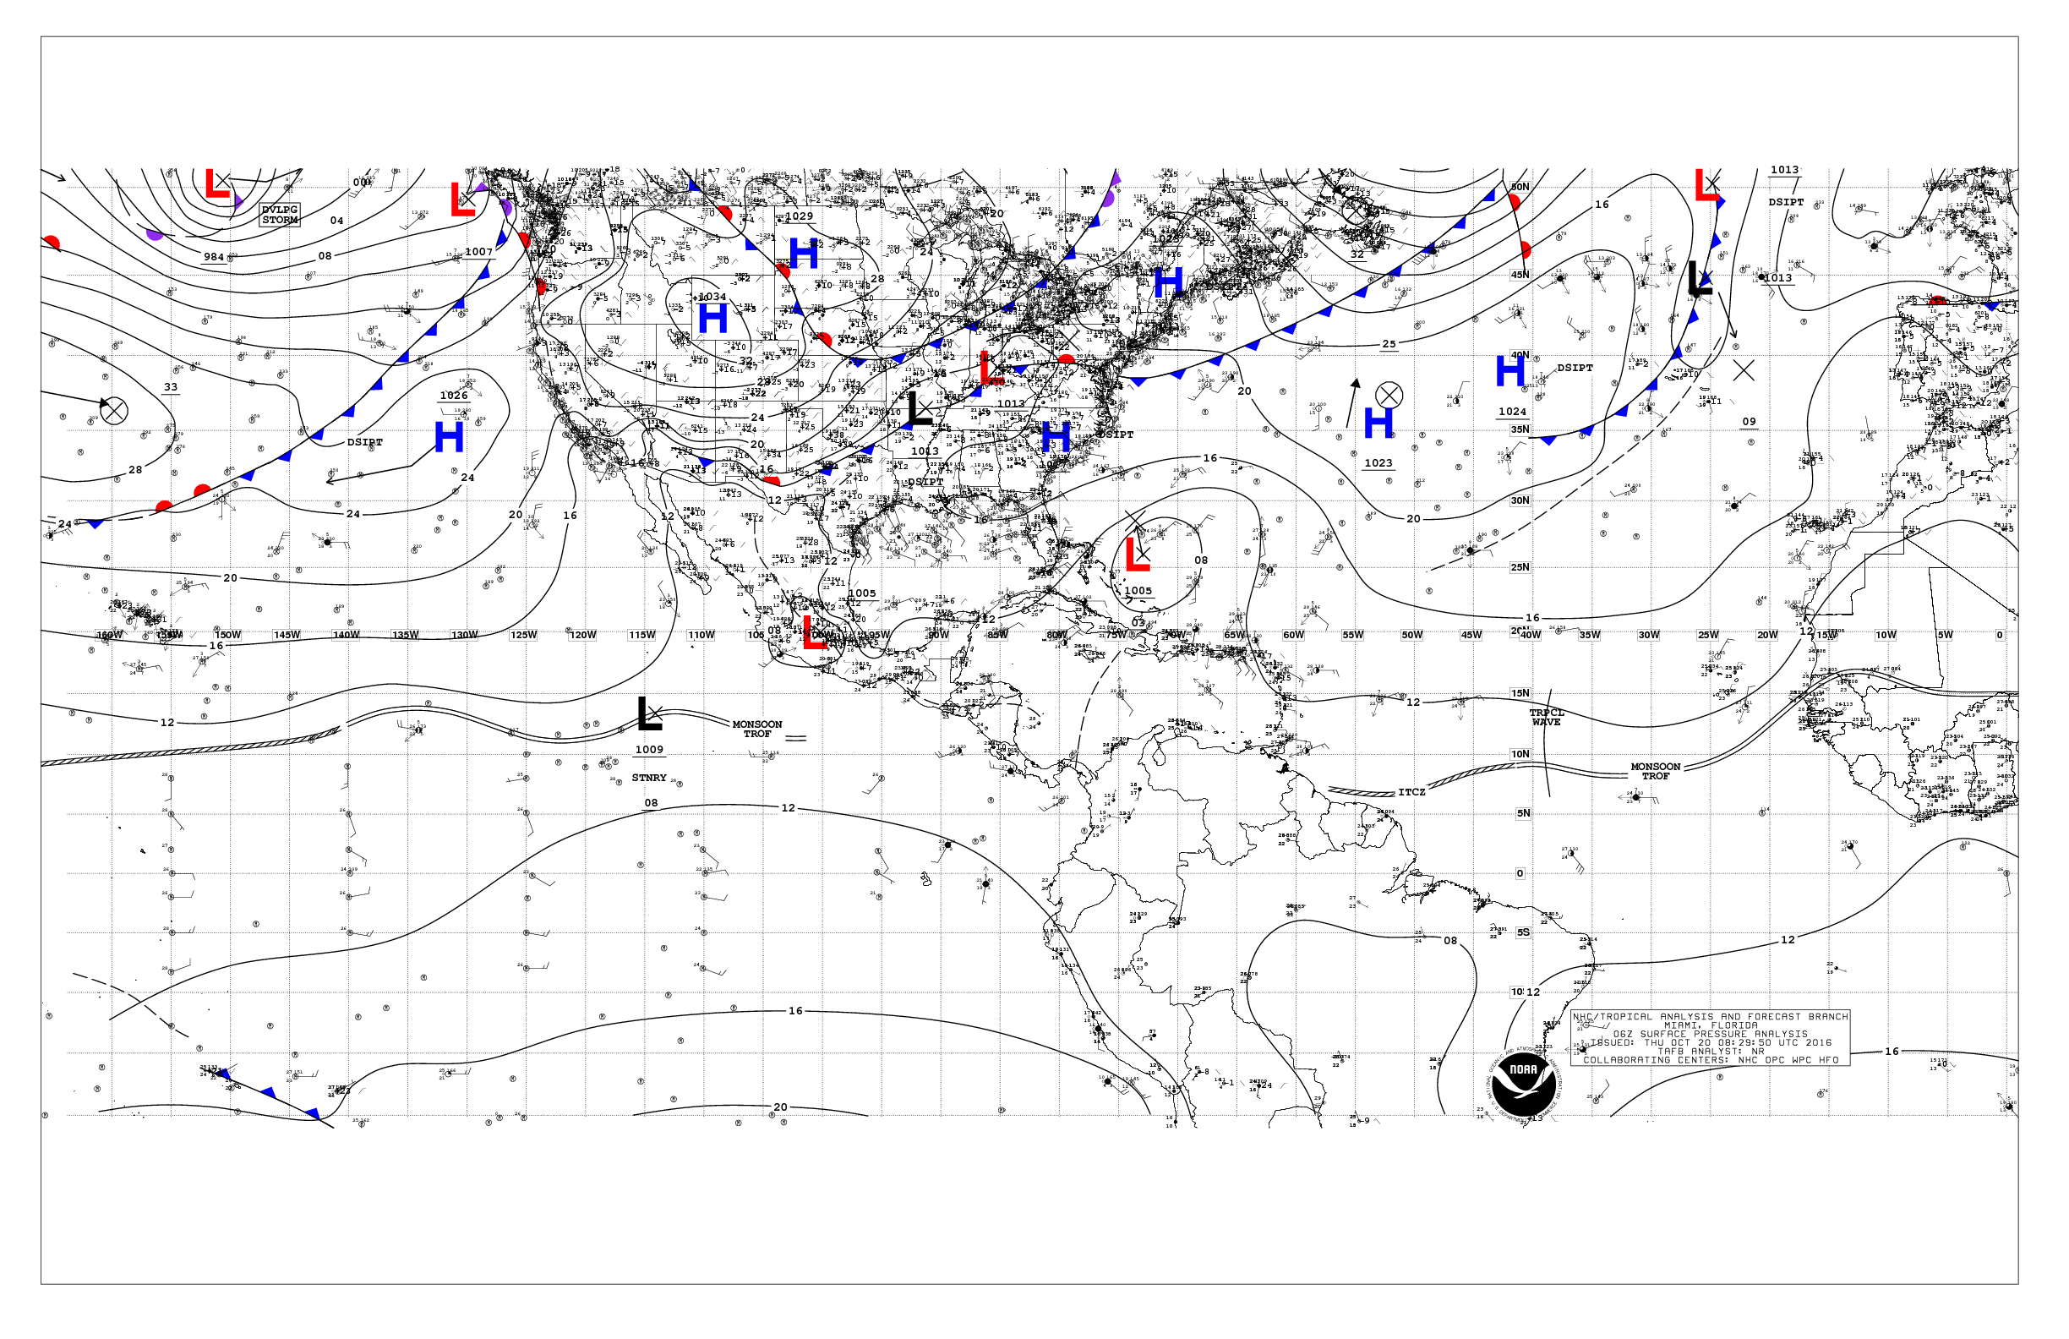

**Figure 3**: Regional Surface Weather Analysis

**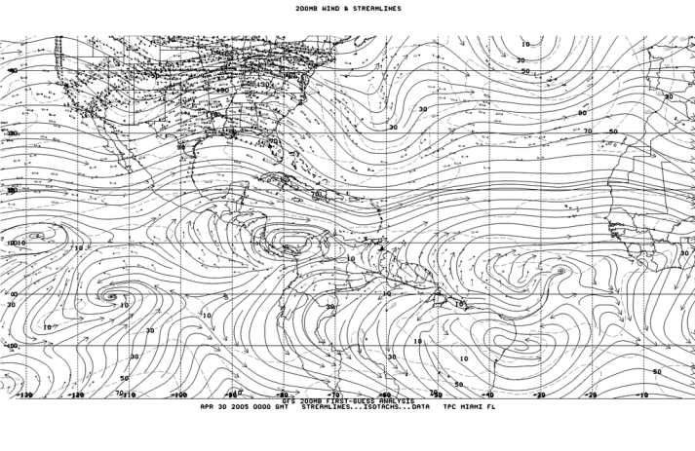**

**Figure 4:** Regional Analysis of the Upper Atmosphere

**Related Elements of the CMO Contribution Formula**

6. As a result of this philosophy, the Council designed the Contribution Formula for Member States of the Organization to define the level of contributions to the ***CMO Headquarters***, the ***Caribbean Institute for Meteorology and Hydrology*** (CIMH), as well as a measure of contribution from all Member States towards the operation of the ***Caribbean Rawinsonde Network*** (CRN) and the ***CMO Weather Radar Network.***

7. The components within the Contribution Formula on the ***Caribbean Rawinsonde Network*** and the **CMO Weather Radar Network** have been modified over the years, such as when the Cayman Islands commenced upper air soundings and were included in the CRN. Under the original CMO Radar Network, the radar in Barbados was excluded from the Formula since it was located at and operated by the CIMH and was already being supported on a regional basis through contributions to the CIMH. Contribution to the Radar Network was scaled down as the aging Network became obsolete through technological changes, and some of the radars (Antigua and Guyana) were decommissioned. This is reflected in the current unit system for Radars in the overall Contribution Formula, which only includes radars in Belize, Jamaica and Trinidad & Tobago.

8. Future changes to the Contribution Formula are imminent. The Caribbean Meteorological Council had decided to wait until the modern CMO Weather Radar Network, comprising radars located in Belize, the Cayman Islands, Jamaica, Barbados, Trinidad and Guyana, was fully operational before modifying the radar component of the Contribution Formula; at which time the current radar in Barbados that is now operated by the Barbados Meteorological Service and not the CIMH, as well as the Cayman Islands and Guyana radars, would be included. In 2014, the Council then decided that the entire Contribution Formula would be revised to reflect the current economic situation in the region and changes in the meteorological elements. However, the Council further decided to await the outcome of potential increases in the Membership of the Organization before carrying out the exercise, as this would again require another comprehensive revision of the overall Formula.

**Disbursement to Host States of the CRN and Radar Network**

9. By a decision of the Council therefore, the contributions of Member States towards the joint facilities (the Rawinsonde and Radar Networks) are embedded into the *CMO Headquarters budget* (see CMC56 Doc 8(a)) and have been periodically disbursed by the CMO Headquarters to those States that operate the facilities ***to assist in their operational upkeep***. The Council further decided that the mechanism for disbursement must first be contingent upon an acceptable overall level of regional contribution from Member States to adequately service the budget of the CMO Headquarters, as well as an acceptable level of contribution from the recipient Host States themselves.

10. Over the years, both the CMO Headquarters and the CIMH have been challenged by declining levels of regional contributions to support their approved budgets, to the extent that the contributions to the CMO Headquarters had not reached an "acceptable" level that would allow regular disbursement of funds held for the Networks. Consequently, irregular disbursements have been made to only a few Member States. In addition and very importantly, between 2008 and 2014, the CMO Headquarters experienced major cash flow challenges as it had to undertake the unbudgeted payment of rent for the premises it occupies in Port of Spain, while the Government of Trinidad and Tobago worked towards resolving a situation with respect to the lease on the property and thus the payment of this rent, in accordance with the Host Country Agreement on the CMO Headquarters. After these matters were resolved, the CMO Headquarters was reimbursed for the rental payments in 2015.

11. However, the CMO Headquarters maintains a record of what can be applied to each recipient for the two Networks based on actual contributions versus what would be applied if full contributions were made. In the absence of regular disbursements over a significant period, the funds actually held for each of the current recipient Member States (Belize, Cayman Islands, Jamaica, Barbados and Trinidad & Tobago for CRN and Belize, Jamaica and Trinidad & Tobago for Radar) has accumulated to an amount that would now make a meaningful contribution to its ***original purpose of assisting in the operational upkeep of the systems***. The CMO Headquarters will therefore resume some level of disbursement to Member States as far as the available resources permit. These Member States were provided with the individual current amount available to them.

12. The CMO Headquarters is convinced that the method used for disbursement in the past has not necessarily served to meet the expressed intention of Council, as there seems to be no formal internal procedure within the recipient Member State to make these funds available for use by the local Meteorological Service for the purpose intended. More often than not, these disbursements were simply deposited into "general revenue" and "lost" to the local Service, with the exception of Jamaica, where internal arrangements have been in place for some time that allows for these funds to be used directly by the Jamaica Meteorological Service for the upkeep of their operational systems.

13. The CMO Headquarters has been told on many occasions by the Meteorological Services operating these networks about the difficulties they sometimes face in sourcing funds for maintenance and spares for the systems. The CMO Headquarters has thus proposed that Directors of Meteorological Services in the recipient Member States discuss this matter with their respective Ministries with the aim of deciding on a system that would allow their local Meteorological Services to utilise these funds as intended. At present, the Council is aware that there is a methodology used for disbursement to Member States of funds referred to as the "*Refundable Balances*" (see CMC56 Doc. 7(a)) that result from CMO's contribution to the World Meteorological Organization (WMO) on behalf of the *British Caribbean Territories* (BCT). The CMO Headquarters is willing to offer a similar application of the methodology used for disbursement of "Refundable Balances" to those Member States that wish to utilize it, since it would ensure that funds can be directly used for the two Networks.

14. The CMO Headquarters has indicated that it will require a formal response, preferably directly from the Permanent Secretary in the line Ministry, or with the clear endorsement of the Permanent Secretary, indicating the method to be used for this disbursement. The individual Member State may wish to keep the rawinsonde and radar funds separate or merge them into a common "maintenance" facility.

15. All CMO Member States should take note, as indicated in paragraph 11 above, that if they make regular and full payment of contributions to the CMO Headquarters, the funds that can be set aside for network upkeep would remain at a meaningful level so that disbursements could be done on a more regular basis.

**Action Proposed to Council:**

16. The Council is invited to:

1. **Discuss** the mechanism that enables all Member States to contribute to the operational upkeep of the Rawinsonde and Radar Networks;
2. **Support** the proposal of the CMO Headquarters and **Urge** Member States concerned to set up internal procedures that would enable funds disbursed for the Networks to be used for the intended purpose;
3. **Reaffirm** that contributions by other Member States to the operational upkeep of the networks are for the common good;
4. **Encourage** all Member States to increase their efforts to make regular and full payments to the budget of the CMO Headquarters, thereby allowing for more meaningful disbursements of allocated Network funds.

\_\_\_\_\_\_\_\_\_\_\_

CMO Headquarters, October 2016