C A R I B B E A N
M E T E O R O L O G I C A L
O R G A N I Z A T I O N

ANNUAL MEETING OF DIRECTORS OF METEOROLOGICAL SERVICES Doc. 5
Rodney Bay, SAINT LUCIA - 14th NOVEMBER 2012

OPERATIONAL MATTERS

(Submitted by the Coordinating Director)

INTRODUCTION

1. Several matters that are particularly related to the operations at National Meteorological Services (NMSs) are raised or addressed in this document. Some of the matters may be of immediate concern or require immediate action on the part of the NMSs, while others are raised to create awareness of issues upcoming in the near future.

A. WMO Annual Global Monitoring

2. The WMO Manual on the Global Telecommunication System (GTS), in its Attachment 1-5, refers to a plan for monitoring the operation of the World Weather Watch (WWW). This plan includes provisions for the internationally coordinated monitoring of the operation of the WWW on a non-real-time basis.

3. The Annual Global Monitoring (AGM) is carried out in October each year. The WWW centres are invited to monitor SYNOP, TEMP, PILOT, and CLIMAT reports from the Regional Basic Synoptic Network (RBSN) stations in accordance with the responsibility taken for the exchange of data on the GTS:
- The National Meteorological Centres (NMCs) should monitor data from their own territory;
- Regional Telecommunication Hubs (RTHs) should at least monitor data from their associated NMCs, and possibly from their own Region:
- World Meteorological Centres (WMCs) and RTHs located on the Main Trunk Network (MTN) should monitor the complete global data set.

4. The results of the AGM make it possible to compare the availability of the reports received from RBSN stations at the NMC responsible for inserting the data in the Regional Meteorological Telecommunication Network (RMTN), at the associated RTH and at MTN centres. The differences in the availability of data between centres are generally due to the following main reasons: (i) differences of requirements in the reception of data, (ii) shortcomings in the relay of the data on the GTS, (iii) data not monitored due to differences in the implementation of the monitoring procedures at centres.

5. There are ten (10) Members States of the Caribbean Meteorological Organization whose National Meteorological Service (NMS) are RBSN stations. These are Antigua and Barbuda, Barbados, Belize, Cayman Islands, Dominica, Grenada, Guyana, Jamaica, Saint Lucia and Trinidad and Tobago.

6. The Headquarters Unit reminded the RBSN stations of the AGM in September of this year and offered assistance in reporting the results to WMO. As at 30 October 2012, only Dominica availed itself of the assistance of the Headquarters Unit. It is not currently known how many actually participated in the AGM.

B. Quality Management System

7. During 2011, the Finland funded Project, "Strengthening Hydrometeorological Operations and Services in the Caribbean SIDS (SHOCS)," held two (2) workshops on the "Implementation of a QMS to aviation weather services." The first was held at the Caribbean Institute for Meteorology and Hydrology (9-13 May) and the second was held in Saint Lucia (5-9 December).

8. The report which was produced at the conclusion of the second workshop indicated that most of the countries which participated had improved in their level of preparedness towards seeking ISO 9001:2008 Quality Management Systems certification as shown in Figure 1.
Figure 1: Level of QMS preparedness from Second workshop report

9. Dominica, Saint Lucia and Trinidad and Tobago are using consultants in the preparation of the documents and the changing of management processes to enable them to achieve certification. St. Kitts/Nevis has been using its own resources for the creation of the necessary documents which have been reviewed by CMO among others, to ensure that they will meet the QMS requirements.

10. During the 2011 Meeting of the Directors of Meteorological Services (Dominica, 16 November 2011), CMO was tasked with assisting the National Meteorological Services with identifying organizations which can provide QMS certification. A list of certification organizations is provided in ANNEX I.

11. The QMS certification process is not difficult; however, it can be time-consuming depending on the level of readiness of the Service. Generally, the process towards certification is as follows:
- Request a quotation and sign the agreement: Most certification organizations operate through websites where a quotation can be requested;
- Submit your documentation and they will review and provide a report (an on-site visit may be required). This may be iterated several times until the document is at QMS standard;
- Prepare for the Registration Assessment: The time depends upon the number of employees and/or locations that you have, the type of processes that you are in control of, etc;
- Correct any deficiencies noted by the audit team;
- Receive your certificate.

12. In requesting the quotation, the certifying organization would usually provide a quotation for multiple years. Hence, they could become the external auditor of the Meteorological Service.

C. Transition to Table Driven Code Forms
13. At the 2008 Meeting of Directors of Meteorological Service held in Georgetown, Guyana and the 2010 Meeting of Directors of Meteorological Service, held in George Town, Grand Cayman, WMO’s planned migration from the traditional alphanumeric code forms to the table driven code forms was presented. The reason for the migration is the ability to easily expand the code form to add new parameters, self description (auto description of content), flexibility (ability to vary the content), sustainability (old archives readable) and compression (for binary digital exchange).

14. The Migration Plan called for the complete migration of the SYNOP, TEMP, PILOT and CLIMAT code forms (category 1 observations) to BUFR by November 2010 after a period of dual code forms transmitted on the Global Telecommunication System (GTS), which started from November 2005. Further, the operational exchange of aviation code forms started in November 2008 and the complete migration of these code forms to BUFR will be completed in November 2016. The Migration Plan is shown in Figure 2 below.

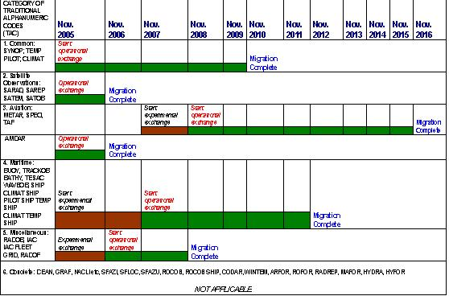
Figure 2: WMO Migration Plan to the BUFR Code Form.

15. However, neither the Member States of the CMO that have RBSN stations nor RTH Washington were able to begin transmission of category 1 observations by November 2010. The WMO Inter-Programme Expert Team on Data Representation and Codes (IPET-DRC) reviewed the results of a TCDF migration survey and found that 80% of WMO Member States would not meet the target date for migration. However, it was decided that these target dates should not be revised, in order to continue to stress the urgency of migration and also provide recognition of the 20% of Members States which met the target.

16. The Final Report of the 3rd Meeting of the IPET-DRC, which was held in Melbourne Australia from 20-23 September 2011, contained information on the ISM/SMM monitoring for the months of October 2010, January 2011, April 2011 and July 2011. This showed that there are fifteen (15) RBSN stations in RA IV transmitting synoptic BUFR observations from a total of 590 RBSN stations. The Final Report of the 4th Meeting of IPET-DRC (Exeter, United Kingdom, 21-25 May 2012) showed no major changes in RA IV and the representatives of Canada and the United States of America indicated to the Meeting that, " a letter was prepared to remind the PRs of the MTDCF in RA IV and suggest the creation of a Regional Work Group to arrive at a regional implementation plan and coordinate its implementation."

17. It must be noted that, at present, no RBSN stations of CMO Member States have migrated to TDCF (MTDCF). Further, according to the migration plan of the USA, they expect to finish their migration by October 2013. Hence, the present practice of changing external observations in BUFR format to alphanumeric code forms for transmission within the Region will cease.

18. The migration of METAR, SPECI SIGMET and TAF is supposed to be completed by November 2016. Testing of the transmission of the observations and forecasts via the Aeronautical Fixed Telecommunication Network (AFTN) occurred in 2009 and 2010 with some success. WMO has developed its Logical Data Model (LDM) in Unified Modeling Language (UML) for the aviation code forms, but ICAO would like the data in eXtensible Markup Language (XML). Therefore, there has been discussion between WMO and ICAO for an automated translation from UML to XML. Testing was due to start in June 2012 and continue for a further three years. It is intended that XML data will not be read directly by humans as all visualisations will be through the use of computers.

D. The Status of the RMTN - post ISCS

19. The US National Weather Service "International Satellite Communications System" (ISCS) ceased transmission of all observations, other data and products, via satellite on 30 June 2012. Prior to the cessation of transmission of data, Meteorological Services were advised to register to access the WAFS Internet File Service (WIFS), which would provide aeronautical meteorological data and products. To access WMO RA IV related weather information in BUFR, GRIB, alpha-numeric text, and T4-FAX data types, it was necessary to register with the Global Telecommunications System (GTS) Internet File Service (GIFS).

20. Transmission of observations, other meteorological data and products from Meteorological Services to RTH Washington would occur in the following ways:
- Secure Socket Layer Virtual Private Network (SSL VPN) / NWSTG FTP Ingest Server [RTH Washington System]
- Email Data Input Service (EDIS) [RTH Washington System]

21. In addition, data could be retrieved by other means available to some Meteorological Service in RA IV, such as GeoNetCast-Americas and Emergency Managers Weather Information Network (EMWIN). Since July 2012, RTH Washington indicated that the Regional Meteorological Telecommunication Network in RA IV has the configuration indicated in Figure 3.

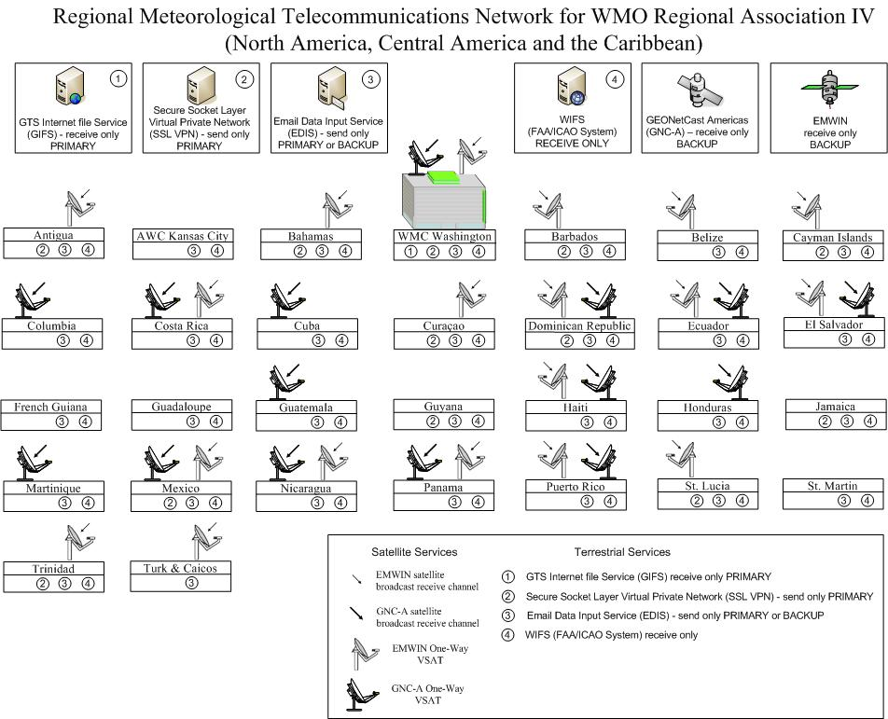
Figure 3: RMTN Network

22. After 30 June 2012, a number of Meteorological Service of CMO Member States indicated that there were problems in retrieving data from the GIFS server. The problems most of the Services were having was that the data was not available in a timely manner. The Headquarters Unit was able to access the data on the GIFs server in September 2012 via the URL
https://ra4-gifs.weather.gov/data/

and found the folder structure as indicated in Figure 4. The data files within the folders are available on the GIFs for up to forty-eight (48) hours following their initial arrival onto the file server.

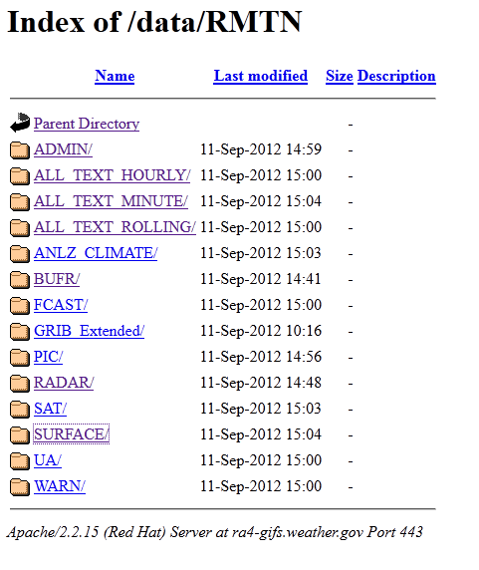
Figure 4: Screen shot of GIFS server

23. The folder All TEXT HOURLY contains all products received during a 60 minute interval, commencing at the top of the hour (at 00 minutes, 00 seconds) and ending at the end of the hour (at 59 minutes, 59 seconds) for each hour in the day.

24. Minute files capture products received during a 60 second interval for each minute of each hour in the day. The 14:00 file (hh:mm) for example, contains products received from 14:00:00 (hh:mm:ss) to 14:00:59; the 14:01 file contains products received from 14:01:00 (hh:mm:ss) to 14:01:59; and so on. The date and time identified in the file names are Coordinated Universal Time. The user manual which describes the folders and the files they contain on the GIFs server can be viewed at
http://www.nws.noaa.gov/iscs/pdf/GIFS%20Open%20Access%20RMTN%20User%20Guide%20r120801-1200.pdf

E. Common Alerting Protocol
25. The Common Alerting Protocol (CAP) is a simple but general format for exchanging all-hazard emergency alerts and public warnings over all kinds of networks. CAP allows a consistent warning message to be disseminated simultaneously over many different warning systems, thus increasing warning effectiveness while simplifying the warning task. The CAP standard addresses the long-standing need to coordinate dissemination mechanisms for warnings and alerts.

26. The CAP standard was adopted as International Telecommunication Union (ITU) Recommendation X.1303. The ITU has been urging nations to implement the CAP standard and guidelines for developing nations, which have been published by the ITU Development sector. The World Meteorological Organization (WMO) has established a Register of WMO Members Alerting Authorities via http://www-db.wmo.int/alerting/authorities.html. It is available for public view or monitoring through news feeds. Each WMO Member entry shows the alerting authority's organization name; the types of that organization's authoritative messages; the geographic area for which messages are typically issued; and, Internet addresses offering these messages in traditional formats or CAP format.

27. CAP serves as a kind of universal adaptor for alert messages. The CAP standard message format has the features essential for both existing and emerging alert systems and sensor technologies. This means CAP can replace many single-purpose interfaces between alert sources and dissemination media. From the perspective of warnings technology, CAP is also a breakthrough standard that opens the door to technical innovation. For example, location-aware (GPS) receiving devices use the standardized geospatial information in a CAP message to select messages based on the device's current location.

28. A key benefit of CAP for sending alert messages is that the sender can activate multiple warning systems with a single input, as shown in Figure 5. Using a single input reduces the cost and complexity of notifying many warning systems. CAP also provides consistency in the information delivered over multiple systems. It is very important that people get exact corroboration of warnings coming through multiple channels. Research has found that people do not typically act on the first warning signal, but begin looking for confirmation. Only when convinced that the warning is not a false alarm, will people act.

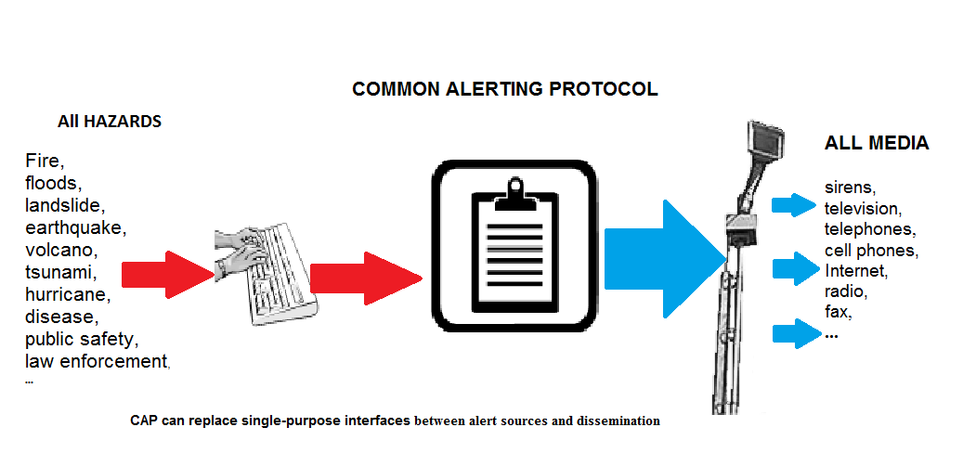
Figure 5: Schematic of the Common Alerting Protocol Standard

29. In addition to text instructions and a description of the event, CAP messages convey the event's "Urgency", "Severity", and "Certainty". Urgency describes how much time is available to prepare; Severity describes the intensity of the impact; and Certainty states how confident is the observation or prediction. An event is typically assigned to a category (e.g., geophysical, meteorological, safety, security, rescue, fire, health, environmental, transportation, infrastructure). A CAP message can also include digital images and audio. Including audio recording in a CAP message allows for broadcasting a warning directly on radio, without requiring an announcer to read the message.

30. Each CAP message has a unique identification number, and may reference related CAP messages. CAP messages include the status and time sent, allowing one message to serve as an update or cancellations of a previous message as shown in Figure 6. CAP messages are compatible with digital encryption and signature techniques that ensure the reliability and security of the message.

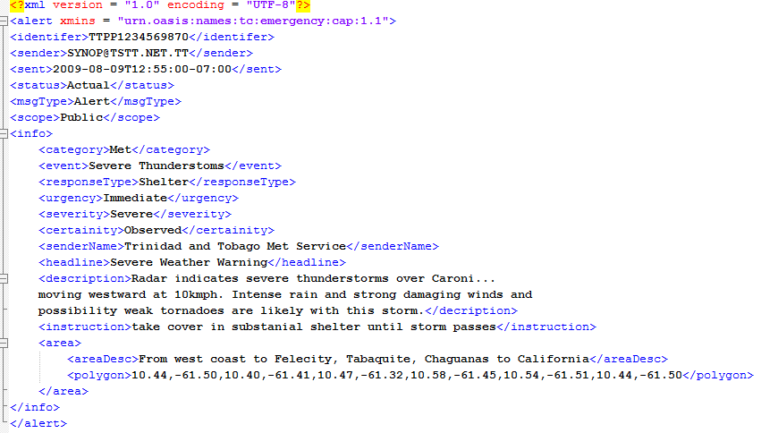

Figure 6: CAP Example of a digital message format for all alert types

31. The benefits of the CAP system have been noted by at least one Member State for some time. The oldest CAP system was installed by the Department of Disaster Management in Anguilla. The United Nations Development Programme (UNDP) Office for Barbados and the Organization Eastern Caribbean States (OECS), under a project entitled “Overseas Countries and Territories (OCTs) Regional Risk Reduction Initiative (R3I)” is using the Anguilla CAP System as a model to roll-out similar CAP systems to the Disaster Management Agencies in the British Virgin Islands, the Cayman Islands, Montserrat and the Turks and Caicos Islands.

32. In August 2012, the Office of Disaster Preparedness and Management (ODPM) in Trinidad and Tobago, with the assistance of the UNDP Office for Trinidad and Tobago, issued a procurement notice to engage a consultant, to develop a methodology for the Strengthening of Emergency Communication and the Establishment of a Multi-hazard Early Warning System in Trinidad and Tobago. It is most likely that the Consultant will recommend a CAP System.

33. It should be noted that thus far, the introduction of a CAP system in each of the five countries named above is driven by the National Disaster Agency, although the issuance of warnings is the responsibility of the National Meteorological Service or in the case of Anguilla, the British Virgin Islands and Montserrat, by the Antigua and Barbuda Meteorological Service. Hence, it would be prudent that there be proper communication between Organizations to ensure that the population’s needs are met.

________

October 2012
ABS QE Headquarters
16855 Northchase Dr.
Houston, TX 77060
Tel: 1-281-673-2843
Fax: 1-281-673-2844
email: certification@abs-qe.com
Website http://www.abs-qe.com/

Advantage International Registrar, Inc.
9660 Falls of Neuse Road
Ste. 138, PMB 141
Raleigh, NC 27615-2435 USA
Tel:1 919-846-6864
Fax: 1 919-846-2074
email info@advantageregistrar.com
Website: http://www.advantageregistrar.com/

AJA Registrars Ltd
Registered Office
Unit 6, Gordano Court
Gordano Gate Business Park
Serbert Close
Portishead,
BS20 7FS
Tel: +(0)1275 849188
Fax: +(0)1275 849198
E: enquiries@ajaregistrars.co.uk
Website http://www.ajaregistrars.co.uk/

AMTec
American Management Technology
1106 Kathy Court
Fontana, Wisconsin 53125
Phone:1 262-275-5468
FAX: 1 262-275-1418
email: caren@amtecregistrar.com
Website: http://www.amtecregistrar.com/

Lloyd's Register Quality Assurance, Inc.
1330 Enclave Pkwy, Suite 200
Houston, TX 77077
United States
Tel: 1 281 649-2293
Fax: 1 281 398-7337
Email: inquiries-usa@lrqa.com
Website: http://www.lrqausa.com/

AQA International
World Headquarters
501 Commerce Drive, NE
Columbia, SC 29223 USA
ph: 800.281.4384
fx: 803.779.8109
email: sblazik@aqausa.com
Website http://www.aqausa.com/

DLS Quality Management, Inc.
108 Hallmore Drive
Camillus, NY 13031
Phone: 1 315.672.3598
Fax: 1 315.672.3596
Email: dlsqual@aol.com
Website: http://www.dlsqual.com

Great Western Registrar L.L.C.
21835 North 23rd Avenue
Phoenix, AZ 85027
Tel: 623-580-1881
Fax: 623-505-9685
Email: karey@greatwesternregistrar.com
Website: http://www.greatwesternregistrar.com

SOQAR Inc
24840 Burnt Pine Drive – Suite 5
Bonita Springs, FL 34134
Toll Free 866 9 ISOQAR (866 947 6727)
Telephone 239 947 6980
Fax 239 947 4251
Email: george.maxwell@isoqarinc.com
Website: http://www.isoqarinc.com

Bureau of Standards Jamaica
6 Winchester Road,
P.O. Box 113 Kingston 10
Tel: (876)-926-3140-5
Fax: (876)-929-4736
Email: info@bsj.org.jm
Website: http://www.bsj.org.jm/

