C A R I B B E A N
M E T E O R O L O G I C A L
O R G A N I Z A T I O N

ANNUAL MEETING OF DIRECTORS OF METEOROLOGICAL SERVICES Doc. 4
Rodney Bay, SAINT LUCIA - 14th NOVEMBER 2012

THE CMO RADAR NETWORK

(Submitted by the Coordinating Director)

INTRODUCTION

1. In 2009, four new Doppler weather radars were installed in CMO Member States through a project of the Caribbean Forum of Africa, Caribbean and Pacific (ACP) States (CARIFORUM), funded by the European Union and implemented by the CMO. These radars joined several other existing radars operated by other States as part of the region’s early warning system.

2. In order to complete the network of nine radar stations which are located in Barbados, Belize, the Dominican Republic, French Guiana, Guadeloupe, Guyana, Jamaica, Martinique and Trinidad and Tobago, the radars are required to generate scans at specific times, elevation and range, which could be transmitted in a code form that would allow for the creation of a radar mosaic by the compositing centre in Martinique. The radar data from the eight radars would be transmitted via the World Meteorological Organization (WMO) Global Telecommunication System (GTS) to Martinique, then Martinique would transmit the mosaic after creation.

3. Through consultation with the various meteorological partners associated with the Project, it was decided that the radars must have the ability to generate the radar data in Binary Universal Form for the Representation (BUFR) of meteorological data. Further, the data which would be transmitted in BUFR would be scans at a range of 400km at zero degree elevation and that the scans would occur every fifteen minutes starting precisely on the hour.

TELECOMMUNICATIONS
4. During 2012, the Headquarters Unit, the Barbados Meteorological Service and the United States National Weather Service collaborated to get the radar data from the 400km scan through the GTS onto the servers in Washington. The data was being transmitted by the Barbados Meteorological Service on the GTS but was being dumped by the server. The problem was identified as a requirement to have included in the message, the file size in a specific format before the WMO header. This was rectified and data was able to be stored on the server, as shown in Figure 1. However, the changes in the BUFR message to include the file size have resulted in additional work for Météo-France to create a code that will automatically remove that line within the BUFR message before it could include Barbados in the mosaic.

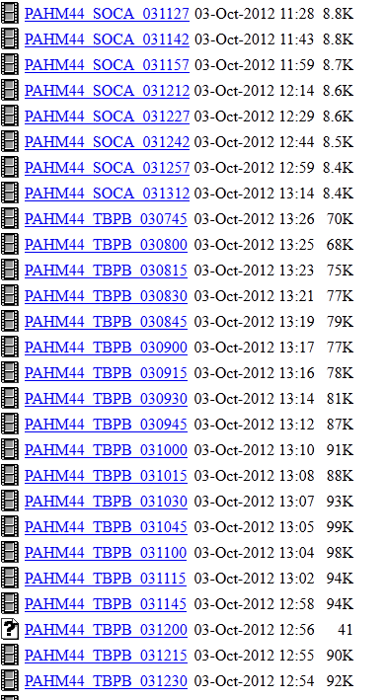
Figure 1: Screen capture of the Radar folder on the GIFS server

INTERNET ACCESS
5. All radar host countries have successfully established a website in which there is radar imagery for the public's use. However, only the Meteorological Service in Trinidad and Tobago has provided FTP access to the radar data, as agreed between CARIFORUM and the radar host countries. It is hoped that in the not-too-distant future, the Meteorological Services in Barbados, Belize and Guyana will provide FTP access to their radar data.

MAINTENANCE ISSUES
6. After the passage of Hurricane Tomas through the Eastern Caribbean, the radar in Barbados was switched off due to issues with the uninterrupted power supply (UPS). The length of time that the radar was switched off caused problems to develop with the radar components. Hence, the radar was not fully restored until August 2011. Similarly, the radar in Trinidad was switched off during October 2011 because of a problem with an electrical board in the UPS. The board was replaced during the first quarter of 2012. However, some electrical components of the radar subsequently malfunctioned because of the length of the down-time, and at the time of the writing of this report, the radar had not yet returned to operational status.

7. The sequence of events which led to the protracted down-time of the radars in Barbados and Trinidad suggests that efforts should be made to minimize the length of time that the radars are not powered. This would prevent some components, such as electrical boards, from deteriorating during prolonged down-time, which would likely result in their replacement.
_________
October 2012

