C A R I B B E A N
M E T E O R O L O G I C A L
O R G A N I Z A T I O N

CARIBBEAN METEOROLOGICAL COUNCIL Doc. 4(a)
FIFTIETH SESSION
George Town, Grand Cayman, CAYMAN ISLANDS, 22-23 NOVEMBER 2010

THE COORDINATING DIRECTOR’S REPORT - 2010

ON CMO HEADQUARTERS UNIT ACTIVITIES

(Submitted by the Coordinating Director)

1. This document highlights activities of the CMO Headquarters since the 49th session of the Council, held in Tortola, British Virgin Islands on 9-10 November 2009. Factors affecting operational aspects at the Headquarters and other matters of interest are also mentioned for information and guidance where appropriate. Details of some activities and developments, where necessary, will be dealt with under separate agenda items.

- For the CMO Headquarters, 2010 was the first year in many in which the 13.2 million Euro European Union-funded CMO Radar Project was not at the centre stage of its activities. The implementation phase concluded in June 2009. A feature of 2010 that impacted on the Headquarters activities was related to the weather itself. A severe regional drought carried over from the latter part of 2009 into the first quarter of 2010, in which all sectors of society were affected. This was complicated, to some extent, by the fall-out of the disastrous earthquake in Haiti in January 2010 that affected weather services. Then after a quiet start, a very active hurricane and rainy season kept the Meteorological Services throughout the Caribbean and the CMO engrossed in operationally-related activities. At the time of preparing this document, overall tropical cyclone activity for the 2010 hurricane season was about 164 percent of the long-term median, with tropical depressions, storms and hurricanes affecting several CMO Member States. Belize was impacted by Tropical Storms Alex, Karl and Matthew and the direct hit by Hurricane Richard. Antigua and Barbuda and several Leeward and Virgin Islands were affected by Hurricane Earl, as well as close encounters with Tropical Storm Fiona and the remnants of Hurricanes Gaston and Otto. Barbados, St. Lucia, St. Vincent and the Grenadines, Dominica and Tobago (Trinidad and Tobago) were severely impacted by Hurricane Tomas, which later swept across the Turks and Caicos Islands. Earlier in the season, the Turks and Caicos Islands were also affected by a depression that became Hurricane Bonnie in the Bahamas. There was loss of life in Belize and St. Lucia from these systems. At the same time, almost every CMO Member State experiences multiple episodes of severe flooding and disruptions throughout the season from tropical waves or depressions, notably the Cayman Islands, Barbados, Jamaica, St. Lucia and Trinidad and Tobago, in which there was again loss of life. A graphical summary is presented in ANNEX I to this document. The CMO Headquarters is very pleased with the timeliness and effectiveness of the various warnings issued by all the Meteorological Services.

- Notwithstanding the weather-related events, a primary focus for the Headquarters during the year has been to get the Meteorological Services of Member States ready to implement the increasing number of regional and international programmes and activities that must be adhered to over the next few years. This was made fairly difficult by the impact that the continuing difficult global and regional economic situation had on the operations of the CMO Headquarters. As discussed in greater detail under Agenda Item 6(c), the very slow and a decline contributions from Member States to the organs of the CMO in 2010, continuing on from 2009, resulted in some curbing of activities on behalf of the Member States themselves.

4. In this context, the CMO Headquarters still had to find ways to ensure that the most urgent and critical matters were dealt with to the best of its ability. The Council will recall that, starting a few years ago, a compulsory requirement for Meteorological Services in the Caribbean and elsewhere has been the implementation of Quality Management Standards (QMS) for their operations. The driving force behind the requirement is the International Civil Aviation Organization (ICAO) in collaboration with the World Meteorological Organization (WMO). Included in the QMS are Staff Requirements & Standards set out by WMO and ICAO. Policies are already being introduced to extend the application of these standards to all areas of the Meteorological Services. The CMO Headquarters and the Caribbean Institute for Meteorology and Hydrology (CIMH) have been working tirelessly with the Meteorological Services to assist them in preparing for the implementation of QMS. Greater details are provided under Agenda Item 9.

5. The CMO keeps abreast of regional and international matters primarily through its intimate involvement with the WMO, as well as with ICAO and other regional partners. The Coordinating Director, as the WMO Second Vice-president and a member of its Executive Council, maintains a strong and now experienced team of senior Advisors and Experts that have all individually become fully versed in WMO’s programmes and activities. In addition, the Coordinating Director has increased the number of focal points on specific topics within the WMO programmes, some of whom are from the CIMH. The importance of the CMO teams and focal points to WMO’s regional activities has increased as most are now quite heavily engaged in the implementation of a number of regional and even global programmes of WMO, such as the implementation of the regional components of the WMO Integrated Global Observing System (WIGOS) and the technical transitioning of the Meteorological Services to new forms of data exchange. The CMO is also currently quite heavily involved in assisting WMO with its regional activities in hydrology and in the Enhancing Capabilities of Member in Multi-Hazard Early Warnings and Disaster Prevention, and serves on project steering committees of other regional and international organizations, such as the CDEMA, UNDP and the Association of Caribbean States. The ANNEX to this document indicates meetings and other events attended (or scheduled attendance) by officers of the CMO Headquarters in 2010.

6. Under Agenda Item 4(b), the Council will be provided with details of the programme of the CIMH. Along with its regional role as an organ of the CMO, the CIMH also has, by agreement between the CMO and the WMO, an internationally recognized role as (i) a WMO Regional Training Centre (RTC), (ii) a WMO Regional Instrument Centre (RIC) and (iii) a WMO Centre of Excellence (CoE) for Satellite Meteorology. The Coordinating Director will seek the endorsement of the Council to have the CIMH developed and recognized as a WMO Regional Climate Centre (RCC) for the English-speaking Caribbean.

7. In addition to its current activities, the CMO Headquarters will be, over the next eighteen months or so, heavily occupied in assisting the Government of the Cayman Islands implement its project to install a Doppler weather radar on Grand Cayman. This important project will become the centrepiece of the Cayman Islands early warning system against hurricanes and other severe weather and will be a major contribution of the Cayman Islands to the region-wide hurricane warning system.

8. In spite of the forgoing activities, which must be undertaken, there are increasing demands for the CMO to contribute to, or partner with institutions and organizations in many areas. Unfortunately, the CMO Headquarters finds it increasingly difficult to become involved because of the level of its human resources. It is simply not physically possible for more activities to be undertaken until the professional staff level is increased. The Council recognized this fact several years ago and decided on an appropriate increase in staff. However, with the economic downturn in the region in 2009 and 2010, this has been held in abeyance. The Council should know that the continuing deferral of its decisions in this regard could have a compounding negative impact for years to come. This matter will be discussed further under Agenda Item 7(b).

9. Some of the internal issues of the Headquarters will also be addressed within the budget estimates of Agenda Item 7(b). These will include the ongoing unsettled issue of the status of the building occupied by the CMO Headquarters in Port of Spain. Since the CMO Headquarters relocated in early 2008, attempts by the owner of the premises to obtain approval for a rezoning from residential commercial have not reached conclusion. The relevant Ministry in Trinidad and Tobago is assisting. However, until it is resolved, the Government of Trinidad and Tobago is unable to pay the rent for the premises, based on the Host Country Agreement on the CMO, so that the CMO Headquarters has to undertake the payment of the rent during this protracted activity, resulting in an enormous budgetary burden that threatens to bring the entire operations of the Headquarters to a halt.

10. Internal issues of the Headquarters include attempts to settle a dispute between the CMO and the European Union over the interpretation of particulars of a contract implemented within the EU-funded CMO Radar Project that ended in June 2009. The matter is being addressed in consultation with the Secretary-General of the Caribbean Forum for ACP States (CARIFORUM), which is the Contracting Agency for the Project.

11. The CMO Headquarters continues to promote the participation in as many scientific, technical and training events as possible by the National Meteorological and Hydrometeorological Services and the CIMH, particularly those sponsored by the WMO and its partners that have a special relevance to the region. The number of such opportunities in 2010 returned to a more normal level after a drop over the last few years. The Coordinating Director facilitated or arranged for the participation of staff and other officiials from the Cayman Islands, Grenada and the CIMH at the events in 2010 listed below. In addition, the Coordinating Director was able to secure a fellowship from the WMO for a staff member of the Meteorological Service of St. Kitts & Nevis, although not a Member State of WMO, to fund his final year of the Bachelors programme in Meteorology at the Cave Hill Campus of the University of the West Indies:

- WMO Satellite Data Requirements Workshop, (Brazil, February 1-3) - Ms Kathy-Ann Caesar, CIMH
- WMO RA IV Workshop on Hurricane Forecasting and Warning and Public Weather Services (Miami, Fl., USA, March 15-26) – Mr Albert Munro, Grenada
- WMO Training Workshop on Multi-Hazard Early Warning Systems (MHEWS), with Focus on Institutional Partnerships and Coordination, (San José, Costa Rica, March 22-25) - BCT Reps:- Mr John Tibbetts, NWS & Mr Omar Afflick – Hazard Management, Cayman Islands
in conjunction with
- WMO Coordination Meeting on Multi-Hazard Early Warning Systems Development in Central America and the Caribbean, (San José, Costa Rica, March 26) - CMO Reps to both sessions: Mr John Peters – NMS & Mr Terence Walters, National Disaster Management Agency (NaDMA) – Grenada
- WMO/IOC JCOMM Training Workshop on Marine Instrumentation for the Regional Association IV, (Stennis Space Center, Saint-Louis, MS, USA, April 13-15) – Mr Damien Prescod, CIMH
- Study Tour and WMO Symposium on Meteorological Service Delivery and Disaster Risk Reduction (Beijing & Nanjing, China, May 5-16) – Mr Fred Sambula, Cayman Islands
- WMO International Workshop on Satellite Meteorology, (Beijing, China, June 22-July 2) - Dr Andrea Sealy, CIMH
- WMO International Workshop on Addressing the Livelihood Crisis of Farmers: Weather and Climate Services (Belo Horizonte, Brazil July, 12-14)
in conjunction with
- WMO Commission for Agricultural Meteorology – 15th Session (Belo Horizonte, Brazil, July 15-21) – Mr Adrian Trotman, CIMH – BCT Delegate
- CIMO Technical Conference 2010 (Helsinki, Finland, August 30-September 1) in conjunction with
- WMO Commission for Instruments and Methods of Observation - 15th Session (Helsinki, Finland, September 2-8) – Mr Marvin Forde, CIMH – BCT Delegate
- WMO Workshop on Human Resources Development for NMHSs in South American Countries and SIDS (Lima, Peru, October 4-8) – Mr Kerry Powery, Cayman Islands (BCT) [along with Antigua & Barbuda; Jamaica; Trinidad & Tobago]
- ICAO/WMO Seminar/Workshop on SIGMET Information for the NAM/CAR/SAM Regions (Guatemala City, Guatemala, October 11-15) – Ms Kathy-Ann Caesar, CIMH (with Jamaica, Guyana & T&T)
- WMO Technical Cooperation Workshop for Development of the Caribbean Regional Cooperation Programme in Multi-Hazard Early Warning System, (Barbados, November 2-5) - Mr John Peters, Grenada, Mr Shawn Boyce, CIMH, among others
- 7th WMO International Workshop on Tropical Cyclones (La Reunion, France, November 15-20) – Mr Lawrence Pologne – CIMH (along with Mr Clem Williams, Barbados, Mr Dale Destin of Antigua & Barbuda).
12. The CMO, as an Organization, comprises 16 Member States. The Directors/Heads of Meteorological and Hydrometeorological Services are the primary points of contacts for Member States with the organs of the CMO (Headquarters & CIMH). The contribution to their Services and to meteorology and hydrology at the regional and international levels is therefore well known within the CMO.

13. In this regard, CMO wishes bon voyage to the veteran Meteorologist Mr Chester Layne, who retired in 2010 as the Director of the Meteorological Services of Barbados. In his career, Mr Layne as served in every specialty position within the Meteorological Service. As Director, he played a major role in the affairs of the CMO and the WMO at the regional and international levels. He took a very active part in WMO’s regional Hurricane Committee and he focussed on ensuring that the Barbados Meteorological Services, along with the relevant national authorities, were part of an excellent early warning system, climaxing with the installation of the Doppler Weather Radar in St. Joseph, Barbados just prior to his retirement.

14. It is also expected that the region will lose to retirement in the very near future, one of its longest serving and most dedicated daughters of meteorology. In anticipation, the CMO proudly salutes Mrs Sylvia McGill, Director of the Meteorological Services of Jamaica, for her outstanding contribution to her nation, the region and the wider meteorological community. Mrs McGill was one of the very early students at the Caribbean Meteorological Institute (now the CIMH) back in 1969. She will be missed.

Action Proposed to Council:

15. The Council is invited to:

- note the impact of the very active 2010 hurricane season and commend the National Meteorological Services of those Member States affected in the timeliness and effectiveness of warnings issued;
- note the activities and issues concerning the CMO Headquarters in 2010, particularly those dealing with the implementation of major WMO and ICAO-related activities;
- note concerns about the impact of the previous deferrals of the filling of new staff posts are having on the programmes of the CMO Headquarters;
- discuss and endorse the proposal to have the CIMH developed and recognized as a WMO Regional Climate Centre (RCC) for the English-speaking Caribbean;
- note the actions being taken to rectify matters concerning the lease on the premises of the CMO Headquarters and provide any guidance on the matter;
- discuss the dispute between the CMO and the European Union over a particular contract implemented within the concluded EU-funded and urge the Secretary-General of CARIFORUM to work diligently towards an amicable solution;
- note the contribution to their nations, the Organs of the CMO and the international meteorological community by Mr Chester Layne of Barbados and Mrs Sylvia McGill of Jamaica.
_________

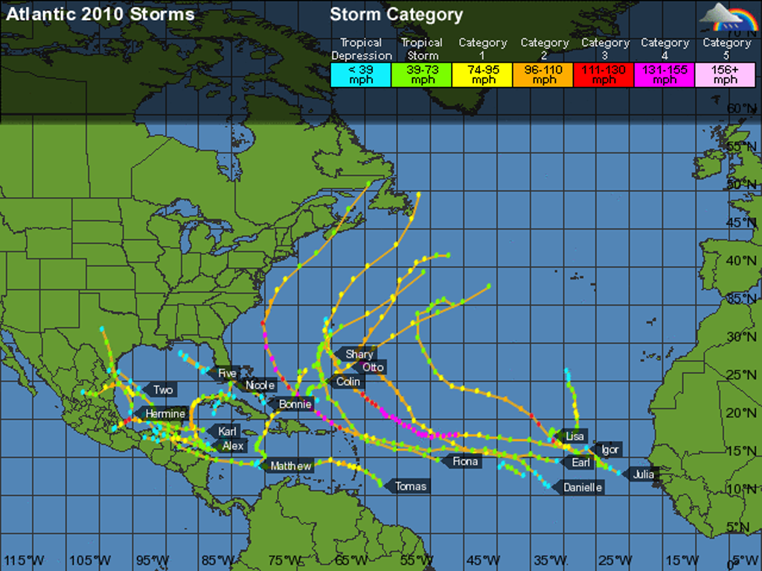

2010 Tropical Storms and Hurricane tracks in the Atlantic-Caribbean basin (courtesy Weather Underground)

2010 CMO HQ Missions

(not related to the CMC meetings)

January 16–21 90th Annual Meeting of the AMS - “Weather, Climate, and Society: New Demands on Science and Services”, Atlanta, GA [CD]

January 25-26 Sixty-Third Session of the WMO Bureau, IOC/UNESCO Headquarters, Paris [CD]

January 27 WMO-IOC Officers Consultation Meeting, IOC/UNESCO Headquarters, Paris [CD]

January 28-29 Tenth session of the WMO Consultative Meetings on High-level Policy on Satellite Matters (CM-10), WMO Headquarters, Geneva [CD]

February 3-10 WMO Commission for Aeronautical Meteorology (CAeM) - 14th session, Hong-Kong, China [STO]

February 11 Caribbean Agrometeorological Initiative Stakeholders Meeting – Barbados [CD]

March 8-12 WMO RA IV Hurricane Committee, Thirty-second session, Bermuda [CD & STO]

March 22-24 CARICOM Meeting of Officials on Institutions and Associate Institutions, Barbados [STO]

March 24-26 WMO EC Working Group (EC-WG) on the WMO Integrated Global Observing System (WIGOS) and the WMO Information System (WIS), Third session, WMO Secretariat, Geneva, Switzerland [CD]

March 29 Meeting on Finland/ACS SHOCS Project, ACS Headquarters, Port of Spain [CD]

April 7 Cayman Islands Special Radar Meeting, Grand Cayman, Cayman Islands [CD & STO]

April 28-30 CARIB-HYCOS Steering Committee, 2nd session, Fort-de-France, Martinique [CD]

May 4 OCTs Regional Risk Reduction Initiative (R3I), First Meeting of the Project Board, Tortola, British Virgin Islands [STO]

June 6-7 WMO Financial Advisory Committee (FINAC), WMO Secretariat, Geneva, Switzerland [CD]

June 7 64th session of the WMO Bureau, Geneva, Switzerland [CD]

June 8-18 62nd session of the WMO Executive Council, Geneva, Switzerland [CD & STO]

July 12-13 WMO Disaster Risk Reduction Consultancy Meeting, CMO HQ, Port of Spain [CD & STO]

September 9-10 ACS Special Committee on Disaster Risk Reduction, 18th Meeting, Santo Domingo, Dominican Republic [CD]
in conjunction with
September 11 Finland/ACS SHOCS Project, 1st Project Board Meeting, Santo Domingo, Dominican Republic [CD]

October 12-13 WMO EC Working Group on Capacity Building, Geneva, Switzerland [CD]

October 18-20 R3I Workshop: “From risk information to an efficient public warning system on floods”, St Maarten [STO]

October 22 CDEMA - 6th Meeting of the PSC on EDF Institutional Support and Capacity Building for Disaster Management in the Caribbean, Barbados [STO]

November 2-5 WMO Workshop for the Development of the Caribbean Regional Cooperation Programme in a Multi-Hazard Early Warning System, Barbados [STO]

November 11-13 65th session of the WMO Bureau, WMO Secretariat, Geneva, Switzerland [CD]

- - - - - - - - - - - - - - - - - - - - - - - - - - - - - - - - - - - - - - - - - - - - - - - - - - - - - - - - - - - - - - - - - - - - - -
December 6 WMO - Final Consultation on the Caribbean Regional Programme in Multi-Hazard Early Warning Systems, Montego Bay, Jamaica

___________

