C A R I B B E A N
M E T E O R O L O G I C A L
O R G A N I Z A T I O N

CARIBBEAN METEOROLOGICAL COUNCIL Doc. 10
FIFTIETH SESSION
George Town, Grand Cayman, CAYMAN ISLANDS, 22-23 NOVEMBER 2010

CMO WEATHER RADAR PROJECTS
(Submitted by the Coordinating Director)

Introduction

1. The 49th session of the Caribbean Meteorological Council (Tortola, 9-10 November 2009) discussed the transition from one weather radar project to another. The year 2010 would be the first year in which the Headquarters of the Caribbean Meteorological Organization (CMO) spent more time focussing on the new weather radar project of the Government of the Cayman Islands than on the CARIFORUM-administered, European Union-funded radar project, since the latter came to an end in 2009. These radar projects consume a considerable amount of the Headquarters’ human resources, particularly in time, whether in a start-up, operational or post-operational mode of implementation.

2. In the case of the EU-funded project, the Council will be briefed on post-implementation activities. Lingering implementation matters within the Project that require resolution will be discussed separately under Agenda item 4(a). The Council will also be informed of the role of the CMO and the progress towards the implementation by the Cayman Islands Government of its Doppler weather radar system.

A. CARIFORUM/EU PROJECT – Post Implementation Activities

Background

3. The “Regional Weather Radar Warning System Project, as it was officially known, was administered by the Caribbean Forum of ACP States (CARIFORUM), funded by the European Union and implemented by the CMO. It was designed to replace an old and obsolete analogue radar network installed by the CMO in the late sixties and early seventies. The Financing Agreement between the European Commission and CARIFORUM was signed in late 2003, the Project implementation got underway in July 2004 and ended on 30 June 2009. This Project, initially approved at 13.2 million Euros, constructed and installed four powerful, high-precision S-band Doppler radars, manufactured by the Selex Sistemi Integrati of Germany, were installed in Barbados, Belize, Guyana and Trinidad and Tobago. These four new radars, along with the Doppler radar installed by Jamaica in 1999, form the new CMO Weather Radar Network. These are also being linked with other radars in the region to form a full regional network.

4. Memoranda of Understanding were signed between CARIFORUM and the Governments of Barbados, Belize, Guyana and Trinidad and Tobago which defined the deliverables by each party to the Radar Project during and post implementation. This section of the document will deal with post implementation matters arising from these MoUs, specifically the operations of the weather radars by the host Governments and particularly issues that require firm actions at the national level to meet international commitments and to ensure the smooth and complete operational use and sustainability of the four new radars.

5. Many operational issues that have to be implemented by the Meteorological and Hydrometeorological Services operating the radars will be dealt with in detail at the Meeting of Directors of Meteorological Services (DMS2010), which will then report, as appropriate, to this session of the Council. However, the Council is reminded that Article 4.1 of each MOU states, in part, that the Government agrees to “operate the Radar Station through the Meteorological/Hydrometeorological Service under the general auspices of the CMO”.

6. Table 1 below provides obligations extracted from the MOUs for which actions were still required or not yet complete within the Meteorological Services.

Table 1: Extracts from Memoranda of Understanding on the Project
Article Number | Text | Some Related Actions Required
5.5 | The Government, …. agrees to make selected “real-time” data …available to other regional Meteorological Services, …. the regional composite radar image system ….and ….. the National Hurricane Center of the USA. | See 6.5 & 6.8 below. Provision of radar imagery to Met. Services, composite centre and the U.S. Hurricane Center is minimal and not fully meeting professional requirements.
6.1 | The Radar Station will be operated by the NMS in accordance with the technical specifications of the manufacturers and within the technical and administrative arrangements established under the CMO. | NMS to establish strict radar management, including restriction of control of radars to designated System Managers (SM).  [CMO has concerns that some designated & trained SMs are not actually functioning as SMs.]
6.5 | The NMS will operate an Internet Server or any agreed superseding technologies to provide radar data to the public and other users. | Establish internal data networks within the NMS and subsidiary offices to share radar data; modern/adequate websites for radar and regular weather data, forecasts and warnings.  [Progress in this area is excessively slow and apparently given low priority. Three of the four NMSs have Websites with radar imagery for public access. Two of the websites received imagery automatically from the radar. The 4th has not yet established a Website but has at least two pages on the parent ministry’s website, where only the mosaic of Météo-France can be accessed. In most cases, available imagery is not adequate for public or professional use.]
6.6 | The NMS will establish the arrangements to provide “real-time” weather radar data to any special user that may have such requirements for its operations. | Planning of local arrangements for data to civil aviation (Air Traffic Control), disaster management, hydrological users, etc.  [This should be a priority along with or after 6.5 above. None yet achieved.]
6.8 | …agrees to participate in the creation of a regional Radar Composite System and Service, through the Météo-France facility in Martinique (SRMA), as defined in arrangements between the CMO and Météo-France. | Regional and international radar data transmission using the WMO BUFR code via the WMO Global Telecommunication System (GTS) and to specific meteorological users using file transfer protocol (ftp) servers.  [Slow progress- only one NMS has an ftp server. Only two transmit – very intermittently – in BUFR code to Martinique. Regional NMSs not receiving benefit from Composite system.]
6.8 (v) | The NMS will participate in a Technical Committee, along with representatives of the other Radar Stations and the SRMA, to determine all technical matters in connection with the Composite Service. | CMO will establish Technical Committee in 2009 comprising System Managers, the CIMH, Météo-France and the CMO HQ. CMO will also establish a Network/Committee of radar technicians.  [Activation is dependent on 6.1 & 6.8]

7. In addition to comments expressed in Table 1 above, the CMO has concerns that not all the personnel trained in radar maintenance by the radar manufacturer, SELEX-Gematronik, are in fact working with the radar in that capacity. Three technicians each from Belize, Guyana and Trinidad & Tobago and two each from Barbados and the CIMH were trained. With the exception of just a few, all the technicians were completely new to radar maintenance. Although the radars are new, there is already evidence of movement of these trained personnel from this task. Familiarity by trained technicians with the radar operations is critical to the longevity of the weather radars, and it is highly advisable that all such personnel spend an adequate amount of time with the radars. The CMO Headquarters believes that there already is the need for periodic refresher maintenance training or training of new maintenance personnel. This is currently under consideration within project proposals under the CIMH (see Agenda Item 4(b)).

8. The Council will recall the circumstances that led to the elimination from the EU-funded Radar Project of the entire Radar Meteorology Training Programme, a very major element designed to provide training in the interpretation of the data from the radars to the meteorological staff that will operate and utilize the radars. The CMO therefore explored the use of residual funds from another regional project administered by the World Meteorological Organization to undertake a scaled-down training programme. It has since been realized that such a scaled-down programme may not adequately meet the needs of the region. As with the refresher maintenance training, further funding for the training programme is currently under consideration within project proposals under the CIMH (see Agenda Item 4(b)).

B. OPERATIONS OF THE CENTRAL RADAR SPARES DEPOT AND MAINTENANCE SUPPORT FACILITY AT CIMH
9. From the introduction of weather radars into the CMO Member States in the late sixties and early seventies, the CIMH has played a critical role in providing training in radar meteorology and in operating a central maintenance support facility. Both these roles are critical to the long-term sustainability of the new weather radars.

10. As was done in the earlier CMO Radar Network, a new Central Spares Depot and Maintenance Support Facility has been established at the CIMH. Each radar site was provided with two sets of radar spares, while a further set was supplied to the CIMH as central spares for the region. Two personnel from the CIMH were also trained in radar maintenance at the SELEX facility in Germany to manage the Central Spares Depot and to provide maintenance support to any of the four radar sites if needed. An arrangement had been put into place between the Barbados Meteorological Service and the CIMH for the CIMH technicians to assist in the routine maintenance of the radar in Barbados.

11. From the onset of this radar Project, the Council decided that the Central Spares Depot/Facility would operate on a supply and replace basis, so that if a radar site required any spares from the CIMH, which would normally be as an emergency, the CIMH would supply the component, and the Member State would pay the CIMH for the part so that the CIMH could purchase a replacement for the Depot/Facility. It is therefore imperative that the CIMH establish a properly computerized management system for the inventory of spares and access to and replacement of spares.

12. The CIMH has commenced setting up the Central Spares Depot/Facility and, to-date, the following has been achieved:
- The Radar Manifest has been computerized into a database using open source software;
- The costs of the spares are also in the database. However, the weight of the items will have to be assessed for the database when they are unpacked and placed into storage (the weight will have to be known for the generation of a shipping invoice as this will affect shipping costs). A cost effective method of storing the spares is to be decided upon given the allocated space for the spares;
- Provisions are under way to create a Graphical User Interface (GUI) for the database to create a computerized inventory management system. This will assist authorized persons to the storage area, in keeping the management of the inventory as accurate as possible. The generation of a shipping invoice will also be done in an automated fashion so they can be produced in a timely and uniform manner;
- The value of the proposed spares Trust Fund could be made available to certain users to the management system.

13. Once the set up of the Central Spares Depot and Maintenance Support Facility has been completed, the CIMH will circulate to the relevant Member States, the Rules and Procedures of the Facility. It is important to note that the CMO purchased a three-year warranty on the radars from the manufacturer SELEX. For most sites, two years have essentially passed, so that each site and the CIMH Depot must be fully ready to manage their maintenance issues on their own in the near future.

14. In this regard, Council will recall that it agreed to a proposal from Barbados for the establishment of the Trust Fund for the purchase of spares and associated shipping costs. The proposal from Barbados was that the four radar host countries, Barbados, Belize, Guyana and Trinidad and Tobago would contribute the sum of BD$10,000.00 per year to the Trust Fund to be held by the CIMH for the purchase of spares and associated shipping costs. The establishment of the Trust Fund will be pursued in 2011.

C. CAYMAN ISLANDS WEATHER RADAR PROJECT - COMMENCEMENT

15. Paragraph 3 above described the new CMO Weather Radar Network, which now comprises the Doppler radars in Belize, Barbados, Guyana, Jamaica and Trinidad. The CMO network is an integral part of a wider network involving radars in the French Caribbean islands of Guadeloupe and Martinique and the radar at the European Space Agency in French Guiana. It is intended that other radars in the Dominican Republic, Puerto Rico and the newly formed country of St. Maarten will be added to the Network to form a weather radar fence stretching along the South American coast to Trinidad, then north along the Eastern Caribbean Islands, then westward across the Greater Antilles to Jamaica and to Belize in Central America. One glaring blind spot in the radar coverage exists around the Cayman Islands. The Council will recall that, a few years ago, the CMO Headquarters made a proposal to the Government of the Cayman Islands to close that gap.

16. The Cayman Islands Government has since developed the Cayman Islands Weather Radar Project to install a Doppler weather radar on Grand Cayman. The Project, estimated to cost Euro 4.6 million, will be jointly funded by the European Union and the Cayman Islands. Once implemented, the new Doppler weather radar would form the centrepiece of the Cayman Islands early warning system and would be integrated into the full CMO network, as depicted in Figure I below.

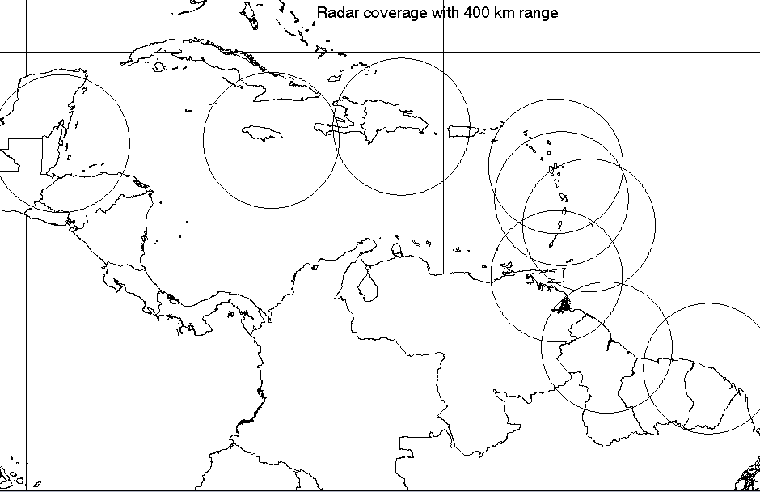
Belize
Jamaica
Dominican Rep.
Guyana
Fr, Guiana
Guadeloupe
Trinidad
Barbados
Martinique
Cayman Isl.

Figure 1: Proposed Radar for the Cayman Islands to provide complete Caribbean radar coverage

17. The Cayman Islands Airport Authority (CIAA) is the Project’s Implementing Agency. The CMO will provide scientific and technical support to the Project through the following two separate contracts, valued at Euro 99,040.00 and CI$546,000, between the CMO and the CIAA:
- Contract for the procurement, testing and commissioning of Radar and telecommunication systems, including the integration of the new radar in the existing Regional Radar Network and an internal distribution system;
- Civil Works planning and supervision, including site selection, associated surveys and studies, and a meteorological training component.

18. The first contract was signed in October 2010. The CMO will undertake its part of the Project implementation by augmenting its Headquarters personnel with two integrated teams comprising a hydrogeologist, radar meteorologists, telecommunication experts, engineers, architects and other construction specialists. If all implementations proceed as planned, the new radar could be operational in 2012.

Action Proposed to Council:

19. The Council is invited to:

- Urge the radar host countries to give priority to complete all operational matters that impact on the proper operations of the radars, as agreed to by their respective Governments;
- Provide any further guidance and support for the operations of the Central Spares Depot and Maintenance Support Facility established at CIMH;
- Note and provide any further guidance it may desire towards the implementation of the new Radar Project in the Cayman Islands.
___________

CMO Headquarters
October 2010

