C A R I B B E A N
M E T E O R O L O G I C A L
O R G A N I Z A T I O N

CARIBBEAN METEOROLOGICAL COUNCIL Doc. 3(d)
FORTY-SIXTH SESSION
St. John’s, ANTIGUA & BARBUDA, 7-8 DECEMBER 2006

THE COORDINATING DIRECTOR’S REPORT - 2006

ON CMO HEADQUARTERS UNIT ACTIVITIES

CMO STANDARD - UNVEILING
(Submitted by the Coordinating Director)

1. The Caribbean Meteorological Council, at its 45th session in 2005, approved the following design of a Standard for the Caribbean Meteorological Organization.

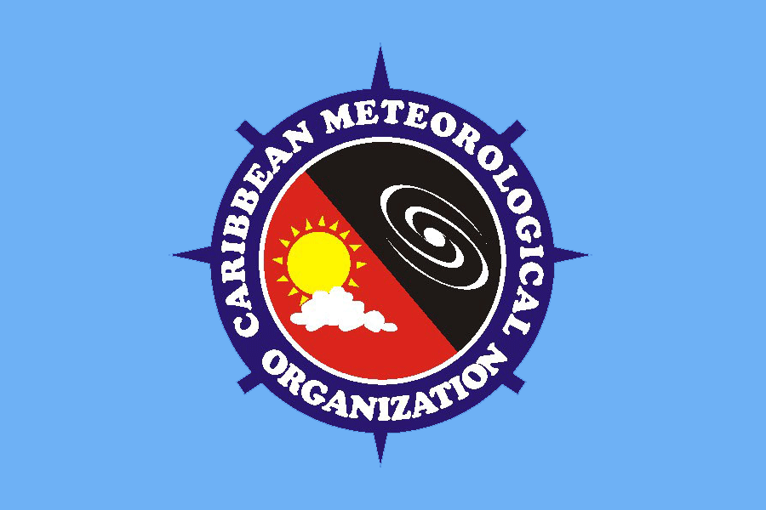

2. The standard has a light blue background representing the atmosphere around the countries. Embedded in the centre is the logo of the Organization, the outer blue circle represents the Caribbean Sea, with the Organization’s name embedded in a compass. The inner circle shows the yin and yang (the good and bad of weather) of the Caribbean

3. The Council also approved adopt the Code and Regulations for the Use of the CMO Standard, shown in the ANNEX to this document.

4. The Standard will be unveiled for the Members of the Council.

_________

RULES FOR THE USE OF THE CMO STANDARD

CODE AND REGULATIONS
OF THE
CARIBBEAN METEOROLOGICAL ORGANIZATION

Introduction:

The Forty-Fifth session of the Caribbean Meteorological Council, held in Port of Spain, Trinidad and Tobago on 8 to 9 December 2005, decided that the Caribbean Meteorological Organization should have a Standard as the official emblem of the Organization, and that the Standard, along with the approved logo, would be the recognized symbols of the Organization regionally and internationally.

Having in mind the desirability of a regulated Standard and the protection of its dignity, the Caribbean Meteorological Council adopted the following Code and Regulations for the CMO Standard:

1. Design of the Standard
The Standard of the Caribbean Meteorological Organization shall be the official emblem of the Caribbean Meteorological Organization. The standard has a light blue background representing the atmosphere around the countries. Embedded in the centre is the logo of the Organization, the outer blue circle represents the Caribbean Sea, with the Organization’s name embedded in a compass. The inner circle shows the yin and yang (the good and bad of weather) of the Caribbean. Such an emblem shall appear on both sides of the Standard except when otherwise prescribed by Regulations. The Standard shall be made in such sizes as may from time to time be prescribed by the Organization.

2. Dignity of the Standard
The Standard shall not be subject to any indignity.

- Standard Protocol
    - The Standard of the Caribbean Meteorological Organization should normally only be displayed on buildings and on stationery Flagstaffs from sunrise to sunset. The Standard of the Caribbean Meteorological Organization may also be so displayed at night upon special occasions.
    - The Standard of the Caribbean Meteorological Organization may be displayed on either side of any other Flag or Standard without being deemed to be subordinated to any such Flag or Standard.
    - The manner in which the Standard of the Caribbean Meteorological Organization may be flown, in relation to any other Flag or Standard, must be prescribed by the following Regulations.

4. Regulations for the Use of the Standard
A. General Use of the Standard
(i) The Standard may be used in accordance with this Code by governments, organization and individuals to demonstrate support of the Caribbean Meteorological Organization and to further its principles and purposes. The manner and circumstances of lay shall conform, in so far as appropriate, to the laws and customs applicable to display of the national Flag of country in which the display is made.

- When Flags or Standards are flown in a conference room, the Flag of the host country is flown first, from left to right, followed by others in alphabetical order, and then at the extreme right, the Standard of the Caribbean Meteorological Organization is flown.

- When all the flags are not flown, then only the flag of the host country and the Standard of the Caribbean Meteorological Organization are flown in the conference room.

- In the case where the Standard may be used by Secretariat of the Caribbean Community or any specialized agency of the Caribbean Community, the protocol used by the Caribbean Community shall apply.

- It is deemed especially appropriate that the Standard of the Caribbean Meteorological Organization should be displayed on the following occasions:
  - On the occasion of any official event of the Caribbean Meteorological Organization;
  - On the occasion of any official event which might be or desired to be related in some way to the Caribbean Meteorological Organization.
  - On a regular basis by the National Meteorological and Hydrometeorological Services of Member States to demonstrate their link to the Caribbean Meteorological Organization. In such cases, the display within offices of a small-size Standard is also appropriate.

B. Use of the Standard by the Organs of the Caribbean Meteorological Organization
(i) The Standard shall be flown from all buildings, offices and other property occupied by the Organs of the Caribbean Meteorological Organization.
(ii) The Standard shall be used in accordance with this Code by any unit acting on behalf of the Caribbean Meteorological Organization, such as any Committee established by the Caribbean Meteorological Organization.

C. Mourning
(i) Upon the death of a Head of State or Head of Government of a Member State, the Standard of the Caribbean Meteorological Organization will be flown at half-mast at the Headquarters of the Caribbean Meteorological Organization in Trinidad and Tobago and at the Caribbean Institute for Meteorology and Hydrology in Barbados.
- On such occasions, the Standard will be flown at half-mast for one day immediately upon learning of the death, or on the day of the funeral. Under exceptional circumstances it may be flown at half-mast on both the day of the death and the day of the funeral.
- The Standard of the Caribbean Meteorological Organization may also be flown at half-mast on special instructions of the Coordinating Director of the Caribbean Meteorological Organization on the death of a regional or world figure who has had a significant connection with the Caribbean Meteorological Organization.

  - Violation
Any violation of this Code and Regulations may be punished in accordance with the law of the country in which such violation takes place.

6. Member States of the Caribbean Meteorological Organization
The Caribbean Meteorological Organization comprises the following sixteen (16) Member States:
Anguilla, Antigua and Barbuda, Barbados, Belize, British Virgin Islands, Cayman Islands, Dominica, Grenada, Guyana, Jamaica, Montserrat, St. Kitts/Nevis, St. Lucia, St. Vincent and the Grenadines, Trinidad and Tobago, Turks and Caicos Islands.

_____________

